Marvell Based Web Manual

Content

1 Web Overview 3
1.1 Brief 3
1.2 Logging in to the Web interface 3
1.3 Logging out of the Web interface 4
1.4 Save Configuration 4
1.5 Reboot 5
1.6 Introduction to the Web interface 5
1.7 Introduction to the Web-based functions 6
2 Monitor 8
2.1 Overview 8
2.2 Port Statistics 9
2.3 Loop Protection 9
2.4 Serial Server State 10
2.5 Security 11
2.6 PoE State 12
2.7 LLDP State 13
2.8 IGMP Snooping State 13
2.9 DHCP Snooping State 14
2.10 QinQ Information 14
2.11 LoopDetect State 15
2.12 ARP Information 15
3 Configuration 16
3.1 VLAN 16
3.1.1 Introduction 16
3.1.2 Configuring VLAN 18
3.2 Port 20
3.2.1 Port Configuration 20
3.2.2 Port Extension 22
3.2.3 Port Mirroring 25
3.2.4 Port Aggregation 26
3.2.5 Port Violation 29
3.3 Spanning Tree 30
3.3.1 Overview 30
3.3.2 Spanning Tree Configuring 30
3.4 ERPS 33
3.4.1 Overview 33
3.4.2 Configure the ERPS 37
3.5 PoE Management 40
3.5.1 PoE Overview 40
3.5.2 PoE Configuration 40
3.6 Security 43
3.6.1 Port Security 43
3.6.2 IP Source Guard 46
3.6.3 Dot1X 49
3.6.4 MAC Auth 54
3.6.5 RADIUS 56
3.7 Control 59
3.7.1 Serial Servers 59
3.7.2 IO Control 62
3.8 LoopDetect 62
3.8.1 Overview 62
3.8.2 Configuring LoopDetect 63
4 Advance 64
4.1 LLDP 64
4.1.1 Overview 64
4.1.2 Configuring LLDP 64
4.2 IGMP Snooping 69
4.2.1 Principle of IGMP snooping 69
4.2.2 Configure the IGMP Snooping 69
4.3 MAC Management 71
4.3.1 Overview 71
4.3.2 Configuring MAC addresses 72
4.4 DHCP Snooping 74
4.4.1 Overview 74
4.4.2 Configuring DHCP Snooping 75
4.5 QinQ 77
4.5.1 Overview 77
4.5.2 QinQ configuration 77
4.6 ACL 79
4.6.1 Overview 79
4.6.2 Configuring Acls 79
4.7 QoS 85
4.7.1 Overview 85
4.7.2 Configuring Qos 85
4.8 Route 89
4.8.1 ARP 89
4.8.2 Route 90
5 Maintenance 93
5.1 System Configuration 93
5.1.1 Host name settings 93
5.1.2 Services Enable 93
5.1.3 Management IP 94
5.2 File Management 95
5.2.1 Basic Information 95
5.2.2 Image Management 95
5.2.3 Configuration Management 96
5.2.4 Configuration Management 97
5.2.5 Page Package Management 97
5.3 User Management 97
5.4 Time Management 98
5.4.1 View the system time 98
5.4.2 Configuring System Time 99
5.4.3 Configuring NTP Server 99
5.5 SNMP 100
6 Diagnosis 101
6.1 Network Utilities 101
6.1.1 Overview 101
6.1.2 Diagnostic tool operations 101
6.2 Optical Transceiver Information 103
6.2.1 Displaying Optical Transceiver Information 103
6.2.2 Displaying detail information 104
6.3 One-click Collection 104
6.4 Dying Gasp 105
6.4.1 Overview 105
6.4.2 Configuring Dying Gasp 105
6.5 Cable Detect 105

1 Web Overview

1.1 Brief
The device provides the Web-based network management function to facilitate the operations and maintenance on devices. Through this function, the administrator can visually manage and maintain network devices through the Web-based configuration interfaces. Figure 1-1 shows a Web-based network management operating environment:
Figure 1-1 Web-based network management operating environment
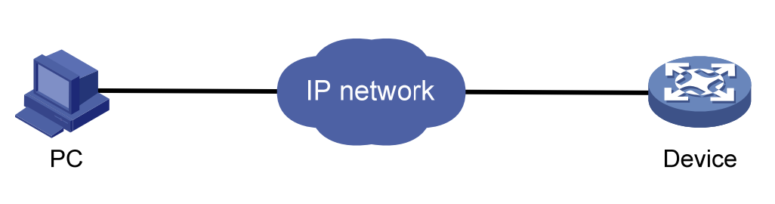

1.2 Logging in to the Web interface
The device is provided with the default Web login information. You can use the following default information to log in to the Web interface:
- Username: ‘admin’
- Password: ‘admin’
- IP address of the device: ’192.168.56.166’
To log in to the device through the Web interface:
1. Connect the Ethernet interface of the device to the PC using a crossover Ethernet cable.
2. Configure an IP address for the PC and ensure that the PC and device can communicate with each other properly.
3. Modify the IP address of the PC to one that within the network segment 192.168.56.0/24 (except for 192.168.56.166), for example, 192.168.56.2.
4. Open the browser, and input the login information.
5. On the PC, open the browser, type the IP address http://192.168.56.166 in the address bar, press Enter and you can enter the login page of the Web interface, as shown in Figure 1-2. Input the username admin and password admin, and click Login.

NOTE
NOTE:
- For better display results, please use edge, chrome, Firefox browsers, other browsers may have compatibility issues.

Figure 1-2 Login page of the Web interface
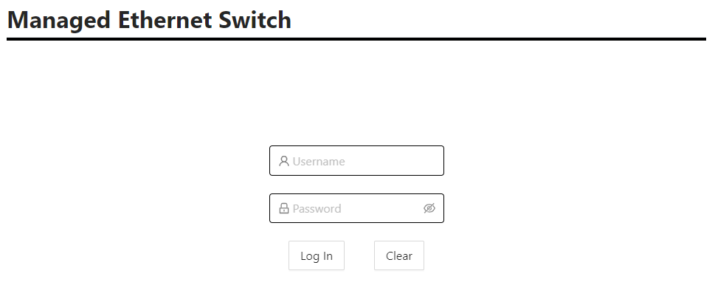

1.3 Logging out of the Web interface
Click Logout button in Auxiliary area to quit Web-based network management, as shown in Figure 1-3. The system does not save the current configuration before you log out of the Web interface. Therefore, we recommend that you save the current configuration before logout.
Figure 1-3 logging out of Web interface

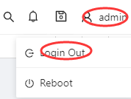

NOTE
NOTE:
- You cannot log out by directly closing the browser.

1.4 Save Configuration
The save configuration module provides the function to save the current configuration to the configuration file for the next startup.
Click the Save button in Auxiliary area to save the current configuration to the configuration file, as shown in Figure 1-4.
Figure 1-4 Save Configuration

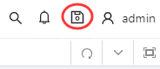

1.5 Reboot
NOTE
NOTE:
- Before rebooting the device, save the configuration; otherwise, all unsaved configurations are lost after device reboot. After the device reboots, you must re-log in to the Web interface.
Click Reboot button in Auxiliary area to reboot the device, as shown in Figure 1-5.
Figure 1-5 Reboot Configuration
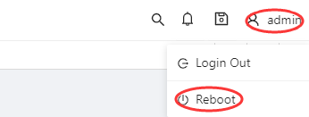

1.6 Introduction to the Web interface
The Web interface is composed of three parts: navigation area, auxiliary area, and body area, as shown in Figure 1-6.
Figure 1-6 Web-based configuration interface
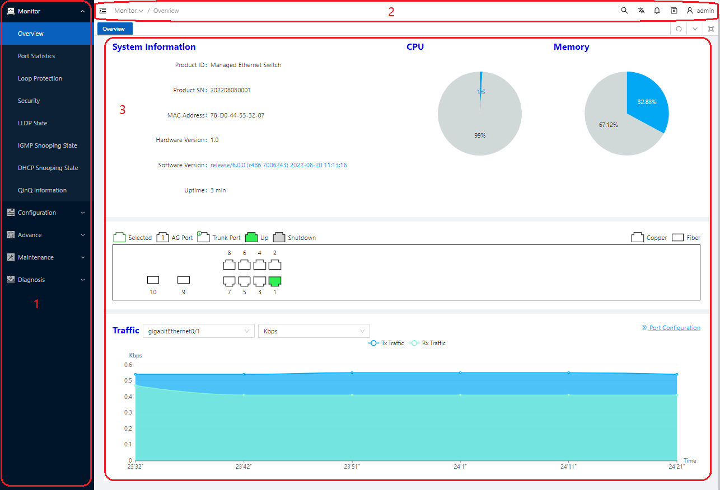

（1）Navigation area | （2）Auxiliary area | （3）Body area
- Navigation area: Organizes the Web-based NM function menus in the form of a navigation area where you can select function menus as needed. The result is displayed in the body area. The Web network management functions not supported by the device are not displayed in the navigation area.
- Auxiliary area：The area where you can search, alarm message prompt, save, exit, restart device and other operations.
- Body area: The area where you can configure and display a function.

1.7 Introduction to the Web-based functions
Table 1-1 describes the Web-based network management functions in detail.
Table 1-1 Description of Web-based functions
Menu/ tab |  |  | Function Description
Monitor | Overview |  | Display the device's MAC address, serial number, software and hardware version, CPU usage, operating  Status such as uptime, display the link status of the port, and the flow of the port.
Monitor | Port statistics |  | Display the count of ports
Monitor | Loop protection |  | Displays the loop protection status of the device
Monitor | Security |  | Displays the security class related status of the device
Monitor | Serial server state |  | Display the working status of the serial port server of the device
Monitor | LLDP Status |  | Display the LLDP working status of the device
Monitor | IGMP Snooping State |  | Display device IGMP Snooping status
Monitor | DHCP Snooping State |  | Display the DHCP snooping status of the device
Monitor | QinQ information |  | Display device QinQ status
Configuration | VLAN |  | Create, modify, and delete VLANs, configure port attributes, and VLAN attribution
Configuration | Port | port  configuration | Set port related properties
Configuration | Port | port extension | Set port rate limit, storm suppression, port isolation
Configuration | Port | port mirroring | Add/remove mirroring of ports
Configuration | Port | Port  aggregation | Add/delete aggregation port
Configuration | Spanning tree |  | Set STP, RSTP, MSTP functions
Configuration | ERPS |  | Set ERPS single ring, tangent ring, intersecting ring
Configuration | PoE |  | Set PoE power, non-standard mode. Enable/disable PoE port power supply
Configuration | Security | port security | Configure and delete the port security function
Configuration | Security | IP Source  Guard | Configure and delete the IP Source Guard function
Configuration | Security | Dot1x | Configuring 802.1X Authentication
Configuration | Security | MAC  authentication | Configuring MAC Authentication Profiles
Configuration | Security | RADIUS | Configure the RADIUS server
Configuration | Control | Serial Server | Configure serial server
Configuration | Control | IO control | Configure DI, DO
Advance | Layer 2 | LLDP  configuration | Configure and delete the LLDP function of the device
Advance | Layer 2 | IGMP Snooping  Configuration | Display/Configure IGMP Snooping
Advance | Layer 2 | MAC  configuration | Configure the MAC address management mode of the device
Advance | Layer 2 | DHCP  Snooping  Configuration | Configuring DHCP Snooping on the Device
Advance | Layer 2 | QinQ  configuration | Configure the QinQ function of the device
Advance | Security | ACL  configuration | Configuring the ACL function of the device
Advance | Security | QoS  configuration | Configure the QoS function of the device
Maintaince | System Configuration |  | Set the electronic label of the device, enable/disable telnet, ssh, http, https functions,  Set management IP
Maintaince | File Management |  | Firmware upgrade management, configuration management, certificate management, page package management
Maintaince | User Management |  | Create/delete users, set user passwords
Maintaince | Time Management |  | Display/set system current date and time
Maintaince | SNMP |  | Create, modify, delete SNMP configuration
Diagnosis | Network Utility |  | Execute ping/trace route operation and display the execution result
Diagnosis | Transceiver Information |  | View optical module information, such as manufacturer information, serial number, optical power, etc.
Diagnosis | One-click collection |  | Generate a diagnostic information file and open the file for viewing or saving to the local host
Diagnosis | Dying gasp |  | Enable/disable the power failure alarm function of dying gasp

2 Monitor

2.1 Overview
Select Monitor > Overview from the navigation tree to enter the overview page. As shown in Figure 2-1, The overview page is divided into 3 sections, namely "System Information", "Panel Port", and "Traffic".
1. In the "System Information" page, you can see the product ID, serial number, MAC address, hardware and software version of the device, the specific parameters are described as shown in Table 2-1.
Figure 2-1 Overview page
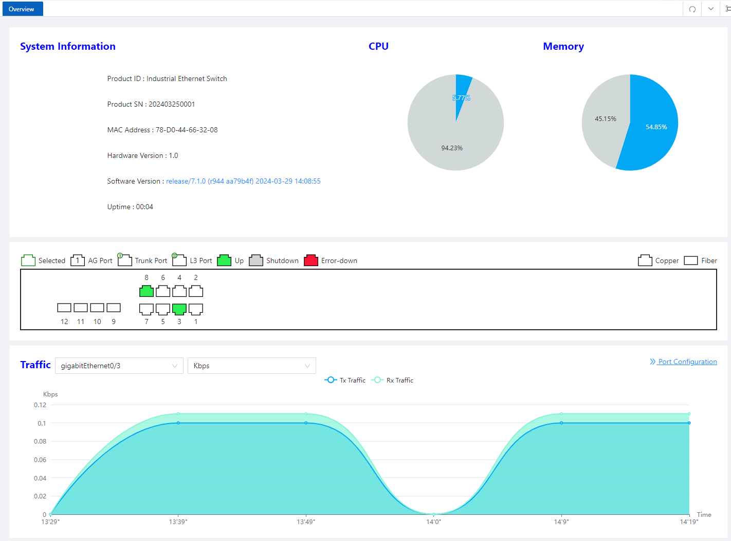

Table2-1 Basic Information configuration items
Item | Description
Host Name | Displays the device name. Allows user to change it.
MAC Address | Displays the device’s MAC address.
Hardware Version | Displays the device’s hardware version.
Software Version | Displays the device’s software version.
Release Date | Displays the device software’s release date.
Product SN | Displays the device’s serial number.
CPU Used | Displays the device’s cpu status.
Memory Avail | Displays the device’s memory status.
System Uptime | Displays the time from last system start.
2. In the "Panel Ports" page, you can see the panel diagram of the device and the working conditions of the panel ports.
3. In the "Traffic" page, you can observe the traffic situation of the port.

2.2 Port Statistics
The port statistics module displays statistics about the packets received and sent through
interfaces.
Displaying port statistics
Select Monitor > Port Statistics in the navigation area to enter the page shown in Figure 2-2. The page displays the port’s Rx Load, Tx Load, Speed, Under size, Over size, CRC Error, Collision Count. Table 2-2 describes the items of port statistics.
Figure 2-2 port statistics page
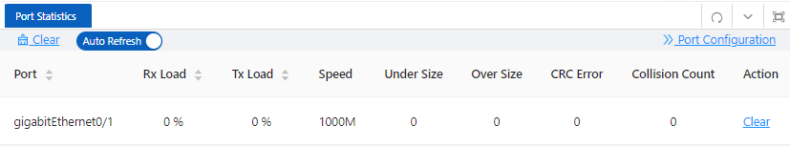
Table 2-2 Items of port statistics
Item | Description
Port | The name of the logical interface.
Rx Load | The port receives the load rate
Tx Load | The port sends the load rate
Speed | The port operating rate
Under Size | The number of packets received by the port is less than 64 bytes
Over Size | The number of packets received by the port is greater than the maximum MTU configuration
CRC Error | The number of packets received of CRC checking error
Collision Count | The number of conflicting packets received by the port
Clear | Click to clear the statistics.

2.3 Loop Protection
The “Loop Protection” page is used to display the working status of device loop-related protocols, such as ERPS and Spanning Tree protocols.
1. Select Monitor > Loop Protection in the navigation area to enter the loop protection status page, as shown in Figure 2-3.
2. You can see the working status of the ERPS and Spanning Tree Protocol that have been enabled, and the specific parameters can be described in the relevant sections of the protocol.
3. Click the ERPS Configuration and Spanning Tree Configuration buttons to directly switch to the relevant configuration interface.
Figure 2-3 Loop Protection status
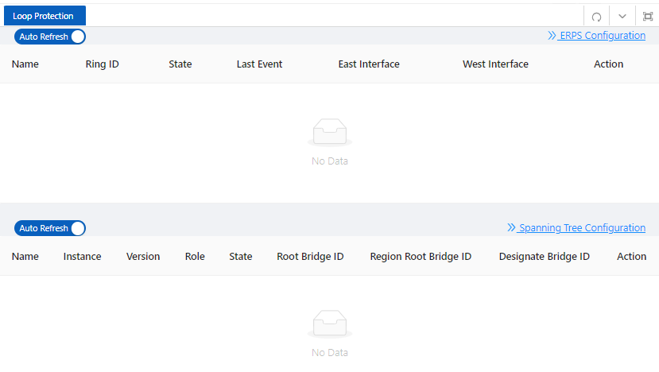

2.4 Serial Server State
The "Serial Server State" page is used to display the working status of Serial Server.
- Select Monitor > Serial Server State in the navigation area to enter the Serial Server State page, as shown in Figure 2-4.
Figure 2-4 Serial Server status
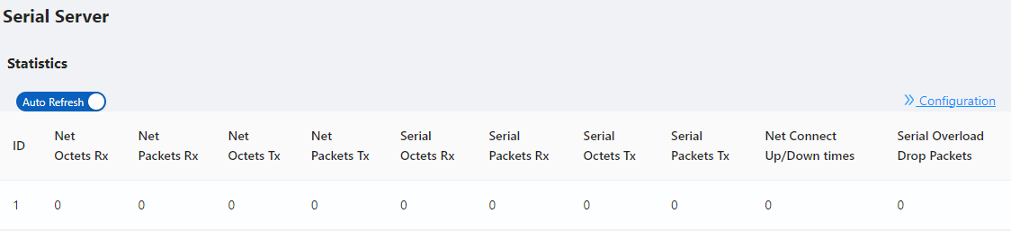
2. In this page, you can see the working status of the serial server. Table 2-3 describes the items of port statistics.
Table 2-3 Items of Serial Server
Item | Description
ID | Serial port ID number of the serial port server
Net Octets Rx | The number of bytes received by the network
Net Packets Rx | The number of packets received by the network
Net Octets Tx | The number of bytes sent by the network
Net Packets Tx | The number of packets sent by the network
Serial Octets Rx | The number of bytes received by the serial port
Serial Packets Rx | The number of packets received by the serial port
Serial Octets Tx | The number of bytes sent by the serial port
Serial Packets Tx | The number of packets sent by the serial port
Net Connect Up/Down times | Number of network connections
Serial Overload Drop Packets | Number of packets discarded by serial port overflow
3. Click the Configuration button to directly switch to the relevant configuration interface.

2.5 Security
The "Security" page is used to display the working status of device security-related protocols, with three parts: port security, IP Source Guard, and MAC authentication.
- Select Monitor > Security in the navigation area to enter the security display page, as shown in Figure 2-5, Figure 2-6, and Figure 2-7.
Figure 2-5 Port Security state
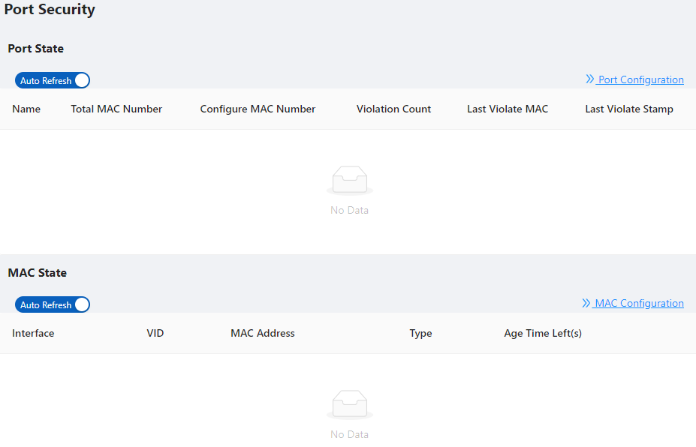

Figure 2-6 IP Source Guard state
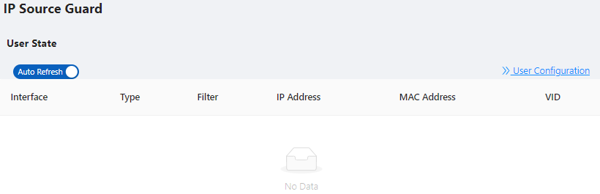
Figure 2-7 MAC Auth state
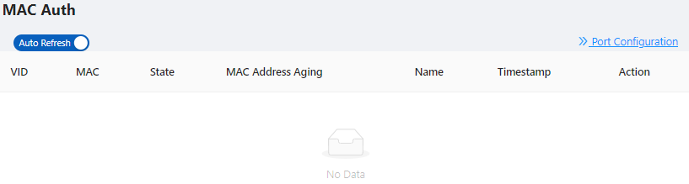
2. In this page, you can see the working status of the ERPS, Spanning tree, IP Source Guard, and MAC authentication, and the specific parameters can be described in the relevant sections of the protocol.
3. Click the corresponding Configuration button to directly switch to the relevant configuration interface.

2.6 PoE State
The " PoE State" page is used to display the current PoE working status of the device.
(1) Select Monitor > PoE State in the navigation bar to enter the PoE status page, as shown in Figure 2-8.
Figure 2-8 PoE State
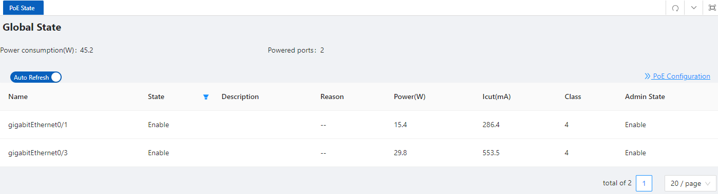
(2) On the current page, you can see the total power supply of the device, the number of power supply ports, and the power supply status of each port. Specific parameter descriptions are shown in Table 2-4.
Table 2-4 Items of PoE State
Item | Description
Global  state | Power  Consumption (W) | current PoE external power supply of the device
Global  state | Powered ports | The current total number of powered up ports
Port | Name | Indication panel port number
Port | State | PoE current power supply status,  disable: power supply off state  enable: power supply on state
Port | Description | PoE port description
Port | Reason | The reason why the port cannot supply power,  Short: load short  Management: insufficient power
Port | Power(W) | The power consumed by the current port
Port | Icut(mA) | The working current of the current port
Port | Class | Class level of the PD device connected to this port
Port | Admin State | Display whether the PoE function of this port is enabled or disabled
- Click the PoE Configuration button to directly switch to the PoE configuration interface.

2.7 LLDP State
The LLDP Status page is used to display the device LLDP working status.
1. Select Monitor > LLDP State in the navigation area to enter the LLDP status page, as shown in Figure 2-9.
2. You can see the working status of the LLDP protocol that has been enabled in the page, and the specific parameters are described in the relevant sections of the protocol.
3. Click the LLDP Configuration button to directly switch to the LLDP configuration interface.
Figure 2-9 LLDP State
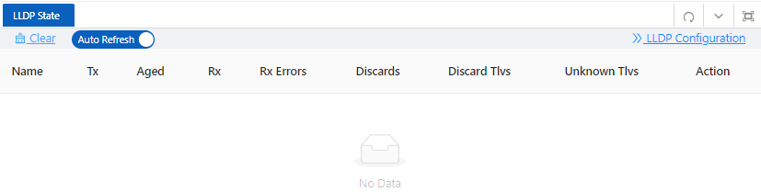

2.8 IGMP Snooping State
The "IGMP Snooping State" page is used to display the working status of the device IGMP Snooping protocol.
1. Select Monitor > IGMP Snooping State in the navigation area to enter the IGMP Snooping Status page, as shown in Figure 2-10.
2. You can see the working status of the IGMP Snooping protocol that has been enabled in the page, and the specific parameters can be described in the relevant sections of the protocol.
3. Click the IGMP Snooping Configuration button to directly switch to the IGMP Snooping configuration interface.

Figure 2-10 IGMP Snooping State
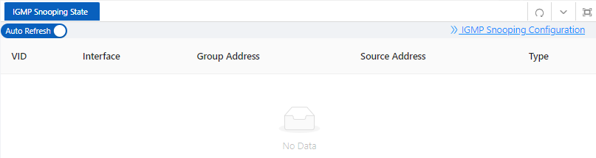

2.9 DHCP Snooping State
The “DHCP Snooping State” page is used to display the working status of the DHCP Snooping protocol of the device.
1. Select Monitor > DHCP Snooping State in the navigation area to enter the DHCP Snooping state page, as shown in Figure 2-11.
2. You can see the working status of dhcp Snooping protocol that has been enabled in the page, and the specific parameters can be described in the relevant sections of the protocol.
3. Click the DHCP Snooping Configuration button to directly switch to the DHCP Snooping configuration interface.
Figure 2-11 DHCP Snooping State
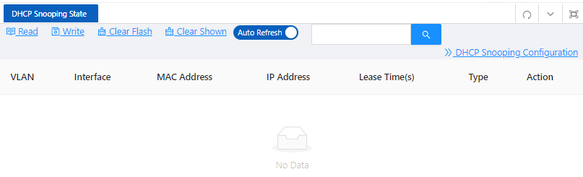

2.10 QinQ Information
The "QinQ Information" page is used to display the working status of the device QinQ information.
1. Select Monitor > QinQ Information in the navigation area to enter the QinQ status page, as shown in Figure 2-12.
2. You can see the working status of QinQ that has been turned on in the page, and the specific parameters can be described in the relevant sections of the protocol.
3. Click the QinQ Configuration button to quickly switch to the QinQ configuration interface.

Figure 2-12 QinQ Information
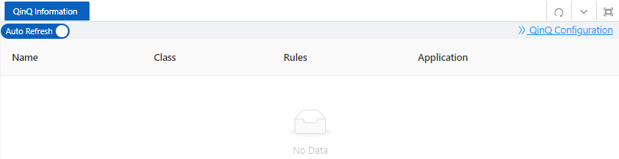

2.11 LoopDetect State
The "LoopDetect State" page is used to display the working status of the loop.
1. Select Monitor > LoopDetect State in the navigation area to enter the LoopDetect status page, as shown in Figure 2-13.
2. You can see the working status of loop detection that has been turned on in the page, and the specific parameters can be described in the relevant sections of the protocol.
3. Click the LoopDetect Configuration button to quickly switch to the loopdetect configuration interface.
Figure 2-13 LoopDetect State
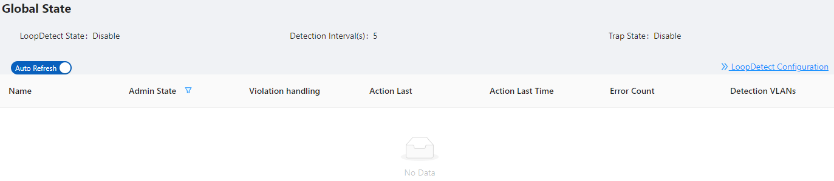

2.12 ARP Information
The "ARP Information" page is used to display the working status of the device ARP information.
1. Select Monitor > ARP Information in the navigation area to enter the ARP status page, as shown in Figure 2-14.
2. You can see the working status of ARP that has been turned on in the page, and the specific parameters can be described in the relevant sections of the protocol.
3. Click the Static ARP button to quickly switch to the static ARP configuration interface.
Figure 2-14 ARP Information
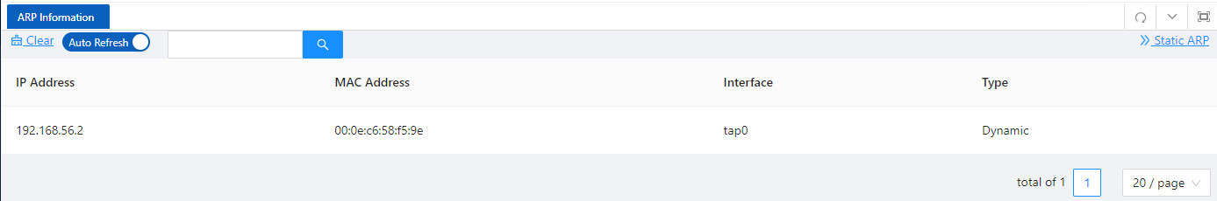

3 Configuration

3.1 VLAN

3.1.1 Introduction
Ethernet is a network technology based on the Carrier Sense Multiple Access/Collision Detect (CSMA/CD) mechanism. As the medium is shared, collisions and excessive broadcasts are common on an Ethernet. To address the issue, virtual LAN (VLAN) was introduced. The idea is to break a LAN down into separate VLANs, that is, Layer 2 broadcast domains whereby frames are switched between ports assigned to the same VLAN. VLANs are isolated from each other at Layer 2. A VLAN is a bridging domain, and ll broadcast traffic is contained within it, as shown in Figure 3-1.
Figure 3-1 A VLAN diagram
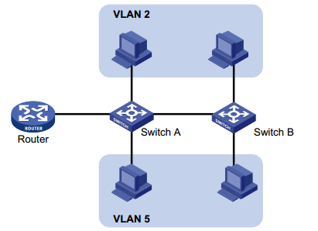
A VLAN is logically divided on an organizational basis rather than on a physical basis. For example, all workstations and servers used by a particular workgroup can be connected to the same LAN, regardless of their physical locations. VLAN technology delivers the following benefits:
• Confining broadcast traffic within individual VLANs. This reduces bandwidth waste and improves network performance.
• Improving LAN security. By assigning user groups to different VLANs, you can isolate them at Layer 2. For hosts in different VLANs to communicate, routers or Layer 3 switches are required.
• Flexible virtual workgroup creation. As users from the same workgroup can be assigned to the same VLAN regardless of their physical locations, network construction and maintenance is much easier and more flexible.
You can create VLANs based on:
• Port
• MAC address
• Protocol
• IP subnet
• Policy
• Other criteria
Because the Web interface is available only for port-based VLANs, this chapter introduces only port-based VLANs.

3.1.1.1 VLAN Mode
Depending on the tag handling mode, the VLAN Mode of a port can be one of the following three:
• Access ：
An access port belongs to only one VLAN and usually connects to a user device.
• Trunk ：
A trunk port can join multiple VLANs to receive and send traffic for them. It usually connects to a network device.
• Hybrid ：
A hybrid port can join multiple VLANs to receive and send traffic for them. It can connect either a user device or a network device.
A hybrid port is different from a trunk port in that:
• A hybrid port allows traffic of multiple VLANs to pass through untagged.
• A trunk port allows only traffic of the default VLAN to pass through untagged.

3.1.1.2 Port link type
By default, VLAN 1 is the default VLAN for all ports. However, you can change the default VLAN for a port as required. When doing that, follow these guidelines:
• Because an access port can join only one VLAN, its default VLAN is the VLAN to which it belongs and cannot be configured.
• Because a trunk or hybrid port can join multiple VLANs, you can configure a default VLAN for the port.

3.1.1.3 Frame handling methods
Table 3-1 A port configured with a default VLAN handles a frame as follows:
Port type | Actions (in the inbound direction) |  | Actions (in the outbound direction)
Port type | Untagged frame | Tagged frame | Actions (in the outbound direction)
Access | Tag the frame with the default VLAN tag. | - Receive the frame if its VLAN ID is the same as the default VLAN ID  - Drop the frame if its VLAN ID is different from the default VLAN ID. | Remove the default VLAN tag and send the frame.
Trunk | Check whether the default VLAN is carried on the port：  - If yes, tag the frame with the default VLAN tag.  - If not, drop the frame. | - Receive the frame if its VLAN is carried on the port.  - Drop the frame if its VLAN is not carried on the port. | - Remove the tag and send the frame if the frame Carries the default VLAN tag.  - Send the frame without removing the tag if its VLAN is carried on the port but is different from the default one.
Hybrid |  |  | Send the frame if its VLAN is carried on the port. The frame is sent with the VLAN tag removed or intact depending on your configuration.

3.1.2 Configuring VLAN

3.1.2.1 Creating VLAN
1. Select Configuration > VLAN in the navigation area. The system automatically enters the VLAN page as shown in Figure 3-2. Table 3-2 describes the configuration items of creating a VLAN.
Figure 3-2 VLAN configuration page
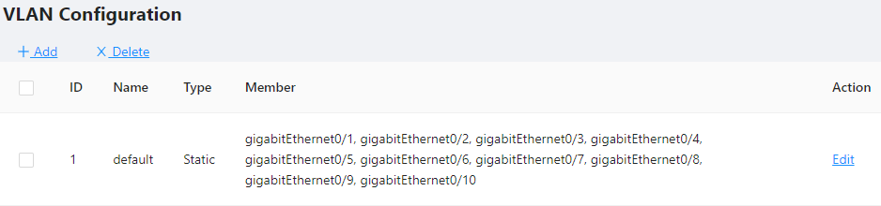
Table 3-2 Vlan configuration items
Item | Description
ID | This field displays the ID of the VLAN
name | By default, the description string of a VLAN is its VLAN ID, such as VLAN 0002.
Members | Indicates that the port sends the traffic of the VLAN without removing the VLAN tag.
Edit | Click to enter the VLAN editing page
Add | Click to enter the VLAN adding page
Delete | Select the VLAN ID, click to delete
2. Click Add button to enter the page for creating a VLAN, as shown in Figure 3-3.
3. Type VLAN number into the ID box, select the Tagged Members in the port panel to be assigned to these VLAN.
Figure 3-3 Create VLAN
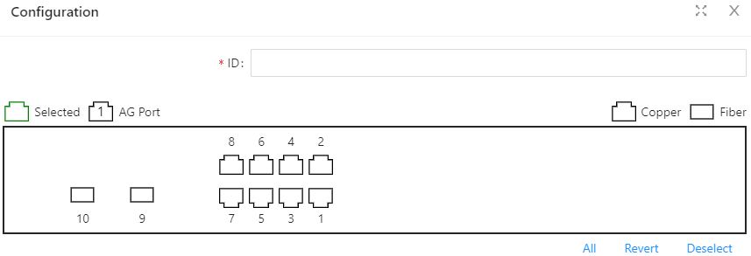
4. Click the Save in the auxiliary area to save the configuration.

3.1.2.2 Configuring Trunk Port
1. Select Configuration > VLAN in the navigation area to enter the VLAN page as shown in Figure 3-4. Table 3-3 describes the configuration items of configuring a Trunk Port.
Figure 3-4 Trunk Configuration page
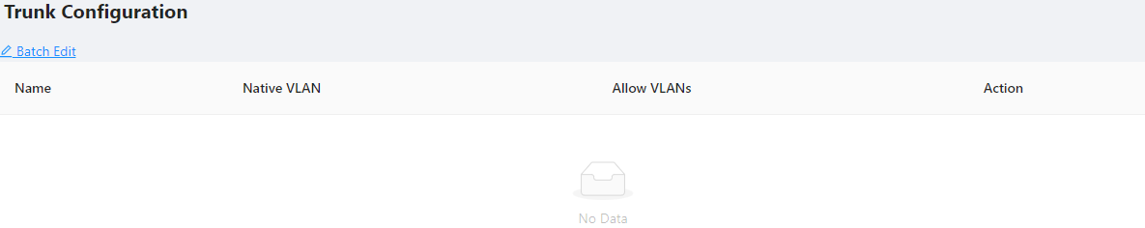
2. Click Batch Edit button below “Trunk Configuration” to enter the trunk configuration page, as shown in Figure 3-5. Table 3-3 describes the configuration items of configuring a VLAN.
Table3-3 The description of the Trunk configuration
Item |  | Description
Mode | Access | Sets the port’s VLAN Mode to access
Mode | Trunk | Sets the port’s VLAN Mode to trunk
PVID |  | Set the port’s default VLAN ID, only exist in access mode.  •The trunk ports at the two ends of a link must have the same PVID. Otherwise, the link cannot properly transmit packets
Native Vlan |  | VLAN（Native Vlan）, only exist in Trunk mode.
Allow VLANs |  | Select the VLANs that are allowed through the port.
Figure 3-5 Interface configuration page
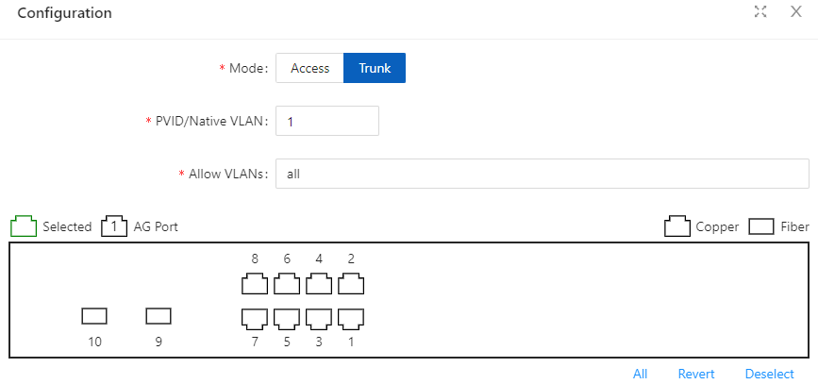
3. Select the Vlan Mode, type VLAN number in PVID and Allow VLANs box, click Ok button to complete the configuration.
4. Click the Save in the auxiliary area to save the configuration.

3.2 Port

3.2.1 Port Configuration
You can use the interface management feature to view interface information, create/remove logical interfaces, change interface status, and reset interface parameters, as shown in Figure 3-6.
Figure 3-6 Port Configuration page
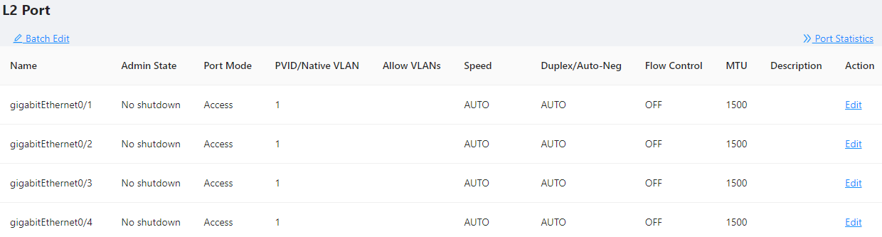
Configuring interface management
1. Select Configuration > Port > Port Configuration in the navigation area to enter the port configuration page as shown in Figure 3-6.
2. Select the ports to be configured, click Edit button to enter the page for configuring an interface, as shown in Figure 3-7. Table 3-4 describes the configuration items of configuring an interface.
Figure 3-7 Port Configuration page
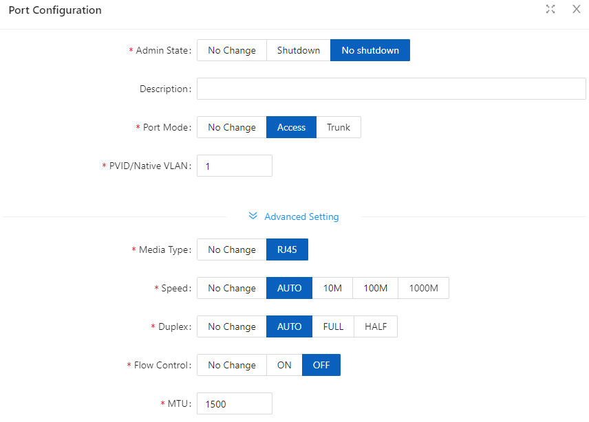

Table 3-4 Configuration items of Port
Item | Description
Admin State | Shutdown/no shutdown the port.
Description | Set the description of a logical interface.
Port Mode | Set the port’s vlan mode, Access or Trunk
PVID/Native VLAN | Set the port’s PVID or Native VLAN.
Medium type | Set the medium type of the Combo ports  - RJ45：the mode of port is 10/100/1000BASE-T  - SFP：the mode of port is 1000BASE-X  Note: only for combo ports.
Speed(copper) | Set the port’s transmission rate:  - 10: indicates 10 Mbps  - 100M：indicates 100 Mbps  - 1000M：indicates 1000 Mbps  - Auto: indicates auto-negotiation  Note: only for copper ports.
Duplex(copper) | Set the port’s duplex mode:  - AUTO：indicates auto-negotiation  - FULL：indicates full duplex  - HALF：indicates half duplex  Note: only for copper ports.
Speed(fiber) | Set the port’s mode  - 100BASE-FX：indicates the port mode is 100BASE-FX.  - 1000BASE-X：indicates the port mode is 1000BASE-X.  - 2500BASE-X：indicates the port mode is 2.5G BASE-X.  - 10G BASE-X: indicates the port mode is 10G BASE-X.  Note: only for fiber ports.
Autoneg(fiber) | Enables or disables port’s autoneg.  The auto-negotiation function needs to be enabled or disabled at the same  time as the peer end, otherwise a link failure will occur.  Note: only for fiber ports.
Flow control | Enables or disables port’s Flow control.
MTU | Allows or forbids jumbo frames to pass through the port. Default length of packets is 46-1500 bytes.
Admin Shutdown | Shutdown/no shutdown the port.

3.2.2 Port Extension

3.2.2.1 Rate Limiting
Port-based rate limiting allows you to limit the speed at which network traffic is sent or received by a device that is connected to a port on your switch. Unlike 802.1p Quality of Service (QoS), port-based rate limiting does not prioritize information based on type. Rate limiting simply means that the switch will slow down traffic on a port to keep it from exceeding the limit that you set. If you set the rate limit on a port too low, you might see degraded video stream quality, sluggish response times during online activity, and other problems.
The best use of rate limiting is to keep low-priority devices that are connected to your switch from using too much of your bandwidth and slowing down your other connected devices. A combination of rate limiting and QoS can help you maximize your network’s efficiency and prioritize devices and activities.
Configuring Port Ratelimit
1. Select Configuration > Port > Port Extension > Rate Limiting in the navigation area to enter the port ratelimit page as shown in Figure 3-8.
2. Click the Batch Edit button below “Rate Limiting” to enter the configure rate limiting page, as shown in Figure 3-9, type the number in the box. Table 3-5 describes the configuration items of configuring an interface.
3. Click the Ok button.
4. Click the Save button in the auxiliary area.
Figure 3-8 Port Ratelimit page
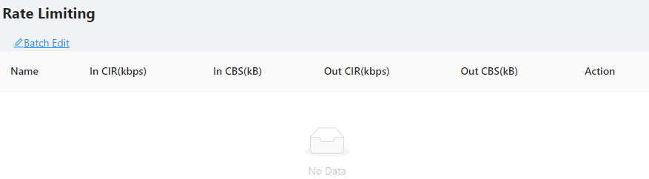
Figure 3-9 Port Ratelimit configuration
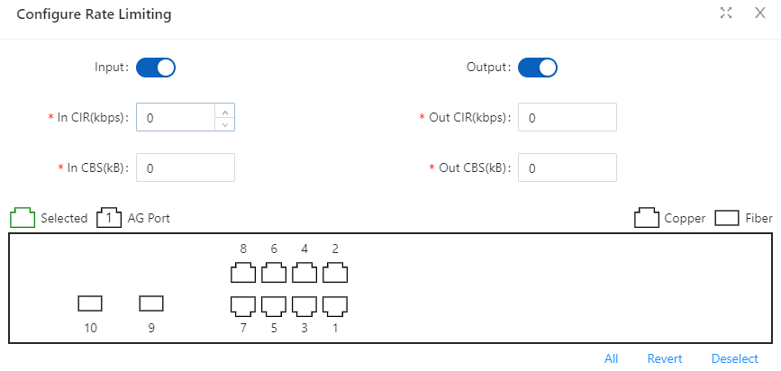
NOTE
NOTE:
- CBS embodies a rate-limit feature for policing traffic. When policing traffic with CBS, here recommends the burst value 4 times of the limit value. If the burst values are too low, then the achieved rate is often much lower than the configured rate.
Table 3-5 Port Ratelimit Configuration items
Item | Description
In CIR (kbps) | Specify the rate limit in the inbound direction (KBits).
In CBS (KB) | Specify the burst size in the inbound direction (KBits).
Out CIR (kbps) | Specify the rate limit in the outbound direction (KBits).
Out CBS (KB) | Specify the burst size in the outbound direction (KBits).

3.2.2.2 Storm Control
A traffic storm occurs when a large amount of broadcast, multicast, or unicast packets congest a network.
You can use the storm suppression function to limit the size of a particular type of traffic (currently broadcast, multicast and unknown unicast traffic) on a per-interface basis in Ethernet port view or port group view.
In interface or port group view, you set the maximum broadcast, multicast or unknown unicast traffic allowed to pass through an interface or each interface in a port group. When the broadcast, multicast, or unknown unicast traffic on the interface exceeds the threshold, the system discards packets until the traffic drops below the threshold.
Configuring the Storm Control
1. Select Configuration > Port > Port Extension > Strom Control in the navigation area to enter the storm control page as shown in Figure 3-10.
Figure 3-10 Strom Control page
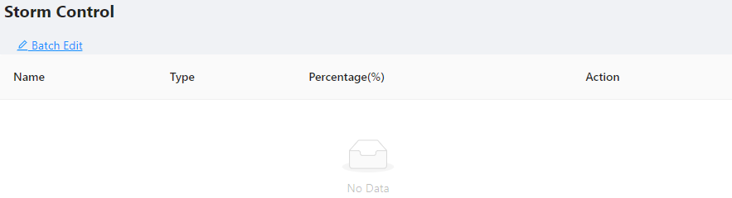
2. Select the Type, type the box of the Percentage, select the ports to be configured in the port panel, as shown in Figure 3-11. Table 3-7 describes the configuration items of configuring Strom control.
3. Click the Ok button to complete the configuration.
4. Click the Save in the auxiliary area.

Figure 3-11 Strom Control configuration
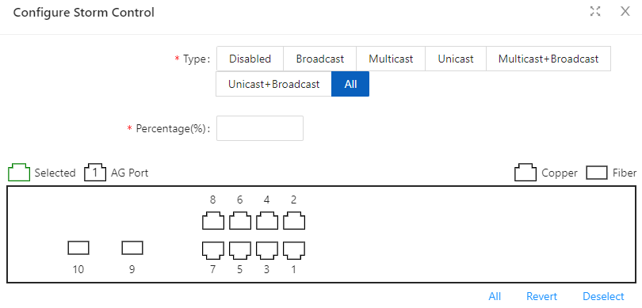
Table 3-7 Items of the storm control
Item |  | Description
Type | Disabled | Disable storm control
Type | Broadcast | Selects the parameter used in broadcast suppression and sets its  value in the percentage box.
Type | Multicast | Selects the parameter used in multicast suppression and sets its  value in the percentage box.
Type | Unicast | Selects the parameter used in unicast suppression and sets its  value in the percentage box.
Type | multicast-broadcast | Selects the parameter used in multicast and broadcast  suppression and sets its value in the percentage box.
Type | unicast-broadcast | Selects the parameter used in unicast and broadcast,  suppression and sets its value in the percentage box.
Type | All | Selects the parameter used in unicast and unicast,  broadcast, suppression and sets its value in the percentage box.
Percentage (%) |  | Indicates the maximum percentage of traffic to the total  transmission capability of an Ethernet interface.

3.2.2.1 Isolation
Usually, Layer 2 traffic isolation is achieved by assigning ports to different VLANs. To save VLAN resources, port isolation is introduced to isolate ports within a VLAN, allowing for great flexibility and security.
1. Switch support multiple isolation groups which can be configured manually. These devices are referred to as multiple-isolation-group devices.
2. There is no restriction on the number of ports assigned to an isolation group.
3. Within the same VLAN, Layer 2 data transmission between ports within and outside the isolation group is supported.

Configuring an Isolation Group
1. Select Configuration > Port > Port Extension > Isolation in the navigation area to enter the Port isolate page as shown in Figure 3-12.
2. Select the port to be isolated, click Ok button.
3. Click Save in the auxiliary area.
Figure 3-12 Port Isolate page
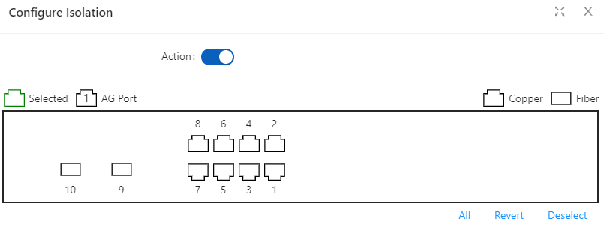

3.2.3 Port Mirroring
Port mirroring is to copy the packets passing through one or multiple ports (called source interface) to a port (called the destination interface) on the local device. The source interface is connected with a monitoring device. By analyzing on the monitoring device, the packets mirrored to the destination interface, you can monitor the network and troubleshoot possible network problems.
Figure3-13 A port mirroring implementation
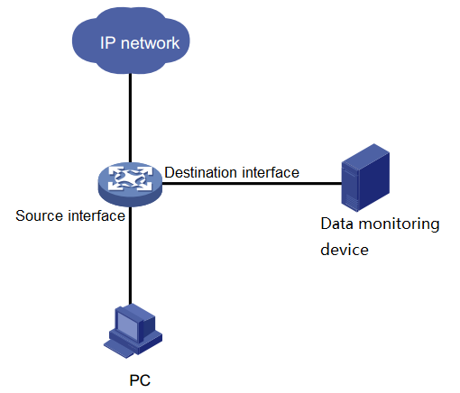
Creating a mirroring group
1. Select Configuration > Port > Port Mirror in the navigation area to enter the Port mirror page as shown in Figure 3-14.

Figure 3-14 Port Mirror Page
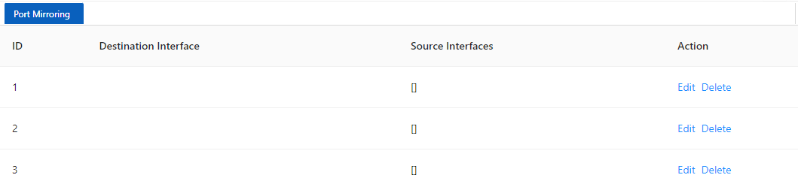
2. Click the Edit button for the corresponding ID and select the destination interface or source interface, as shown in Figure 3-15. Table 3-8 describes the configuration items of creating a mirroring group.
Table 3-8 Configuration items of creating a mirroring group
Item | Description
Session | ID of the mirroring group to be created
Destination Interface | the monitor port for the mirroring group, there can only be one
Source Interface | mirroring ports for the mirroring group, there can be more than one
Figure 3-15 The page for creating a mirroring group
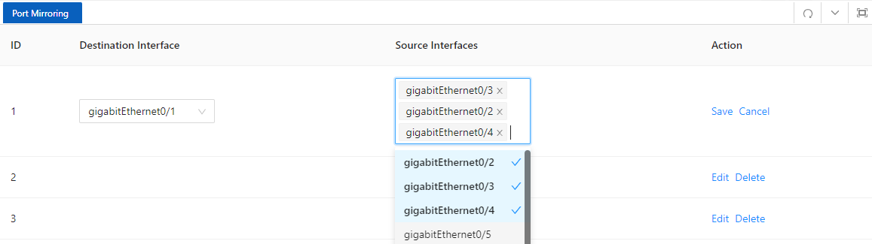
3. Click the Save button for the corresponding ID.
4. Click Ok button.
5. Click Save in the auxiliary area.

3.2.4 Port Aggregation

3.2.4.1 Overview
Link Aggregation
Ethernet link aggregation, most often simply called link aggregation, aggregates multiple physical Ethernet links into one logical link to increase link bandwidth beyond the limits of any one single link. This logical link is called an aggregate link. It allows for link redundancy because the member physical links dynamically back up one another.
As shown in Figure 3-16, Switch A and Switch B are connected with three physical Ethernet links. These physical Ethernet links are aggregated into an aggregate link, Link aggregation 1. The bandwidth of this aggregate link can be as high as the total bandwidth of these three physical Ethernet links.

Figure 3-16 Port Isolate page
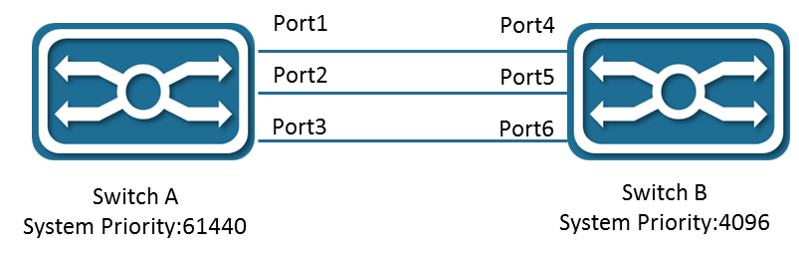
LACP
The IEEE 802.3ad Link Aggregation Control Protocol (LACP) enables dynamic aggregation of physical links. It uses link aggregation control protocol data units (LACPDUs) for exchanging aggregation information between LACP-enabled devices.
There are two link aggregation modes: dynamic and static. Dynamic link aggregation uses LACP while static link aggregation does not. A link aggregation group operating in static mode is called a static link aggregation group, while a link aggregation group operating in dynamic mode is called a dynamic link aggregation group.

3.2.4.2 Configuring an Aggregation Group
Configuration procedure:
1. Select Configuration > Port > Port Aggregation in the navigation area to enter the Link Aggregation page as shown in Figure 3-17, The description of the link aggregation is described in Table 3-9.
Figure 3-17 Global Configure Page
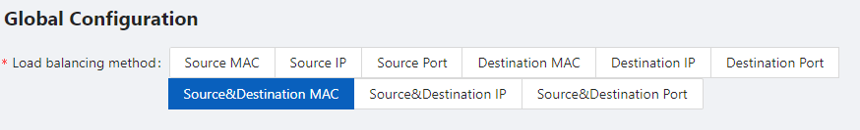
Table 3-9 description of global configure item
Item | Description
Load balancing method | dst-mac | Equalize according to the destination MAC address
Load balancing method | src-mac | Equalize according to the source MAC address
Load balancing method | src-dst-mac | Equalize according to the destination MAC address and source MAC address
Load balancing method | dst-ip | Equalize according to the destination IP address
Load balancing method | srt-ip | Equalize according to the source IP address
Load balancing method | src-dst-ip | Equalize according to the destination IP address and source IP address
Load balancing method | dst-port | Equalize according to the L4 TCP/UDP destination port number
Load balancing method | src-port | Equalize according to the L4 TCP/UDP source port number
Load balancing method | src-dst-port | Equalize according to the L4 TCP/UDP destination port number and source port number
2. In the Aggregate ports Configure page, click +Add button to enter port configuration page, as shown in Figure 3-18, The description of the link aggregation is described in Table 3-10.

Table 3-10 description of Aggregation Member
Item |  | Description
port  configuration | ID | The ID of the Aggregation Member
port  configuration | Type | Manual | Manual mode
port  configuration | Type | Active | In this mode, the ports send LACP packets at regular  intervals to the partner ports
port  configuration | Type | Passive | In this mode, the ports do not send LACP packets until the  partner port sends LACP packets.  After receiving the LACP packets from the partner port, the  ports send LACP packets to the partner port.
Figure 3-18 Aggregation port configuration page
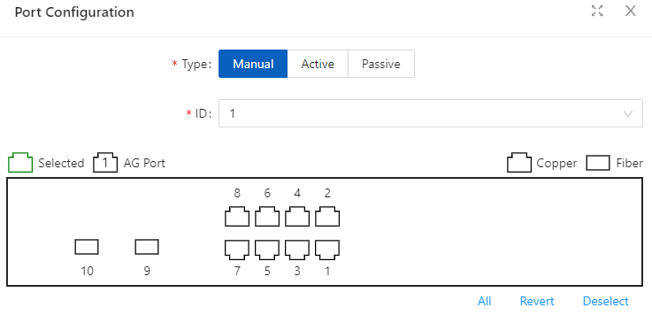
Select the type of aggregation, text the “ID” box, select the port in the port panel, click Ok button to complete the configuration.
After the configuration is completed, the aggregation port created is displayed on the Aggregation Port page, as shown in Figure 3-19. The description of Aggregation Port is described in Table 3-11.
Figure 3-19 Aggregation port page
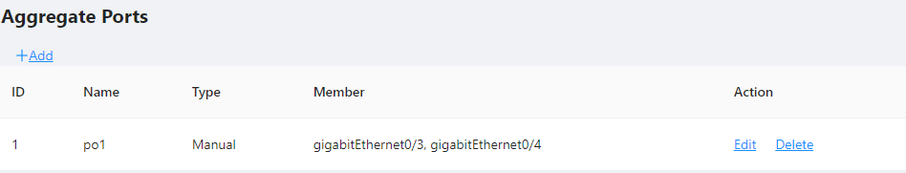

Table 3-11 description of Aggregation port
Item |  | Description
Aggregation  Port | ID | The ID of the Aggregation Port
Aggregation  Port | Name | The name of the Aggregation Port
Aggregation  Port | Type | The mode of the Aggregation Port
Aggregation  Port | Member | The member ports of the Aggregation Port

3.2.5 Port Violation
During the use of the device, active or passive violations may occur on the switch port, such as port security violations, port flapping violations, port loop detection violations, etc. The port violation module is used to configure the recovery enablement and recovery time of the violating port, and displays the port's violation behavior.
Configuration procedure:
Select Configuration > Port > Port Violation in the navigation bar to enter the port violation global configuration interface, check the service that needs to be violated, turn on the automatic recovery button and configure the recovery time, click the Apply button to complete the configuration, such as Figure 3-40 is shown, and the global configuration parameters are shown in Table 3-13.
Figure 3-19 Global configuration page
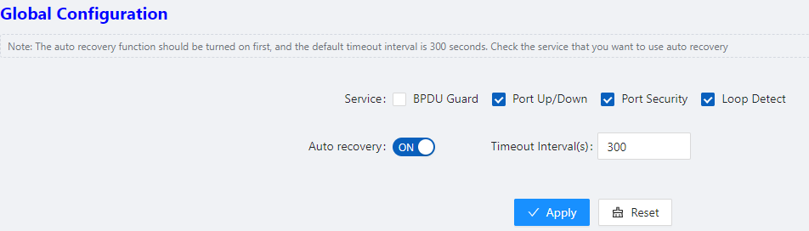
Table 3-11 Description of Global configuration
Items |  | Description
Service | BPDU Guard | Violations caused by port BPDU protection
Service | Port Up/Down | Violations caused by frequent port Up/Down
Service | Port Security | Violations caused by illegal port security
Service | Loop Detect | Violations caused by a loop in the device downstream of the port
Auto recovery |  | Enable/disable automatic recovery of violating ports
Timeout interval |  | Configure the recovery time of the violating port, in seconds
When you need to manually restore the violating port, select the port that needs to be restored and click the Reset button to restore the port function.

Figure 3-20 Port State
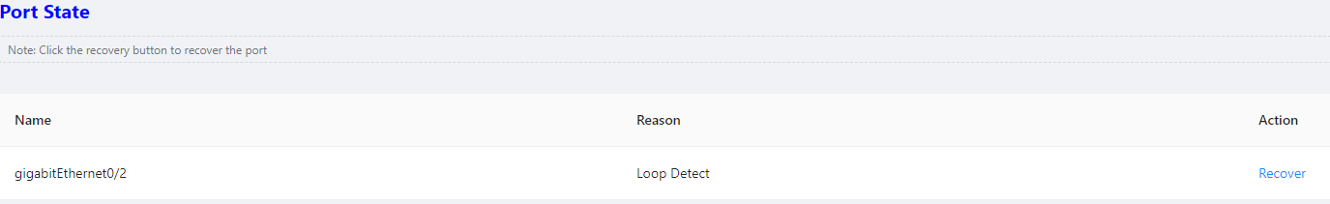

3.3 Spanning Tree

3.3.1 Overview
Spanning Tree Protocol (STP) is a Layer-2 management protocol. It cannot only selectively block redundant links to eliminate Layer-2 loops but also can back up links.
Like many protocols, STP is continuously updated from Rapid Spanning Tree Protocol (RSTP) to Multiple Spanning Tree Protocol (MSTP) as the network develops.
For the Layer-2 Ethernet, only one active link can exist between two local area networks (LANs). Otherwise, a broadcast storm will occur. To enhance the reliability of a LAN, it is necessary to establish a redundant link and keep some paths in backup state. If the network is faulty and a link fails, you must switch the redundant link to the active state. STP can automatically activate the redundant link without any manual operations. STP enables devices on a LAN to:
• Discover and start the best tree topology on the LAN.
• Troubleshoot a fault and automatically update the network topology so that the possible best tree topology is always selected.
The LAN topology is automatically calculated based on a set of bridge parameters configured by the administrator. The best topology tree can be obtained by properly configuring these parameters.
RSTP is completely compatible with 802.1D STP. Like traditional STP, RSTP provides loop-free and redundancy services. It is characterized by rapid speed. If all bridges in a LAN support RSTP and are properly configured by the administrator, it takes less than 1 second (about 50 seconds if traditional STP is used) to re-generate a topology tree after the network topology changes.
STP and RSTP have the following defects:
• STP migration is slow. Even on point-to-point links or edge ports, it still takes two times of the forward delay for ports to switch to the forwarding state.
• RSTP can rapidly converge but has the same defect with STP: Since all VLANs in a LAN share the same spanning tree, packets of all VLANs are forwarded along this spanning tree. Therefore, redundant links cannot be blocked according to specific VLANs and data traffic cannot be balanced among VLANs.
• MSTP, defined by the IEEE in 802.1s, resolves defects of STP and RSTP. It cannot only rapidly converge but also can enable traffic of different VLANs to be forwarded along respective paths, thereby providing a better load balancing mechanism for redundant links.
In general, STP/RSTP works based on ports while MSTP works based on instances. An instance is a set of multiple VLANs. Binding multiple VLANs to one instance can reduce the communication overhead and resource utilization.

3.3.2 Spanning Tree Configuring
Global Configuration of the Spanning Tree
Select Configuration > Spanning Tree > Global Configuration in the navigation area to enter the Global Configuration page, as shown in Figure 3-20. Table 3-12 describes the Spanning Tree Global Configuration items.

Figure 3-20 Spanning Tree Global Configuration
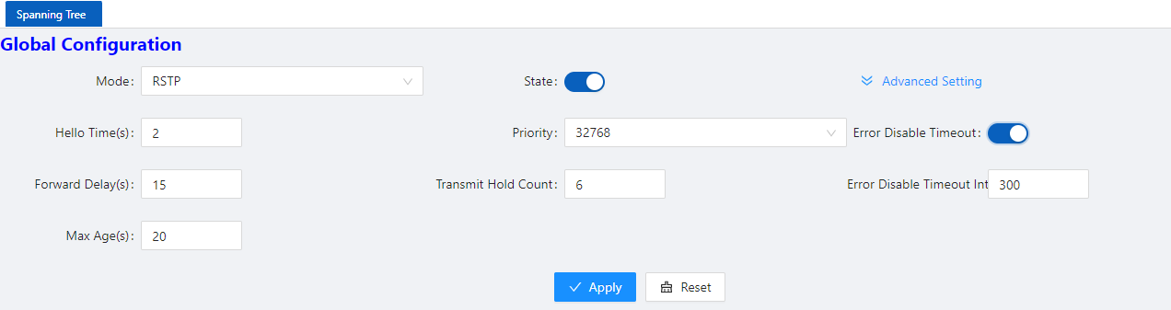
Table 3-12 Spanning Tree Global Configuration items
Item |  | Description
Global  Configuration | Mode | Set the working mode of STP, including STP, RSTP, and MSTP.  STP: In STP mode, each port of the device sends STP BPDUs.  RSTP: In RSTP mode, each port of the device will send out RSTP BPDUs. When it is connected to the device running STP, the port will automatically migrate to STP mode.  MSTP: In MSTP mode, each port of the device sends MSTP BPDUs. When it is connected to the device running STP, the port is automatically migrated to work in STP mode.
Global  Configuration | State | Enable STP.
Global  Configuration | Hello Time | Hello timer interval
Global  Configuration | Priority | Bridge priority
Global  Configuration | Forward Delay | Set the delay time before an interface change to forwarding
Global  Configuration | Transmit Hold Count | Maximum number of BPDUs sent by the bridge per second
Global  Configuration | Max Age | Set the maximum duration that messages are saved in the device
Global  Configuration | Error Disable Timeout | Configuration error port auto disable function
Global  Configuration | Error Disable Timeout Interval | Configuration error port is automatically disabled timeout.
Configuring the Instance
Select Configuration > Spanning Tree > Instance Configuration in the navigation area to enter the instance configuration page, as shown in Figure 3-21. Table 3-13 describes the Instance Configuration items.
Figure 3-21 Spanning Tree Instance Configuration
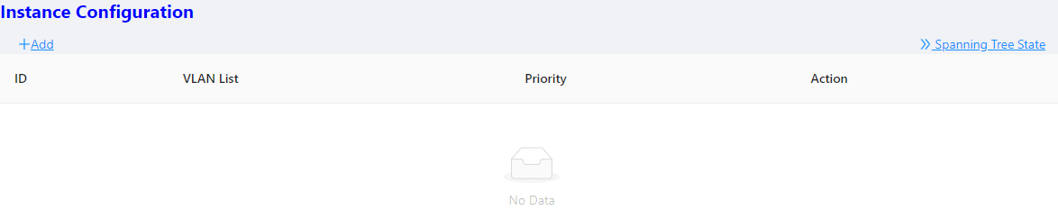

Table 3-13 Spanning Tree Instance items
Item |  | Description
Instance  Configuration | ID | Instance ID
Instance  Configuration | VLAN List | Instance associated VLAN list
Instance  Configuration | Priority | Bridge priority in this instance
Instance  Configuration | Action | Click to delete this entry
Configuring the Ports
Select Configuration > Spanning Tree > Port Configuration in the navigation area to enter the port configuration page, as shown in Figure 3-22. Table 3-14 describes the port Configuration items.
Figure 3-22 Spanning Tree port Configuration
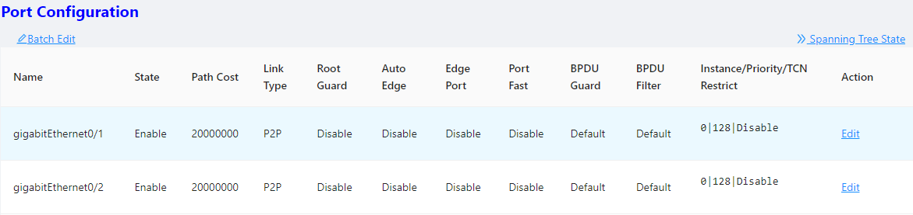
Table 3-14 Spanning Tree port Configuration items
Item |  | Description
Port Configuration | Name | Interface name
Port Configuration | State | STP status
Port Configuration | Path Cost | Configure interface path cost
Port Configuration | Link Type | Configure interface link type
Port Configuration | Root Guard | Configure the interface to enable root protection.
Port Configuration | Auto Edge | Configure the interface to automatically recognize the function of the edge port.
Port Configuration | Edge Port | Configure the interface as an edge port.
Port Configuration | Port Fast | Configure the interface as a fast port.
Port Configuration | BPDU Filter | Configure the interface to enable BPDU filtering.
Port Configuration | BPDU Guard | Configure the interface to enable BPDU protection.
Port Configuration | Instance/Priority/TCN restrict | Configure the instance, Priority, and TCN restrict.

3.4 ERPS

3.4.1 Overview
The ITU-T G.8032 ERPS feature implements protection switching mechanisms for Ethernet layer ring topologies. This feature uses the G.8032 Ethernet Ring Protection (ERP) protocol, defined in ITU-T G.8032, to provide protection for Ethernet traffic in a ring topology, while ensuring that no loops are within the ring at the Ethernet layer. The loops are prevented by blocking traffic on either a predetermined link or a failed link.
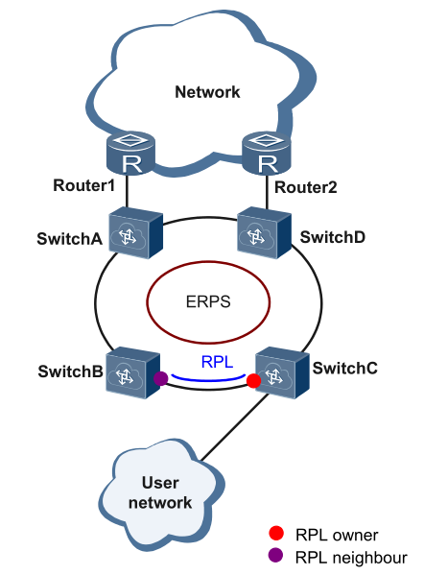
Initial State
As the following figure, the devices on the ring have been configured, and all the link status is up.
The RPL owner interface will be blocked by ERPS protocol to prevent loops. If a RPL neighbor interface is configured, it will also be blocked. Other interfaces are under the forwarding state, can forward the traffic.
Link failure
When there is a link failure between SwitchD and SwitchE, the two interfaces on the link will be blocked by ERPS protocol, the RPL owner interface will be forwarded.
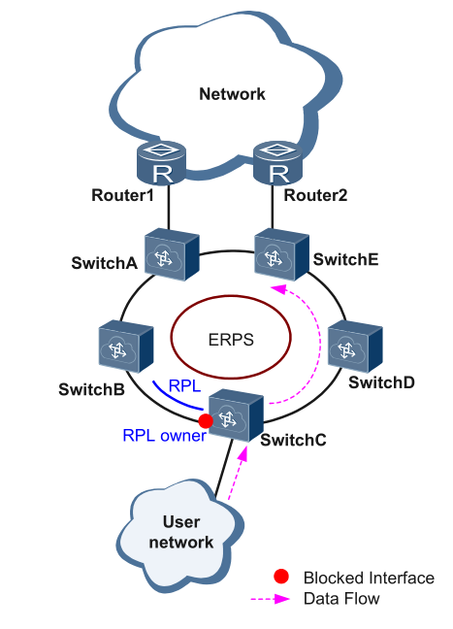
Figure 1 Link failure

Link restores
When the failure link is restored. When the erps ring is configured to revertive mode, the RPL owner interface will be blocked by ERPS protocol, the restored link will be configured to forwarding state to forward traffic.
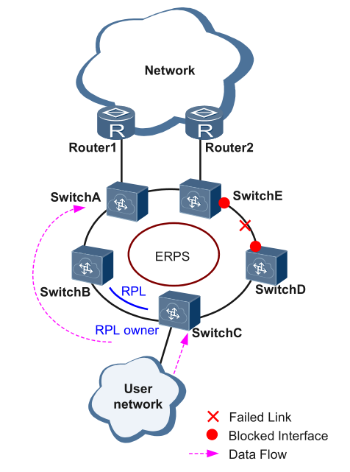
Single-Ring：
Only one ring in a network topology needs to be protected.
In Figure 3-23, the network topology has only one ring, only one ring protection link (RPL) owner node, and only one RPL. All nodes must belong to the same ring automatic protection switching (R-APS) virtual local area network (VLAN).
All devices in the ring network must support ERPS.
The links between devices in the ring network must be directly connected, and there must be no intermediate devices.

Figure 3-23 ERPS single ring

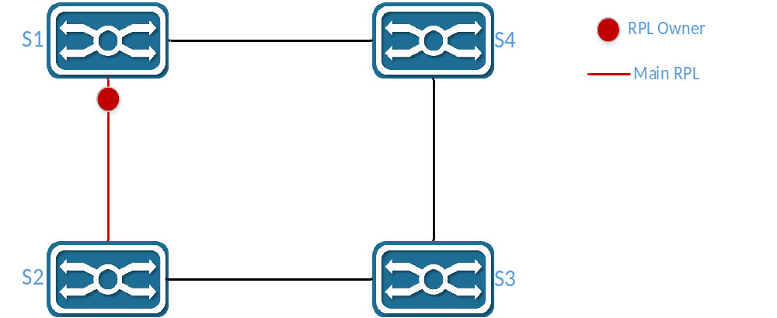
Tangent Rings：
The two rings in a network topology that share one device need to be protected.
In Figure 3-24, the two rings in the network topology share one device. Each ring has only one PRL owner node and only one RPL. The two rings belong to different R-APS VLANs.
All devices in the ring network need to support ERPS.
The links between devices in the ring network must be directly connected, and there must be no intermediate devices.
Figure 3-24 ERPS Tangent Rings
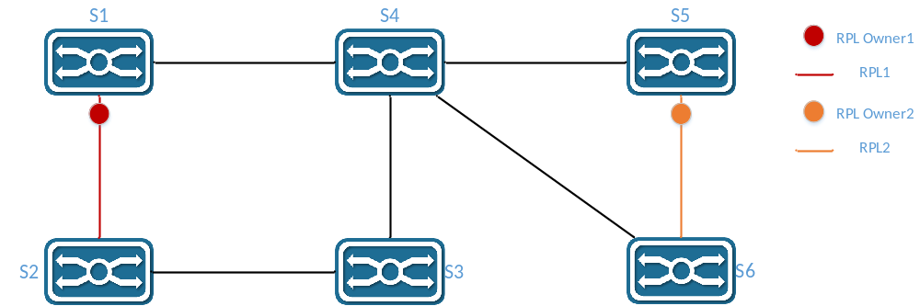
Intersecting Rings：
Two or more rings in a network topology share one link. (Each link between intersecting nodes must be a direct link without any intermediate node.)
In Figure 3-25, four rings exist in the network topology. Each ring has only one PRL owner node and only one RPL. The four rings belong to different R-APS VLANs.
All devices in the ring network need to support ERPS.
The links between devices in the ring network must be directly connected, and there must be no intermediate devices.

Figure 3-25 ERPS Intersecting Rings
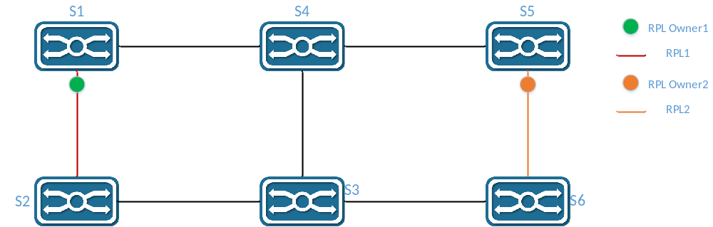

3.4.2 Configure the ERPS
Ring Configuration
Select Configuration > ERPS > Ring Configuration in the navigation area to enter the ERPS Ring Configuration page as shown in Figure 3-26, The description of the ERPS Ring Configuration is described in Table 3-15.
Figure 3-26 ERPS Ring Configuration
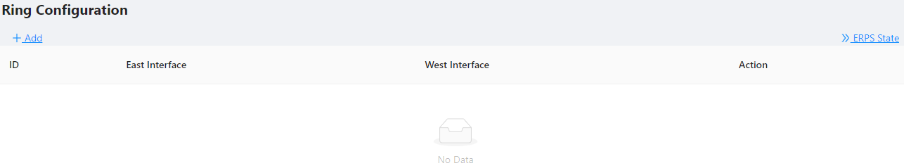
Table 3-15 Ring Configuration description
Item | Description
Ring ID | Can be any number. The ring number of each ERPS ring must be unique.
East Interface | The east interface of the ERPS ring
West Interface | The west interface of the ERPS ring
Action | Delete ERPS Ring
ERPS instance configuration
Select Configuration > ERPS > Instance Configuration to enter the ERPS instance configuration page, as shown in Figure 3-27.
Figure 3-27 ERPS Instance Configuration
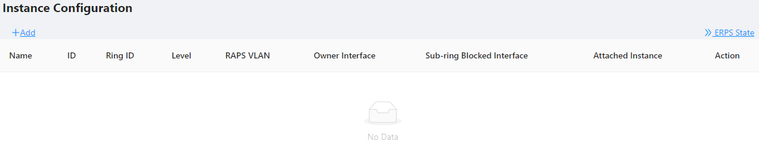
Click +Add button below “Instance Configuration” to create an erps instance, as shown in Figure 3-28. The description of the ERPS Instance Configuration summary is described in Table 3-16.

Table 3-16 Description of the ERPS Instance Configuration
Item | Description
Ring Configuration | Create a new one or Link to a ERPS ring which has been created
Ring ID | The associated ring ID must be the ring that has been created.
East Interface | The east interface of the ERPS ring
West Interface | The west interface of the ERPS ring
RAPS VLAN | Each switch in the same ring must be configured with the same RAPS management VLAN for transmitting ERPS protocol packets.  The RAPS management VLAN can be a virtual VLAN and needs to be distinguished from the data VLAN.  * It does not need to be created in 6&8 series switch, as it is created by default.
Owner interface | ERPS Owner interface can select either the east interface or the west  interface as the Owner node.  Each ERPS ring has one and only one interface configured as an RPL owner interface that controls the ports that need to be blocked.
Sub-ring Block  Interface | The subring ‘s blocked interface, one subring has only one blocking port. You can choose east or west.  This parameter needs to be configured only for the tangent ring. The sub-rings of the two devices with tangent to the ring must be configured with the sub-ring blocking port.
Attached  Instance | It only needs to be set when the sub-ring blocking port needs to be configured, and is set to the ring ID that is tangent to the current sub-ring.

Figure 3-28 ERPS Instance Configuration

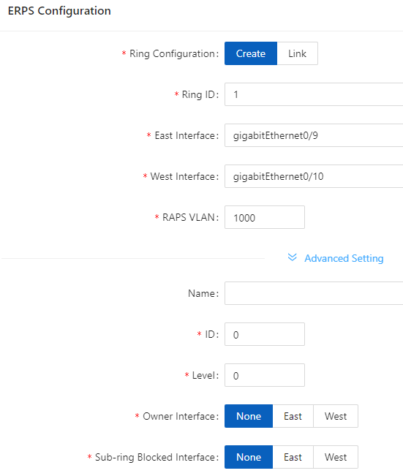
View ERPS state
Click ERPS State button to enter the ERPS State page, as shown in Figure 3-29. The description of the ERPS State summary is described in Table 3-17.
Figure 3-29 ERPS State
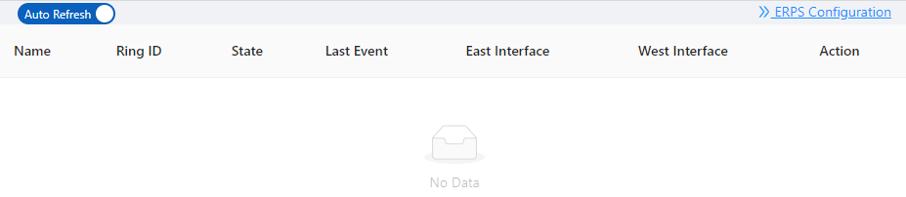
Table 3-17 ERPS state description
Item | Description
Name | The name of the ERPS ring
Ring ID | The number of the ERPS ring
State | ERPS ring status, include：  Idle：  Stable state when all non-RPL links are available. In this state, the owner node blocks the RPL port and periodically sends NR-RB packets. The neighbor node blocks the RPL port. All nodes enter the idle state after the owner node enters the idle state.  Pending：  Transient state between the previous states  Protection：  State when a non-RPL link is faulty. In this state, the RPL link is unblocked to forward traffic. All nodes enter the protection state after a node enters the protection state.
Last Event | Recent state event  RAPS-NR：remote failure recovery  RAPS-NR-RB: remote switchback  RAPS-SF：remote fault  LOCAL-SF：local fault  LOCAL-CLEAR-SF：local failure recovery  WTR-EXP：local switchback
East Interface | The east interface of the ERPS ring
West Interface | The west interface of the ERPS ring
Action | When the faulty link is restored, you can choose to manually revert immediately, otherwise the system will automatically revert after 5 minutes.

3.5 PoE Management

3.5.1 PoE Overview
Power over Ethernet (PoE) means that power sourcing equipment (PSE) supplies power to powered devices (PDs) from Ethernet interfaces through twisted pair cables.

3.5.2 PoE Configuration
NOTE
NOTE:
- 1. Before configure PoE, make sure that the PoE power supply and PSE are operating normally; otherwise, you cannot configure PoE or the configured PoE function does not take effect.
- 2. For switches with external power supply, the input voltage range is 44-57 V. In order to obtain a more stable power supply, it is recommended that the power supply voltage of AT equipment be greater than 50V, and that of BT equipment be greater than 53V.

- Select Configuration > PoE in the navigation area to enter the PoE Management page as shown in Figure
3-30, the Table 3-18 describes the items of PoE Global Configuration.
2. Type the “Power supply” and “Power reserved” boxes, and click Apply button.
Figure 3-30 PoE Global Configuration
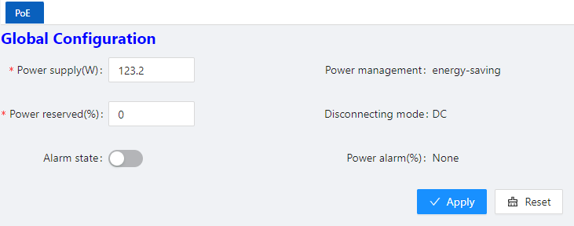
Table 3-18 description of PoE Global Configuration
Item | Description
Power supply (w) | By default, the default power provided by the device is 15.4W*port number, for example, the maximum power provided by an 8-port device is 123.2W  • For devices with external power supply, please fill in this parameter according to the actual configured power supply  • For devices with built-in power supply, please refer to the description of PoE power in the product manual for this parameter
Power reserved (%) | Reserved power set against power fluctuations  • For devices with external power supply, it is recommended to fill in the power consumption of the main board  • For devices with built-in power supply, this parameter can be set 0 by default
Power  management | Display the mode of power management is energy-saving. In this mode, the power requested and allocated to the port is based on the actual port's (real time) power consumption.
Disconnect mode | Display the mode of disconnection is DC disconnect
Alarm state | Turn on/off the log alarm when the power is insufficient
Power alarm (%) | Alarm power limit setting, when the PoE power consumption exceeds this value, the system will automatically output a log alarm
- Click Batch Edit below “port configuration” to enter PoE port configuration page, Select the port to be configured, as shown in Figure 3-31.

Figure 3-31 PoE Interface Configuration
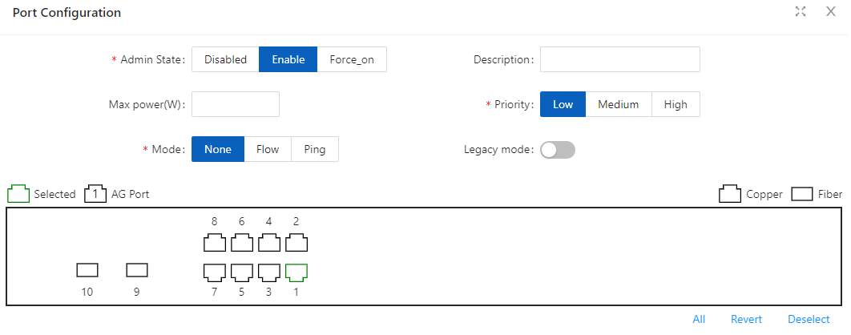
4. Click the OK to complete the operation, and then the page will return to the PoE Interface Configuration page, as shown in Figure 3-32. the Table 3-19 describes the items of the PoE Interface Configuration.
Figure 3-32 PoE Interface Configuration
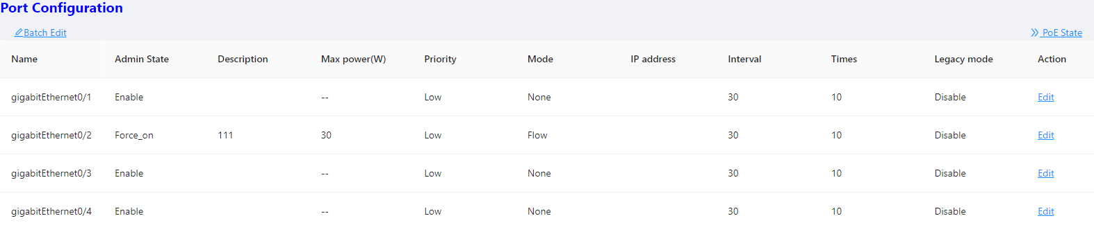
5. Click the Save in the navigation area to save the configuration.
Table 3-19 the items of the PoE Interface Configuration
Item | Description
Name | Indication panel port number
Admin State | Enable/disable PoE for the PoE Interface.  Disabled: Disable the PoE power supply of the port  Enable: Enable the Po E power supply of the port  Force_on: Forcibly turn on the PoE power supply of the port. This function is implemented  by skipping the PD valid detection and PD classification detection, and directly supply  power to the PD load. In this mode, the default maximum load power is 15w, if you need  to power the device above 15w, the maximum power parameter needs to be configured  at the same time.
Description | Description of PoE port
Max Power (W) | Configure the maximum power for this port.  For AF/AT ports, the maximum port power range is 1-30  For BT ports, the port maximum power range is 1-90  In default mode, the port will perform power management according to PD class.
Priority | Configuring the port’s priority  Users can configure the interface power supply priority of the PoE switch. The priority from high to low is: high, medium, and low.  When the overall power of the PoE switch is insufficient, the ports with lower priority will be powered off first.  The port priorities of the same priority are arranged in the order of the port number, and the priority of the port with the smaller port number is higher. For example, the priority of port 0/1 is higher than ports 0/2 and 0/3.  Newly inserted ports will not affect the power supply of PDs that are already powered which has the same priority.  Newly inserted ports which have higher priority will preempt low- priority ports.
Mode | None: Disable the PD alive detection function  Flow: Enable the PD alvie detection function in Flow mode. This function is realized by monitoring the port counter, if the port packets counter does not change, it is judged that the PD device connected to the port is in abnormal state, and then turn off the power supply for a few seconds and then turn on.  Ping: Enable the PD alive detection function in Ping mode. This function is realized by continuously pinging the PD load, if a period of time the ping packet fails during the interval, it is judged that the PD device connected to the port is in abnormal state, and the power supply is turned off for a few seconds and then turned on again.  It is recommended to use the switch diagnostics network tool ping to test whether the ping packet of the PD device can be used before enabling this function.
IP address | Ping mode, the IP address of the PD load requires that the switch and the PD load be in the same network segment.
Interval | The detection time interval
Times | The detection times  PD start up time must be less than the interval * times, otherwise the PD load will always be in the power- off and start -up state.
Legacy mode | ON/OFF, the default is OFF.  OFF: Only standard PD devices are supported, the detection resistance is between 19k-26.5k, and the detection capacitance is less than 150nF.  ON: Support non-standard PD devices, and can supply power to some PD devices whose detection resistance and capacitance values exceed the standard values.

3.6 Security

3.6.1 Port Security

3.6.1.1 Overview
The Port Security function restricts the number of valid MAC addresses on the port to limit the access of illegal users to the port. The illegal MAC packets will be directly discarded.
The legal MAC can be generated statically or dynamically. The static legal MAC is generated through user command line configuration; the dynamic legal MAC is dynamically generated through the MAC address learning function.
When the number of secure addresses on the port has reached the configured value of the maximum number of secure addresses, the new MAC access port will be recognized as an illegal MAC and a violation event will be generated. The user can configure the actions to be taken when the violation event occurs, respectively restrict or shutdown the port.
Restrict: Prohibit illegal MAC data from passing, and generate alarm log prompt information. Illegal MAC will prohibit access to the port within the MAC address aging time. It can be restored through shutdown and no shutdown ports.
Shutdown: The port is forced to be down, and the port recovery time can be configured. The port will automatically recover when the time is up; it can also be recovered by the shutdown, no shutdown command.
If you want to convert a dynamic security user to a static security user, you can enable the sticky function on the port. When the sticky function is enabled on the port, the dynamic users learned on the port will exist as static users. If the configuration is saved, the device will still exist after restarting the device.
NOTE
NOTE:
- Only support L2 port configuration port security, such as ordinary physical port, aggregation port.
- Only support port security configuration in access mode.
- Does not support aggregation port member ports to configure port security functions.
- Does not support SPAN destination port configuration port security function.
- Does not support configuring port security functions on ports that have been configured with static MAC addresses.

3.6.1.2 Configuring Port Security
Port Configuration
Select Configuration > Security > Port security in the navigation area to enter the Port security page as shown in Figure 3-33.
Figure 3-33 Port Security statistic page
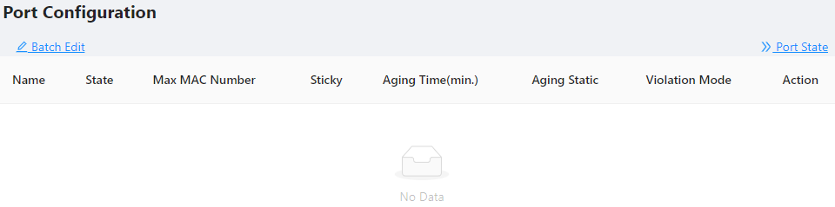
Click the Batch Edit button below “Port Configuration” to enter the Port Configuration page, as shown in Figure 3-34. The items of the port configuration are described in Table 3-20.

Figure 3-34 Port Security configuration page
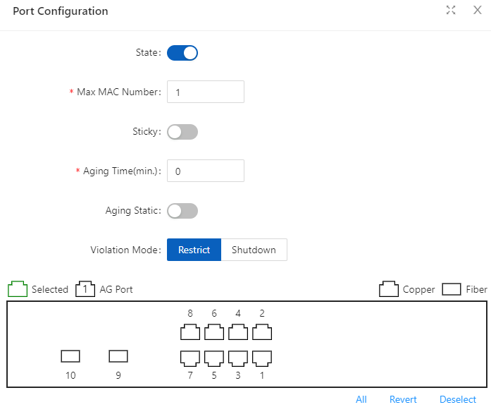
Table 3-20 the items of the port security configuration
Item |  | Description
Port  Configuration | State | Enable/disable port Security of the interface.
Port  Configuration | Max MAC Number | Configure the maximum number of secure MAC addresses for the port, the default maximum number of secure addresses is 1, the range is <1-1024>
Port  Configuration | Sticky | Turn on/off the Sticky function.
Port  Configuration | Aging  Time(min) | Configure the security address aging time, in minutes. The default aging time is 0, which means that the aging function is turned off.  Aging time range <0-1440>  The default aging function only takes effect for dynamic and sticky security addresses.
Port  Configuration | Aging Static | Enable the static security address aging function.
Port  Configuration | Violation Mode | Configure port security violation handling, default violation  mode is Restrict.  Restrict：Prohibit illegal user data from passing, and log prompt  Shutdown：shutdown interface，and resume passing after errdisable recovery time.
MAC Configuration
Select Configuration > Security > MAC Configuration in the navigation area to enter the MAC Configuration page as shown in Figure 3-35.

Figure 3-35 MAC configuration summary
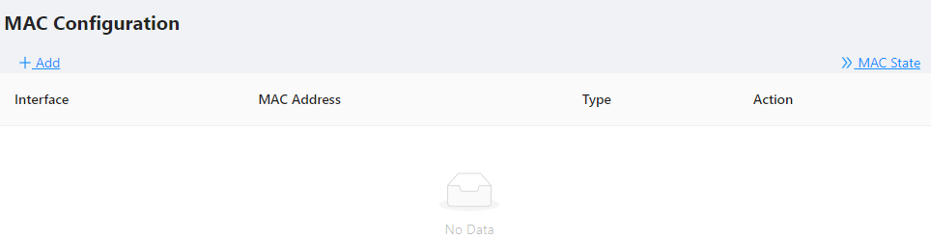
Click +ADD to enter the page of MAC Configuration page as shown in Figure 3-36. The items of the mac configuration are described in Table 3-21.
Figure 3-36 MAC configuration page
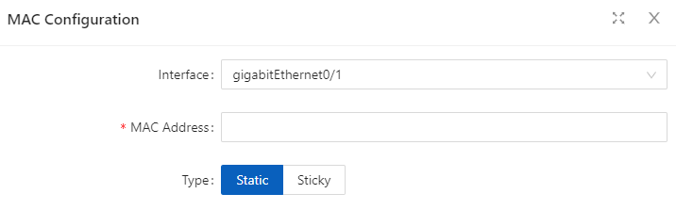
Table 3-21 the items of the mac configuration
Item |  | Description
MAC  Configuration | Interface | Select the interface to be configured.
MAC  Configuration | MAC Address | Configure a static security address, the format of the security address: XXXX.XXXX.XXXX  The security address cannot be a broadcast or multicast Address.
MAC  Configuration | Type | Configure the MAC address as dynamic or static.

3.6.2 IP Source Guard

3.6.2.1 Overview
IP Source Guard：
The Ip Source Guard binding function allows IP packets conforming to the IP+MAC binding to pass through the port, and non-conforming packets are directly discarded, thereby achieving the purpose of preventing IP/MAC spoofing attacks.
The binding entries of Ip Source Guard mainly come from two sources: user static configuration and dynamic acquisition in the ip dhcp snooping environment.
User static configuration: mainly for host users whose IP addresses are statically configured in the local area network.
Ip dhcp snooping dynamic acquisition: mainly respond to the host users who dynamically acquire the IP address through dhcp in the local area network.
IP/MAC spoofing attack: Illegal MAC users send IP packets with legal source IP to realize the legalization of access identity.

ARP Check：
The Arp-check (ARP packet check) function filters all ARP packets under the port and discards all illegal ARP packets, which can effectively prevent ARP spoofing in the network and improve the stability of the network.
In the device that supports the Arp-check function, the Arp-check function can generate corresponding ARP filtering information based on the legal user information (IP+MAC) generated by the security application modules such as IP Source Guard, so as to realize the illegal ARP packets filtering in the network.

3.6.2.2 Configuring IP Source Guard
1. Select Configuration > Security > IP Source Guard in the navigation area to enter the IP Source Guard Summary page as shown in Figure 3-37.
Figure 3-37 IP source guard Summary
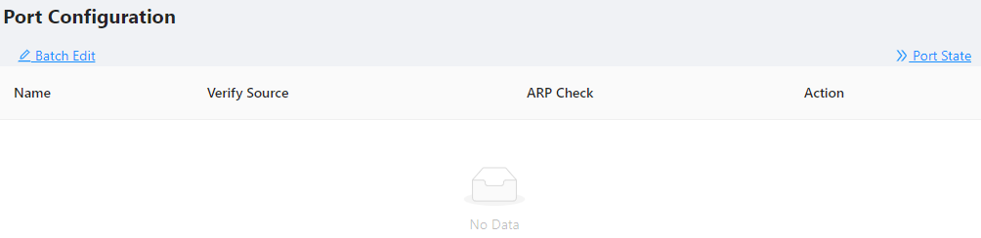
2. Click Batch Edit button below “Port Configuration” in the current page, select the interface to be configured in the port panel, click Verify Source button, as shown in Figure 3-38.
Figure 3-38 IP source guard port configuration
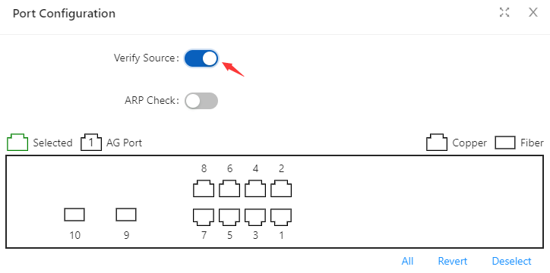
Click OK button, the rules created were displayed in summary page as shown in Figure 3-39.

Figure 3-39 port configuration
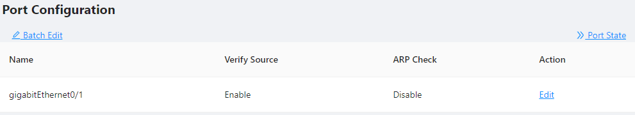
3. Click +ADD button below “User Configuration” in current page, to enter the user configuration page, Select the port in the interface box, text VID, IP Address, MAC Address, as shown in Figure 3-40.
Figure 3-40 IP source guard user configuration
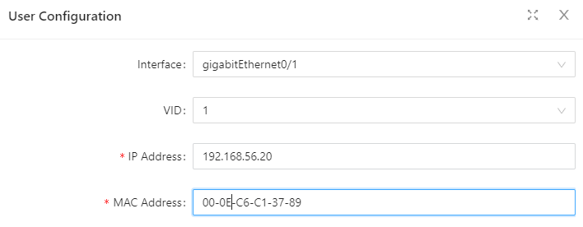
4. Click OK button, the rules created were displayed in summary page as shown in Figure 3-41.
Figure 3-41 IP source guard rules Summary
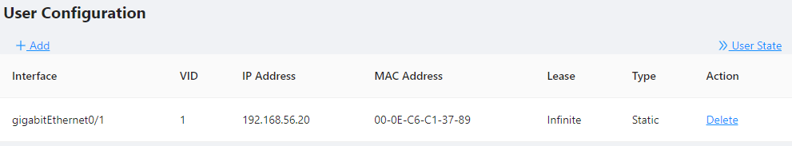

3.6.2.3 Configuring ARP Check
1. Select Configuration > Security > IP Source Guard in the navigation area to enter the IP Source Guard Summary page as shown in Figure 3-37.
2. Click Batch Edit button below “Port Configuration” in the current page, select the interface to be configured in the port panel, click ARP Check button, as shown in Figure 3-42.

Figure 3-42 IP Source Guard ARP Check
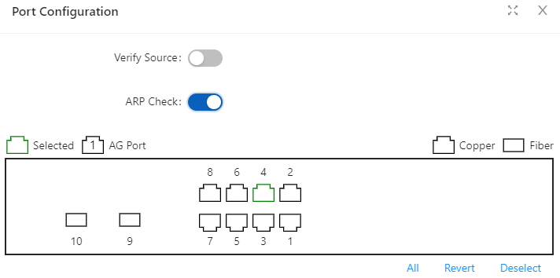
3. Click +ADD button below “User Configuration” in current page, to enter the user configuration page, as shown in Figure 3-43.
Figure 3-43 IP Source Guard User Configuration
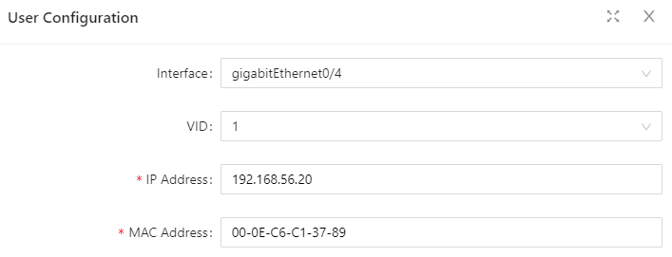
4. Click APPLY button, the rules created were displayed in summary page as shown in Figure 3-44.
Figure 3-44 ARP Check rules
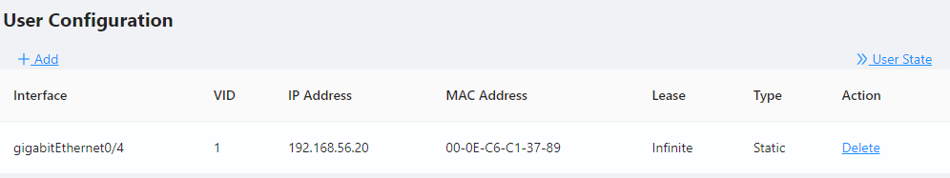

3.6.3 Dot1X

3.6.3.1 Overview
The 802.1X(Dot1X) protocol was proposed by the IEEE 802 LAN/WAN committee for security of wireless LANs (WLAN). It has been widely used on Ethernet as a common port access control mechanism.
As a port-based access control protocol, 802.1X authenticates and controls accessing devices at the port level. A device connected to an 802.1X-enabled port of an access control device can access the resources on the LAN only after passing authentication.

Architecture of 802.1X
802.1X operates in the typical client/server model and defines three entities: Client, Device, and Server, as shown in below.
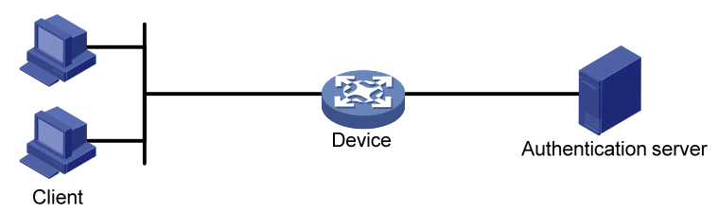
• Client is an entity seeking access to the LAN. It resides at one end of a LAN segment and is authenticated by Device at the other end of the LAN segment. Client is usually a user-end device such as a PC. 802.1X authentication is triggered when an 802.1X-capable client program is launched on Client. The client program must support Extensible Authentication Protocol over LAN (EAPOL).
• Device, residing at the other end of the LAN segment, authenticates connected clients. Device is usually an 802.1X-enabled network device and provides access ports (physical or logical) for clients to access the LAN.
• Server is the entity that provides authentication services to Device. Server, normally running RADIUS (Remote Authentication Dial-in User Service), serves to perform authentication, authorization, and accounting services for users.
Authentication modes of 802.1x
The 802.1X authentication system employs the Extensible Authentication Protocol (EAP) to exchange authentication information between the client, device, and authentication server. Client Device Server
• Between the client and the device, EAP protocol packets are encapsulated using EAPOL to be transferred on the LAN.
• Between the device and the RADIUS server, EAP protocol packets can be exchanged in two modes: EAP relay and EAP termination. In EAP relay mode, EAP packets are encapsulated in EAP over RADIUS (EAPOR) packets on the device, and then relayed by device to the RADIUS server. In EAP termination mode, EAP packets are terminated at the device, converted to RADIUS packets either with the Password Authentication Protocol (PAP) or Challenge Handshake Authentication Protocol (CHAP) attribute, and then transferred to the RADIUS server.
Basic concepts of 802.1x
These basic concepts are involved in 802.1X: controlled port/uncontrolled port, authorized state/unauthorized state, and control direction.
Controlled port and uncontrolled port
A device provides ports for clients to access the LAN. Each port can be regarded as a unity of two logical ports: a controlled port and an uncontrolled port. Any packets arriving at the port are visible to both logical ports.
• The uncontrolled port is always open in both the inbound and outbound directions to allow EAPOL protocol packets to pass, guaranteeing that the client can always send and receive authentication packets.
• The controlled port is open to allow data traffic to pass only when it is in the authorized state.
Authorized state and unauthorized state

Figure 3-45 Authorized/unauthorized state of a controlled port
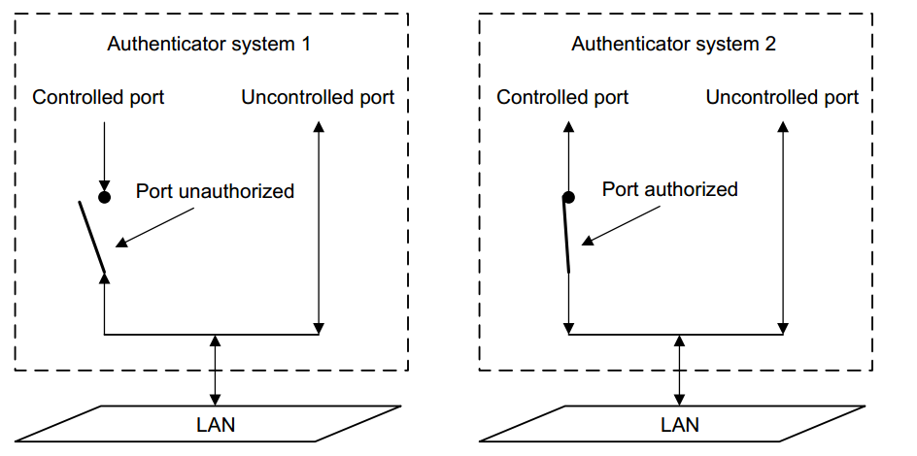
A controlled port can be in either authorized state or unauthorized state, which depends on the authentication result, as shown in Figure 3-45.
You can control the port authorization status of a port by setting port authorization mode to one of the following:
• Force-Authorized: Places the port in authorized state, allowing users of the port to access the network without authentication.
• Force-Unauthorized: Places the port in unauthorized state, denying any access requests from users of the port.
• Auto: Places the port in the unauthorized state initially to allow only EAPOL packets to pass, and turns the port into the authorized state to allow access to the network after the users pass authentication. This is the most common choice.
Control direction
In the unauthorized state, the controlled port can be set to deny traffic to and from the client or just the traffic from the client.
802.1X authentication triggering
802.1X authentication can be initiated by either a client or the device.
Unsolicited triggering of a client
A client can initiate authentication unsolicitedly by sending an EAPOL-Start packet to the device. The destination address of the packet is 01-80-C2-00-00-03, the multicast address specified by the IEEE 802.1X protocol.
Some devices in the network may not support multicast packets with the above destination address, and unable to receive authentication requests of clients as a result. To solve this problem, the device also supports EAPOL-Start packets using a broadcast MAC address as the destination address.
Unsolicited triggering of the device
The device can trigger authentication by sending EAP-Request/Identity packets to unauthenticated clients periodically (every 30 seconds by default). This method can be used to authenticate clients that cannot send EAPOL-Start packets unsolicitedly to trigger authentication, for example, a client running the 802.1X client application provided by Windows XP.

Authentication process of 802.1x
An 802.1X device communicates with a remote RADIUS server in two modes: EAP relay and EAP termination. The following describes the 802.1X authentication procedure in the two modes, which is triggered by the client in the examples.
EAP relay
EAP relay is defined in IEEE 802.1X. In this mode, EAP packets are carried in an upper layer protocol, such as RADIUS, so that they can go through complex networks and reach the authentication server. Generally, relaying EAP requires that the RADIUS server support the EAP attributes of EAP-Message and Message-Authenticator, which are used to encapsulate EAP packets and protect RADIUS packets carrying the EAPMessage attribute respectively.
Figure 3-46 shows the message exchange procedure with EAP-MD5
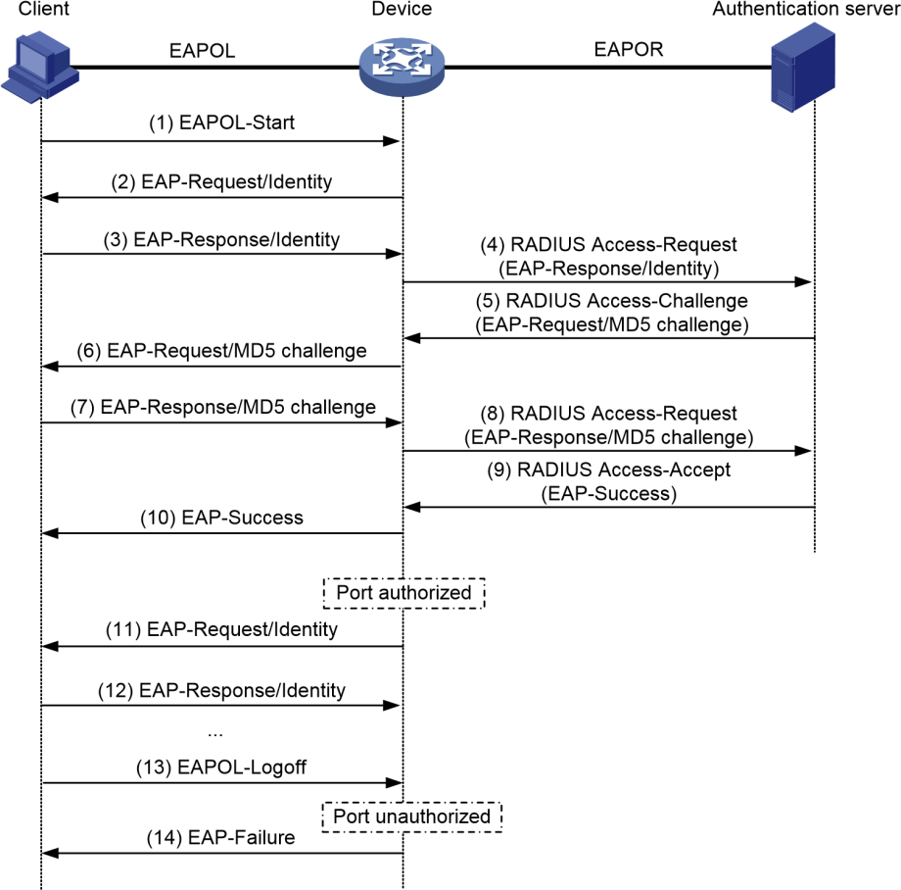
1. When a user launches the 802.1X client software and enters the registered username and password, the 802.1X client software generates an EAPOL-Start frame and sends it to the device to initiate an authentication process.
2. Upon receiving the EAPOL-Start frame, the device responds with an EAPRequest/Identity packet for the username of the client.
3. When the client receives the EAP-Request/Identity packet, it encapsulates the username in an EAP-Response/Identity packet and sends the packet to the device.
4. Upon receiving the EAP-Response/Identity packet, the device relays the packet in a RADIUS Access-Request packet to the authentication server.
5. When receiving the RADIUS Access-Request packet, the RADIUS server compares the identify information against its user information table to obtain the corresponding password information. Then, it encrypts the password information using a randomly generated challenge, and sends the challenge information through a RADIUS Access-Challenge packet to the device.
6. After receiving the RADIUS Access-Challenge packet, the device relays the contained EAP-Request/MD5 Challenge packet to the client.
7. When receiving the EAP-Request/MD5 Challenge packet, the client uses the offered challenge to encrypt the password part (this process is not reversible), creates an EAP-Response/MD5 Challenge packet, and then sends the packet to the device.
8. After receiving the EAP-Response/MD5 Challenge packet, the device relays the packet through a RADIUS Access-Request packet to the authentication server.
9. When receiving the RADIUS Access-Request packet, the RADIUS server compares the password information encapsulated in the packet with that generated by itself. If the two are identical, the authentication server considers the user valid and sends to the device a RADIUS Access-Accept packet.
10. Upon receiving the RADIUS Access-Accept packet, the device opens the port to grant the access request of the client. After the client gets online, the device periodically sends handshake requests to the client to check whether the client is still online. By default, if two consecutive handshake attempts end up with failure, the device concludes that the client has gone offline and performs the necessary operations, guaranteeing that the device always knows when a client goes offline.
11. The client can also send an EAPOL-Logoff frame to the device to go offline unsolicitedly. In this case, the device changes the status of the port from authorized to unauthorized and sends an EAP-Failure packet to the client.

3.6.3.2 Configuring Dot1X
Select Security > Dot1x> Configuration from the navigation area. The system automatically displays the 802.1X Global Configuration and Port Configuration, as shown in Figure 3-47 and Figure 3-48. Table 3-22 and Table 3-23 describes the Global Configuration and Port Configuration items.
Figure 3-47 802.1X Global Configuration
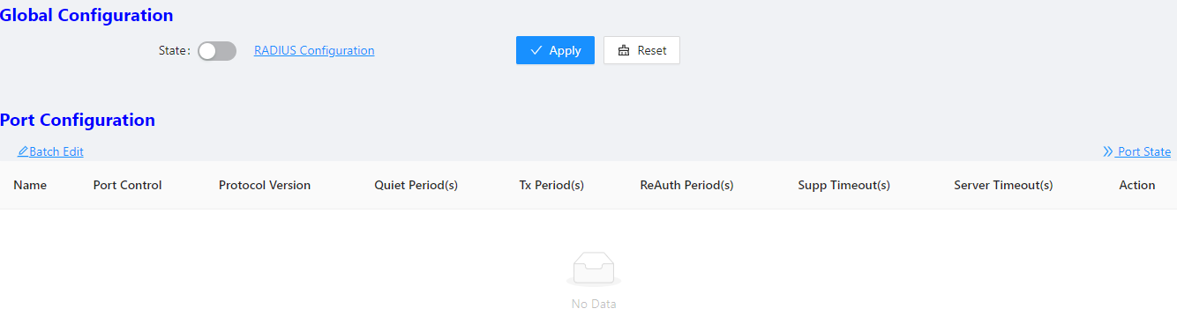
Table 3-22 The 802.1X Configuration items
Item |  | Description
Global  Configuration | State | Enables the 802.1X feature on your switch.
Global  Configuration | RADIUS  Configuration | Click to jump to the RADIUS configuration interface
Figure 3-48 802.1X Port Configuration

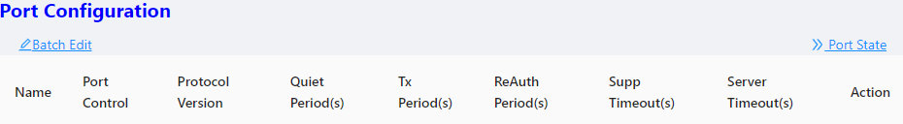

Table 3-23 The 802.1X port Configuration items
Item |  | Description
Port  Configuration | Name | Physical interface name
Port  Configuration | Port Control | Port control mode
Port  Configuration | Protocol Version | Eapol protocol version, default version 2
Port  Configuration | Quiet Period(s) | Sets the number of seconds that the switch remains in the quiet-period following a failed authentication exchange with the client. The range is 0 to 65,535 seconds; the default is 60.  When the switch cannot authenticate the client, the switch remains idle for a set period, and then tries again. The idle time is determined by the quiet-period value.
Port  Configuration | Tx Period(s) | Sets the number of seconds that the switch waits for a response to an EAP-request/identity frame from the client before retransmitting the request. The range is 1 to 65,535 seconds; the default is 30.
Port  Configuration | ReAuth Enabled | Enables periodic reauthentication of the client
Port  Configuration | ReAuth Period(s) | Specifies the number of seconds between reauthentication attempts or have the switch use a RADIUS-provided session timeout. The range is 1 to 65,535; the default is 3600 seconds. This command affects the behavior of the switch only if periodic reauthentication is enabled.
Port  Configuration | Supp Timeout(s) | Sets the number of seconds that the switch waits for a response to an EAP-Request/MD5 Challenge frame from the client before retransmitting the request. The range is 1 to 65,535 seconds; the default is 30.
Port  Configuration | Server Timeout(s) | Sets the number of seconds that the switch waits for a response to a RADIUS Access-Request packet from the server. The range is 1 to 65,535 seconds; the default is 30.

3.6.4 MAC Auth

3.6.4.1 Overview
Authentication of MAC addresses is supported using a RADIUS server that contains a database of all valid users.
When the mac-auth option is enabled on any interface, all source MAC addresses from any incoming frame are sent for authentication. If the username and password of the source address are configured in the RADIUS server, then authentication succeeds, otherwise it fails. When authentication succeeds, the source MAC is added to the forwarding table with forwarding enabled. In the case of failure, the source MAC either is added to the forwarding table as discarded or is added to a restricted VLAN.
NOTE
NOTE:
- If the configured static MAC is the same as the silent MAC, the MAC silent function after the MAC address authentication fails will be invalid.

3.6.4.2 Configuring MAC authentication
Displaying MAC Authentication Summary
Select Configuration > Security > MAC Authentication from the navigation area. The system automatically displays the MAC Authentication summary, as shown in Figure 3-49. Table 3-24 describes the MAC Authentication Summary items.

Figure 3-49 The MAC Authentication Summary
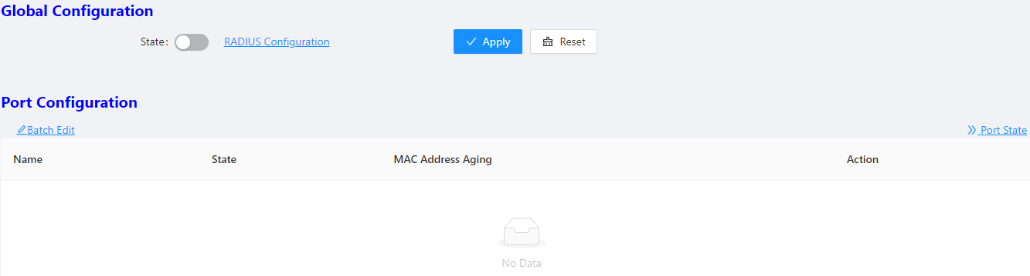
Table 3-24 The MAC Authentication Summary items
Item |  | Description
Global  Configuration | State | Enables the 802.1X feature on your switch.
Global  Configuration | RADIUS  Configuration | Click to jump to the RADIUS configuration interface
Port  Configuration | Name | Physical interface name
Port  Configuration | State | Display the state of MAC Auth
Port  Configuration | MAC Address Aging | Display the state of MAC Address Aging
Port  Configuration | Action | Click to Edit the rule
Configuring MAC Authentication
- Enable MAC Auth
Select Configuration > Security > MAC Authentication from the navigation area. Click Statebutton in “Global Configuration”, click Apply button to enable the MAC Auth function.
- Configuring Port
Click Batch Edit button below “Port Configuration” to enter the port configuration page, as shown in Figure
3-50. Click State button, select the port to be configured in port panel, click Ok button.
Figure 3-50 MAC Authentication Port Configuration
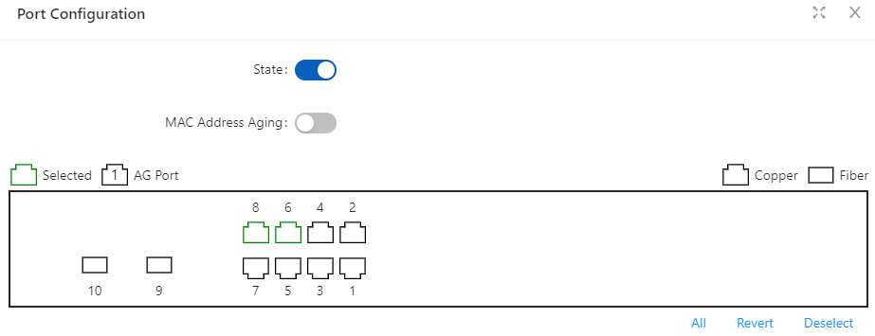

3.6.5 RADIUS

3.6.5.1 Overview
Remote Authentication Dial-In User Service (RADIUS) is protocol for implementing Authentication, Authorization, and Accounting (AAA).
RADIUS is a distributed information interaction protocol using the client/server model. RADIUS can protect networks against unauthorized access and is often used in network environments where both high security and remote user access are required. RADIUS uses UDP, and its packet format and message transfer mechanism are based on UDP. It uses UDP port 1812 for authentication and 1813 for accounting.
RADIUS was originally designed for dial-in user access. With the diversification of access methods, RADIUS has been extended to support more access methods, for example, Ethernet access and ADSL access. It uses authentication and authorization in providing access services and uses accounting to collect and record usage information of network resources.
Client/server model
• Client: The RADIUS client runs on the NASs located throughout the network. It passes user information to designated RADIUS servers and acts on the responses (for example, rejects or accepts user access requests).
• Server: The RADIUS server runs on the computer or workstation at the network center and maintains information related to user authentication and network service access. It listens to connection requests, authenticates users, and returns the processing results (for example, rejecting or accepting the user access request) to the clients.
In general, the RADIUS server maintains three databases: Users, Clients, and Dictionary, as shown in Figure 4-39.
Figure 4-39 RADIUS server components
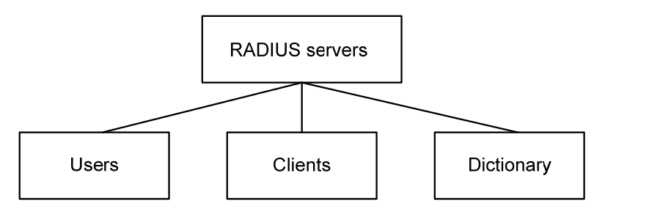
• Users: Stores user information such as the usernames, passwords, applied protocols, and IP addresses.
• Clients: Stores information about RADIUS clients, such as the shared keys and IP addresses.
• Dictionary: Stores information about the meanings of RADIUS protocol attributes and their values.
Security and authentication mechanisms
Information exchanged between a RADIUS client and the RADIUS server is authenticated with a shared key, which is never transmitted over the network. This enhances the information exchange security. In addition, to prevent user passwords from being intercepted on insecure networks, RADIUS encrypts passwords before transmitting them.
A RADIUS server supports multiple user authentication methods, for example, the Password Authentication Protocol (PAP) and Challenge Handshake Authentication Protocol (CHAP) of the Point-to-Point Protocol (PPP). Moreover, a RADIUS server can act as the client of another AAA server to provide authentication proxy services.
Basic message exchange process of RADIUS
Figure 3-51 illustrates the interaction of the host, the RADIUS client, and the RADIUS server.

Figure 3-51 Basic message exchange process of RADIUS
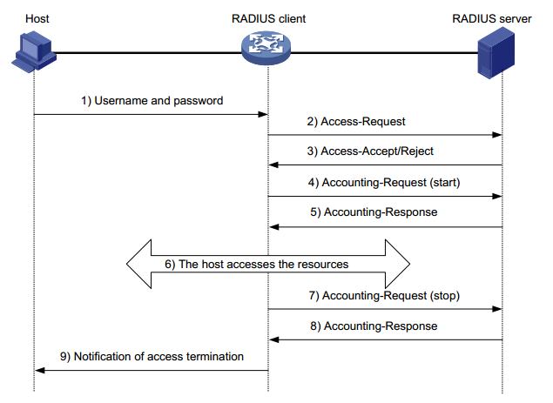
The following is how RADIUS operates:
1. The host initiates a connection request carrying the username and password to the RADIUS client.
2. Having received the username and password, the RADIUS client sends an authentication request (Access-Request) to the RADIUS server, with the user password encrypted by using the Message-Digest 5 (MD5) algorithm and the shared key.
3. The RADIUS server authenticates the username and password. If the authentication succeeds, it sends back an Access-Accept message containing the user ‘s authorization information. If the authentication fails, it returns an Access-Reject message.
4. The RADIUS client permits or denies the user according to the returned authentication result. If it permits the user, it sends a start-accounting request (Accounting-Request) to the RADIUS server.
5. The RADIUS server returns a start-accounting response (Accounting-Response) and starts accounting.
6. The user accesses the network resources.
7. The host requests the RADIUS client to tear down the connection and the RADIUS client sends a stop-accounting request (Accounting-Request) to the RADIUS server.
8. The RADIUS server returns a stop-accounting response (Accounting-Response) and stops accounting for the user.
9. The user stops access to network resources
NOTE
NOTE:
- Do not support RADIUS accounting function

3.6.5.2 Configuring RADIUS
RADIUS global configuration
Select Configuration > Security > RADIUS from the navigation area. The system automatically displays the RADIUS Global Configuration, as shown in Figure 3-52. Table 4-19 describes the RADIUS Global Configuration items.
Figure 3-52 The RADIUS Global Configuration
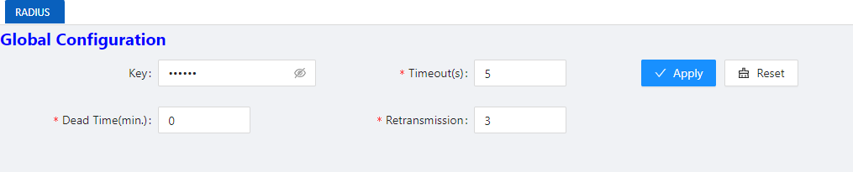
Table 4-19 The RADIUS Global Configuration items
Item |  | Description
Global  Configuration | Key | Global default password configuration; configurable, unreadable; optional configuration
Global  Configuration | Timeout | Global server timeout; optional configuration
Global  Configuration | Retransmission | Global server retransmissions; optional configuration
Global  Configuration | Dead Time | Server death duration; optional configuration; default 0, indicating that the server will be revived immediately after death
RADIU Server configuration
Click +Add button below Server Configuration in current page to enter the configuration page, as shown in Figure 3-53. Table 4-20 describes the RADIUS Server Configuration items.
Table 4-20 The RADIUS Server Configuration items
Item | Description
IP | Server IP address
Auth Port | Server authentication port number; default 1812
Key | Server key; global configuration when not configured
Timeout | Server timeout; default 5s
Retransmission | Server retransmission times, default 3 times

Figure 3-53 The RADIUS Server Configuration
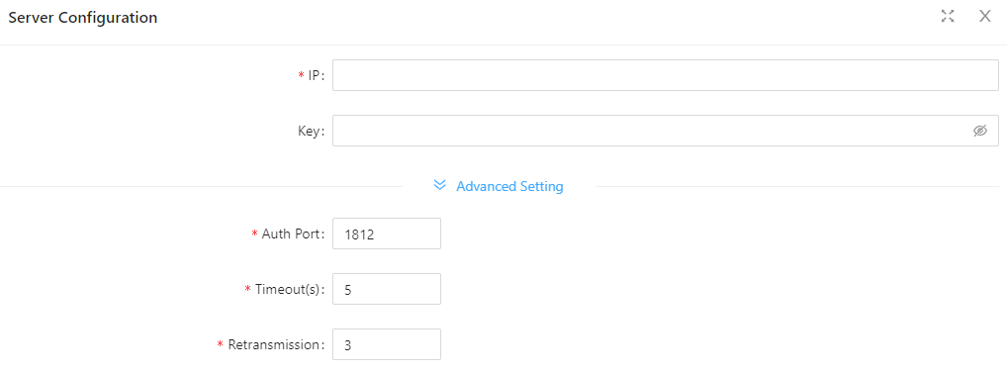

3.7 Control

3.7.1 Serial Servers

3.7.1.1 Overview
The serial device server is used to connect serial devices to the Ethernet. The serial device server supports bidirectional conversion and transmission of network data and serial data. Serial device server work in tcp-client mode, as shown in Figure 3-53.
Figure 3-53 Serial device server work in tcp-client mode
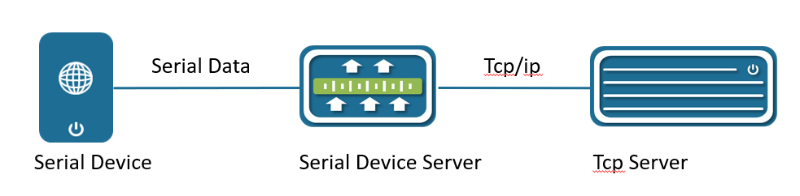
Serial device server in tcp-client mode provides client connections for TCP network servers. it actively initiates a connection and connect to the server to realize the interaction between serial device and tcp server. The Tcp/Ip and serial data are transparently transmitted in both directions. The serial device server supports to establish multiple TCP Clients to connect to different Tcp Server. Serial device server work in tcp-server mode, as show in Figure 3-54.
In TCP Server mode, the module monitors the local port, accepts and establishes a connection for data communication when a connection request is sent. Used for communication with TCP clients within a local area network. It is suitable for scenarios where there is no server in the LAN and there are multiple computers or mobile phones requesting data from the module.

Figure 3-54 Serial device server work in tcp-server mode
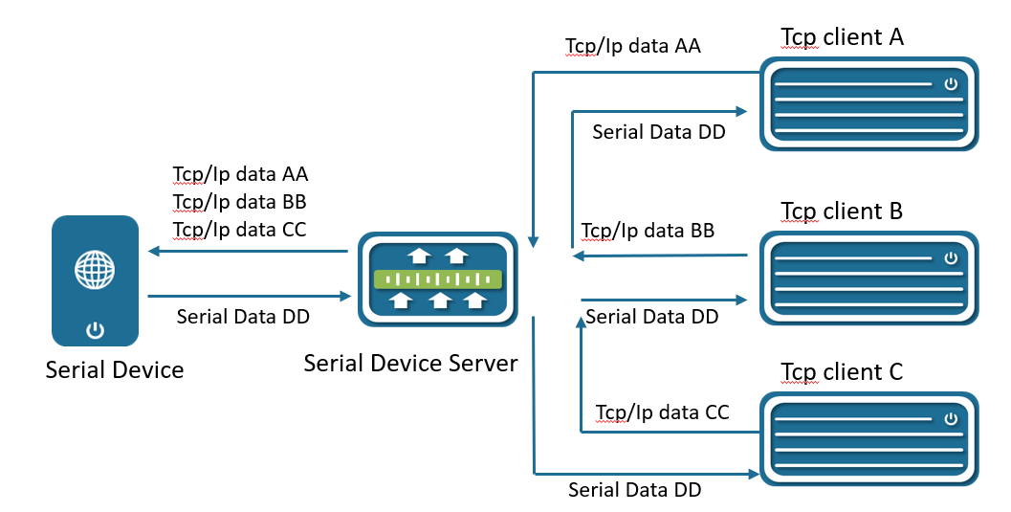

3.7.1.2 Configuring Serial Server
Select Configuration > Control > Serial Server from the navigation area. The system automatically displays the Serial Server Configuration page, as shown in Figure 3-55.
Figure 3-55 Serial Server Configuration Summary
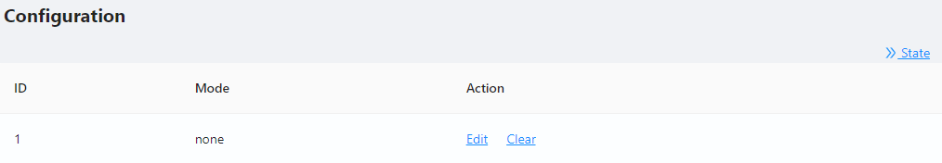
Click Edit button to enter Serial Server Configuration page, as shown in Figure 3-56. Table 3-25 describes the Serial Server Configuration items.

Figure 3-56 Serial Server Configuration
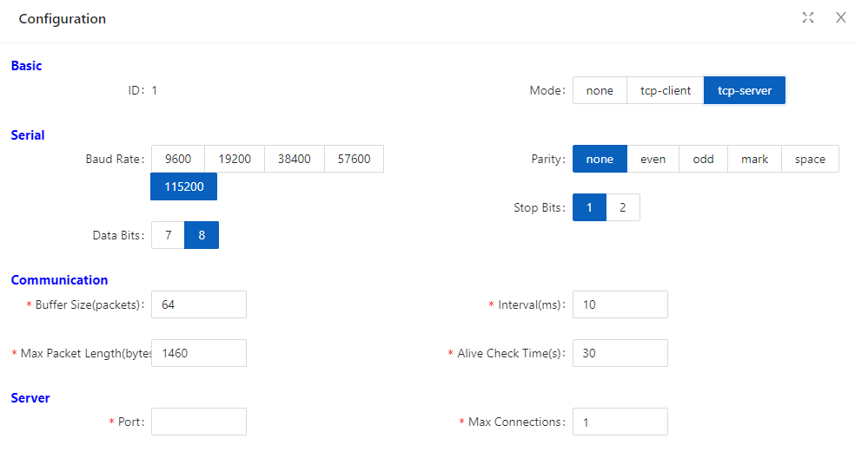
Table 3-25 Serial Server Configuration items
Item |  | Description
Basic | ID | Serial port number
Mode | None | Shut down the serial port server
Mode | tcp-client | Configure the working mode to tcp-client
Mode | tcp-server | Configure the working mode to tcp-server
Serial | Baud Rate | The baud rate of the serial port is configured, and there are five kinds of options: 9600, 19200, 38400, 57600, and 115200
Serial | Data Bits | The data bits of the serial port are configured, and there are two kinds of options: 7 and 8
Serial | Parity | There are five types of configuration checksum methods: none, even, odd, mark, and space
Serial | Stop Bits | There are two options for configuring the stop bit, 1 and 2
Communication | Buffer size | Serial port data bits are transmitted at low speed, and the data is transferred from the network end to the serial port side to increase the fifo, improve the forwarding ability, the range < 0-128>, the default 64
Communication | Max packet  Length | The length of the serial port data packet, beyond the LEGGTH value, the packet is forwarded to the network end, the range <0-1460>, the default is 1460
Communication | Interval | If the interval between the bytes before and after the serial port data exceeds MILLISECONDS, the post-byte data is recognized as the new message header byte  The range < 1-1000 >, the default is 10ms
Communication | Alive check time | Configure the serial port server to keep alive, during which there is no data interaction, then active detection is initiated
Client | Remote IP | Configure the remote connection IP address
Client | Remote port | Configure the port number for the remote connection, ranging from < 1-65535>
Client | Local port | For optional configurations, the default system is automatically assigned
Server | Port | Configure the tcp-server port number, which < range from 1-65535>
Server | Max connections | The maximum number of connections in tcp-server mode, ranging from 1 to 65535 >

3.7.2 IO Control
IO control module is divided into DI, DO two parts. In current software, DO only supports simple manual control relay (DO) ON/OFF switching function, as shown in Figure 3-57. DI only supports input level high and low judgment, as shown in Figure 3-58.
Figure 3-57 DI Configuration page
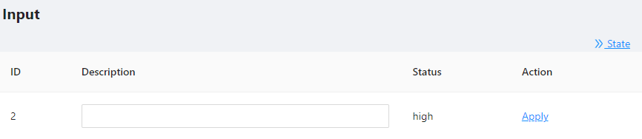
Figure 3-58 DO Configuration page
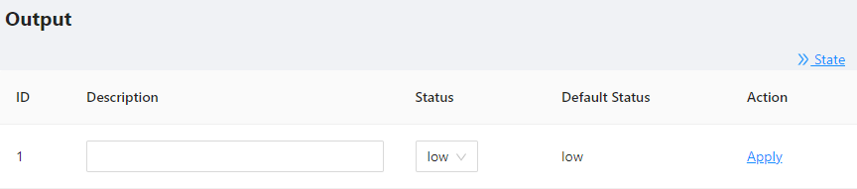

3.8 LoopDetect

3.8.1 Overview
LOOP-DETECT is an Ethernet loop detection protocol, which is used to quickly detect loop faults on downlink interfaces. If a fault is found, LOOP-DETECT will notify the user to manually close or automatically close the relevant port according to the fault handling method configured by the user, so as to avoid affecting the normal data exchange.
Enable control: Enable control is divided into global enable control and port enable control. When the global enable control is enabled and the loop detection is enabled on the port, the port supports the loop detection function.
Loop action: When a loop fault is detected on the port, the user will be notified to manually handle the loop fault by default, and the automatic closing of the port can also be configured. When the port is automatically shut down, the port can recover from the fault by waiting for timeout, shutdown/no shutdown port, recovery command, or restarting the device.
Specify vlan: By default, the port vlan attribute is ignored; if you need to detect whether a loop fault occurs in a specific vlan domain, you can configure the specified vlan on the port, and only detect Whether there is a loop data path in this vlan domain.
The device supports loop fault alarm and loop fault recovery message traps to the snmp server, which is disabled by default.

3.8.2 Configuring LoopDetect
LoopDetect Configuration
1. Select Configuration > LoopDetect in the navigation area to enter the loopdetect page. This page contains two parts: "Global Configuration" and "Port Configuration".
2. Turn on the loop detection switch in the global configuration page, configure the detection
interval, turn on the Trap switch (optional), and click the Apply button to complete theconfiguration, as shown in Figure 3-59, the Table 3-26 describes the items of PoE Global Configuration.
Figure 3-59 LoopDetect Global Configuration

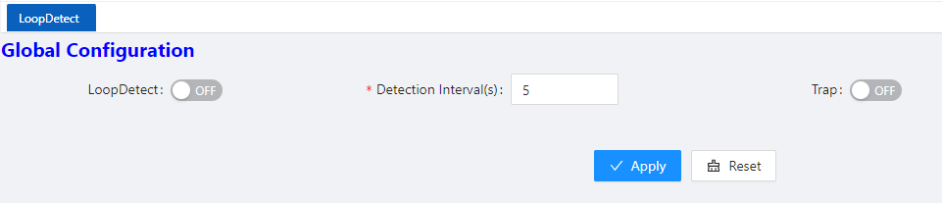
Table 3-26 Loop detection global configuration items
Items | Description
Loop detection | Turn on/off the loop detection function. The default is to turn off globally and the port.
Detection interval | Configure loop detection interval, range 5-300 seconds, default 5 seconds
Trap | Enable/disable loop fault trap alarm
3. Click the Batch Edit button under "Port Configuration" or the Edit button behind the port that needs to be configured to enter the loop detection port configuration interface, configure the management status, violation handling method, VLAN domain detection, and select the required. The port that enables this function is shown in Figure 3-60, and the parameter description is shown in Table 3-27.

Figure 3-60 LoopDetect Port Configuration
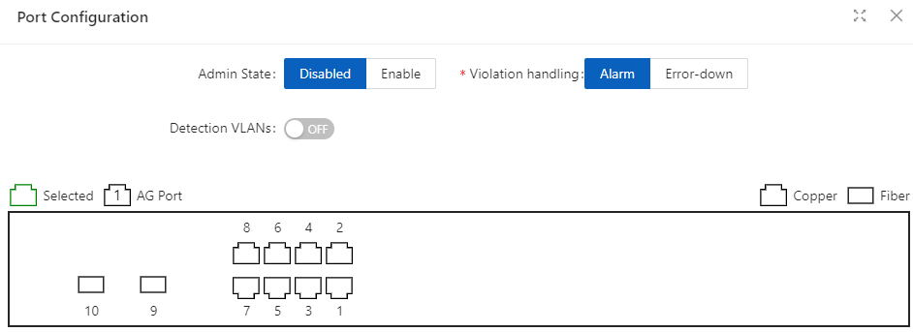
Table 3-27 Loop detection port configuration items
Items | Description
Admin State | Enable: Enable the loop detection function of the port  Disabled: Turn off the loop detection function of the port
Violation handling | Alarm: Trap alarm when a loop occurs  Error-down: When a loop occurs, shut down the loop port.
Detection VLANs | Detect whether a data path loop occurs within the specified vlan domain

4 Advance

4.1 LLDP

4.1.1 Overview
In a heterogeneous network, a standard configuration exchange platform ensures that different types of network devices from different vendors can discover one another and exchange configuration.
The Link Layer Discovery Protocol (LLDP) is specified in IEEE 802.1AB. The protocol operates on the data link layer to exchange device information between directly connected devices. With LLDP, a device sends local device information as TLV (type, length, and value) triplets in LLDP Data Units (LLDPDUs) to the directly connected devices. Local device information includes its system capabilities, management IP address, device ID, port ID, and so on. The device stores the device information in LLDPDUs from the LLDP neighbors in a standard MIB. LLDP enables a network management system to quickly detect and identify Layer 2 network topology changes.
NOTE
NOTE:
- TLV for PoE-related sections is not supported.

4.1.2 Configuring LLDP
LLDP global Configuration
Select Advance > Layer2 > LLDP Configuration in the navigation area to enter the Global Configuration page, as shown in Figure 4-1. Table 4-1 describes the Global Configuration items.
1. Click enable button behind “Status”.
2. Type the boxes behind of the “System Name” and “Description”.
3. Click Apply button to enable LLDP Configuration.

Figure 4-1 LLDP Global Configuration
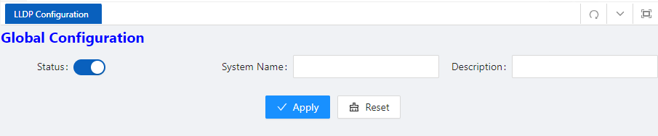
Table 4-1 LLDP Global Configuration Items
Item | Description
Status | Disabled: global disable  Enabled: global enable
System Name | The name of the device, can be empty
Description | Description of the system, can be empty
Apply | Click to enable
LLDP port setting
1. The LLDP port configuration page appears after global configuration was enabled, as shown in Figure 4-2.

Figure 4-2 LLDP port configuration status
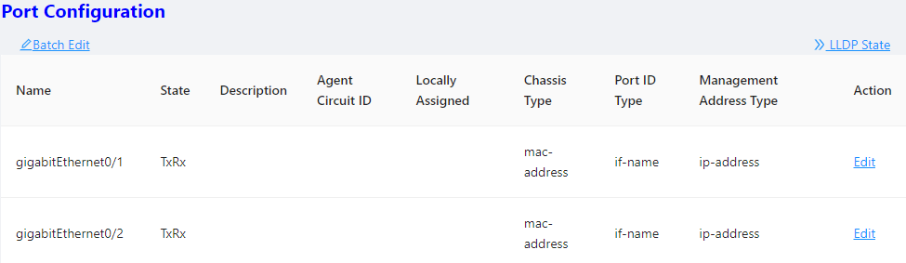
2. Click Batch Edit button below “port configuration” or Edit button correspond of the port to enter the page for configuring ports, as shown in Figure 4-3. Table 4-2 describes the configuration items of configuring ports.

Figure 4-3 LLDP port status
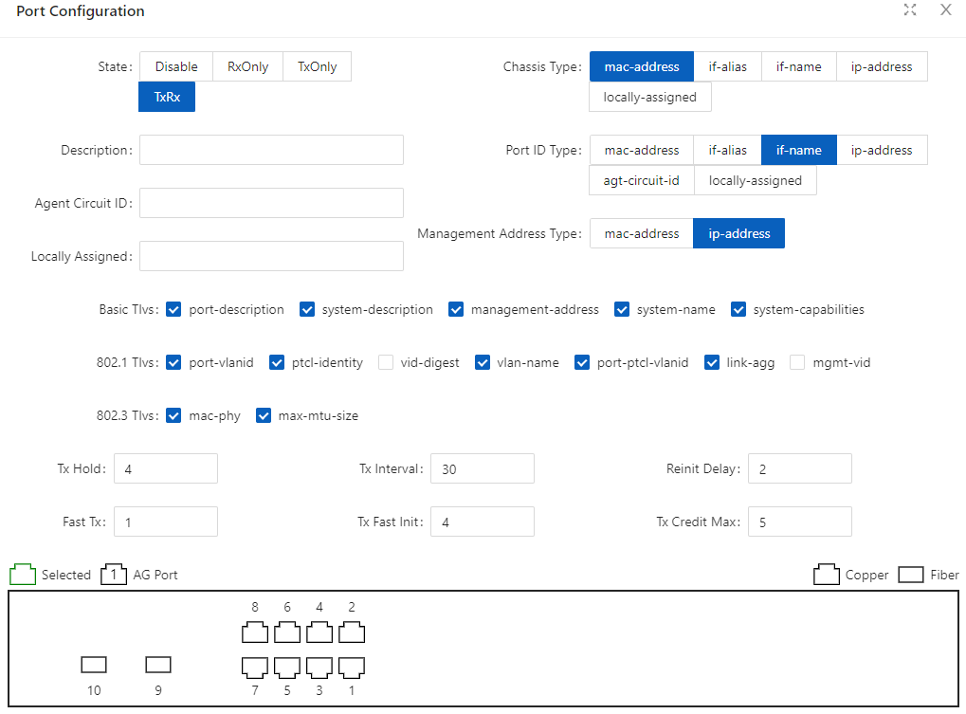
Table 4-2 LLDP port Configuration Items
Item | Description
Description | Description of the currently configured LLDP port
Agent Circuit ID | Agent circuit identification. Can be used as a value for port-id-tlv
Locally Assigned | Locally Assigned
Admin Status | Disabled: No LLDP packets are sent/receive on the interface  TxOnly: LLDP packets are sent on the interface  RxOnly: LLDP packets are received on the interface  TxRx: LLDP packets are sent/receive on the interface
Chassis Subtype | Mac-address: indicates the MAC address  If-alias: Indicates the interface alias  If-name: indicates the interface name  Ip-address: Indicates the IP address  Locally-assigned: indicates local configuration
Port ID Subtype | Mac-address: indicates the MAC address  If-alias: Indicates the interface alias  If-name: indicates the interface name  Ip-address: Indicates the IP address  Agt -circuit-id: Indicates the agt-circuit-id  Locally-assigned: indicates locally-assigned value
Management  Address Subtype | Mac-address: Device MAC address  Ip-address: Device IP address
Basic Tlvs | port-description: port descriptor  system-description: system descriptor  management-address: management address  system-name: system name  system-capabilities: system capabilities
802.1 Tlvs | port-vlanid: port's vlanid  ptcl -identity: protocol id  vid-digest: vid digest  vlan-name: vlan name  port-ptcl - vlanid: port protocol vlanid  link- agg mgmt -vid: Link Aggregation Management vid
802.3 Tlvs | mac-phy: The rate and duplex status supported by the port, whether it supports port rate auto-negotiation, whether the auto-negotiation function is enabled, and the current rate and duplex status  max - mtu -size: maximum mtu value
Tx hold | Transmission hold, the default value txFastInit is 4, used for packet TTL calculation; TTL= msgTxInterval * msgTxHold + 1
Tx interval | Transfer intervals, default is 30 s; admin can change this value to any value between5and 300.
Reinit delay | Indicates the amount of delay between when adminStatus becomes ' disabled' and when reinitialization is attempted. The default value of reinitDelay is 2 s.
Fast tx | Defines the time interval for the timer interval between two transfers within a fast transfer period (ie txFast is not zero). The default value for msgFastTx is 1; administrators can change this value to any value between 1 and 3600.
Tx fast init | This variable is used as the initial value of the txFast variable. This value determines the number of LLDPDUs transmitted during the fast transmission period.
Tx credit max | Configure the maximum value of txCredit. The default value is 5. Administrators can change this value to any value in the range 1 to 10.
View LLDP State
In the current page, click the LLDP State button on the right to enter the LLDP state page, as shown in Figure 4-4, and the specific parameters are described as described in Table 4-3.
Figure 4-4 LLDP port statistics
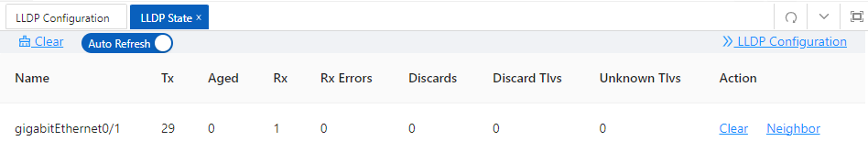
Table 4-3 LLDP port Configuration Items
Item | Description
Name | Description of the currently configured LLDP port
Tx | The number of packets sented on the interface
Aged | The number of packets aged on the interface
Rx | The number of packets received on the interface
Rx Errors | The number of error packets received on the interface
Discards | The number of packets discarded on the interface
Discard Tlvs | The number of tlv packets of discarded on the interface
Unknown Tlvs | The number of unknown tlvs packets on the interface
CLEAR | Clear counters on the current interface
View neighbor information
On the current LLDP state page, click the ‘Neighbor’ button of the corresponding port to enter the neighbor information view interface.
Figure 4-5 LLDP neighbor information

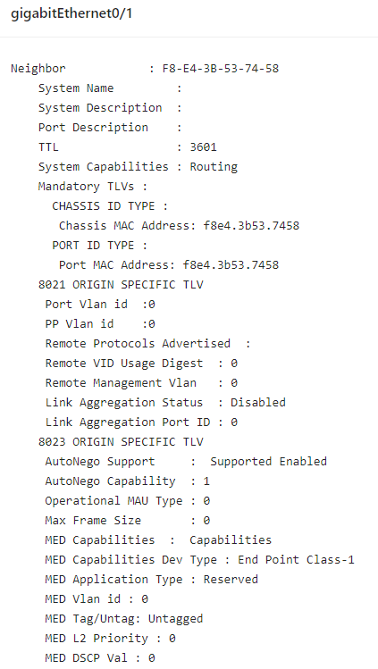

4.2 IGMP Snooping
Internet Group Management Protocol Snooping (IGMP snooping) is a multicast constraining mechanism that runs on Layer 2 devices to manage and control multicast groups.

4.2.1 Principle of IGMP snooping
By analyzing received IGMP messages, a Layer 2 device running IGMP snooping establishes mappings between ports and multicast MAC addresses and forwards multicast data based on these mappings. As shown in Figure 4-6, when IGMP snooping is not running on the switch, multicast packets are flooded to all devices at Layer 2. However, when IGMP snooping is running on the switch, multicast packets for known multicast groups are multicast to the receivers, rather than broadcast to all hosts, at Layer 2.
Figure 4-6 Multicast forwarding before and after IGMP snooping runs

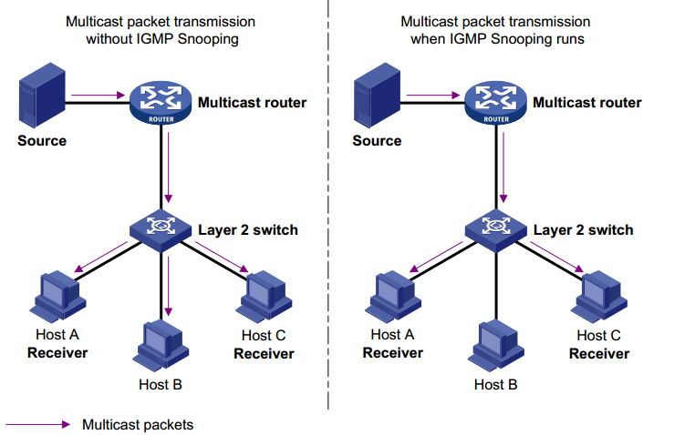

4.2.2 Configure the IGMP Snooping

4.2.2.1 Global Configuration
Select Advance > Layer2 > IGMP Snooping Configuration in the navigation area to enter the Global Configuration page, as shown in Figure 4-7. Table 4-4 describes the IGMP snooping configuration items.
Figure 4-7 IGMP Global Configuration
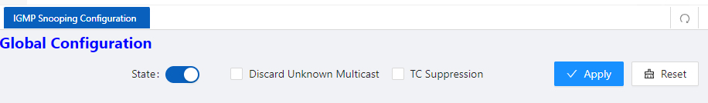

Table 4-4 IGMP snooping summary items
Item |  | Description
Global Configuration | State | Disabled: global disable  Enabled: global enable
Global Configuration | Discard Unknown Multicast | If this option is enabled, unknown multicast traffic will be dropped by switch.
 | TC Suppression | If this option is enabled, topology change event will be ignored by switch

4.2.2.2 IGMP Mrouter Interface Configuration
1. Select Advance > Layer2 > IGMP Snooping Configuration in the navigation area to enter the IGMP Mrouter Interface page shown in Figure 4-8. Table 4-5 describes the IGMP Mrouter Interface configuration items.
Figure 4-8 IGMP Mrouter Interface
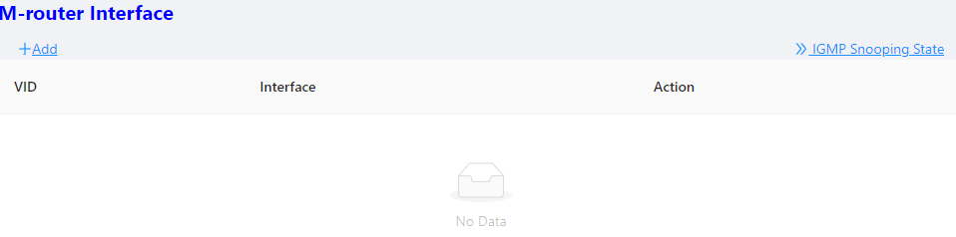
Table 4-5 IGMP IGMP Mrouter Interface items
Item |  | Description
IGMP Mrouter Interface | VID | VLAN ID
IGMP Mrouter Interface | Interface | Interface Name.
IGMP Mrouter Interface | Delete | Click to delete this entry.
2. Click the +Add button to create an IGMP Mrouter Interface, as shown in Figure 4-9. Configure ‘Vid’, ‘Interface’, click Ok.
Figure 4-9 Creating IGMP Mrouter Interface
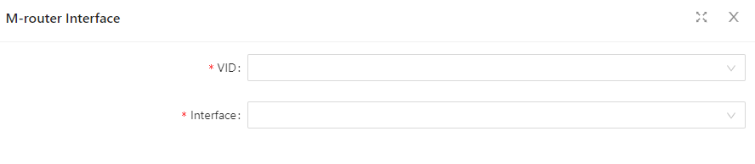

4.2.2.3 IGMP Static Group Configuration
1. Select Advance > Layer2 > IGMP Snooping Configuration in the navigation area to enter the IGMP Static Group page shown in Figure 4-10. Table 4-6 describes the IGMP Static Group configuration items.

Figure 4-10 IGMP Static Group
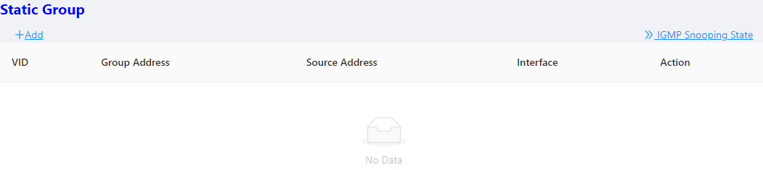
Table 4-6 IGMP IGMP Static Group items
Item |  | Description
IGMP Static Group | VID | VLAN ID
IGMP Static Group | Group Address | Group IP address
IGMP Static Group | Source Address | Source IP address
IGMP Static Group | Interface | Interface name.
IGMP Static Group | Delete | Click to delete this entry.
2. Click the +Add button to create an IGMP Static Group, as shown in Figure 4-11. Configure ‘Vid’, ‘Group Address’, ‘Source Address’, ‘Interface’, click Ok.
Figure 4-11 Creating IGMP Static Group
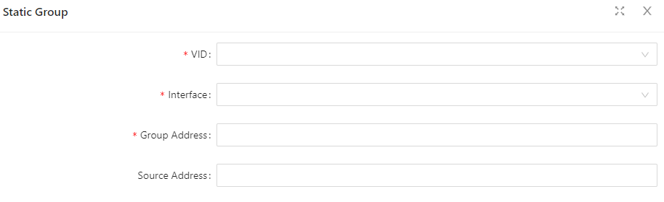

4.3 MAC Management

4.3.1 Overview
A device maintains a MAC address table for frame forwarding. Each entry in this table indicates the MAC address of a connected device, to which interface this device is connected and to which VLAN the interface belongs. A MAC address table consists of two types of entries: static and dynamic. Static entries are manually configured and never age out. Dynamic entries can be manually configured or dynamically learned and will age out.
Your device learns a MAC address after it receives a frame from a port, port A for example, as it executes the following steps.
1. Checks the frame for the source MAC address (MAC-SOURCE for example).
2. Looks up the MAC address table for an entry corresponding to the MAC address and do the following:
• If an entry is found for the MAC address, updates the entry.
• If no entry containing the MAC address is found, adds an entry that contains the MAC address and the receiving port (port A) to the MAC address table.
3. After the MAC address (MAC-SOURCE) is learned, if the device receives a frame destined for MAC-SOURCE, the device looks up the MAC address table and then forwards the frame from port A.
When forwarding a frame, the device adopts the following forwarding modes based on the MAC address table:
• Unicast mode: If an entry matching the destination MAC address exists, the device forwards the frame directly from the sending port recorded in the entry.
• Broadcast mode: If the device receives a frame with the destination address being all Fs, or no entry matches the destination MAC address, the device broadcasts the frame to all the ports except the receiving port.
Figure 4-11 MAC address table of the device
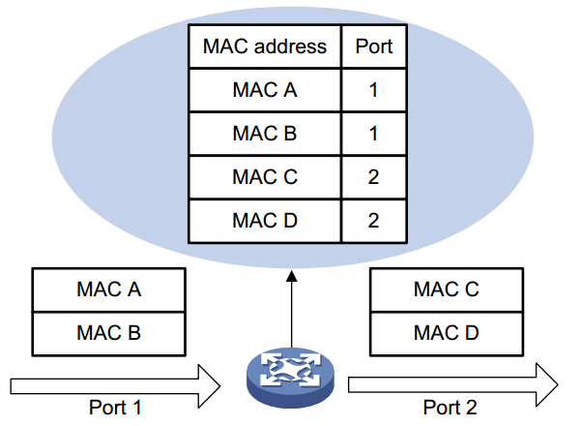

4.3.2 Configuring MAC addresses
MAC addresses configuration includes the configuring and displaying of static MAC address, Filter MAC Address, and the setting of MAC address entry aging time.
Global Configuration
1. Select Advance > Layer2 > MAC Configuration in the navigation area to enter the MAC global Configuration page shown in Figure 4-12. Table 4-7 describes the MAC Configuration items.
Figure 4-12 MAC global configuration
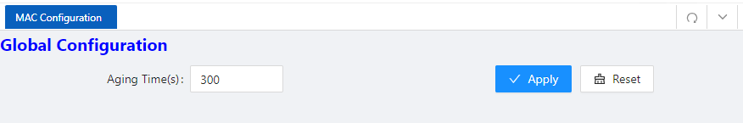
Table 4-7 MAC global configuration items
Item |  | Description
Global  configuration | Aging time | Set the aging time for the MAC address, the default value is 300 seconds.
Global  configuration | Apply | Click to enable

Configuring static MAC address
1. Select Advance > Layer2 > MAC Configuration in the navigation area to enter the Static MAC Address Configuration page shown in Figure 4-13.
Figure 4-13 MAC static address page
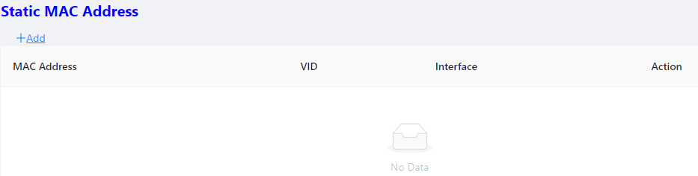
2. Click +Add to enter the page for creating static MAC address, as shown in Figure 4-14. Table 4-8 shows the detailed configuration for creating a static MAC address.
3. Type in MAC address box, for example ‘00eb.fc00.8877’, select the VID in the VLAN drop down list, select the Interface in the Interface drop list.
4. Click Ok to end the operation.
Figure 4-14 Creating static MAC address
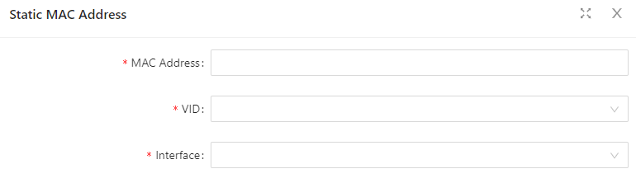
Table 4-8 Static MAC Address items
Item |  | Description
Static  Mac  Address | MAC Address | Set the MAC address to be added.
Static  Mac  Address | VID | Sets the ID of the VLAN to which the MAC address belongs.
Static  Mac  Address | Interface | Sets the port to which the MAC address belongs.
Configuring Filter MAC address
1. Select Advance > Layer2 > MAC Configuration from the navigation area. The system automatically displays the Filter MAC Address page, as shown in Figure 4-15.

Figure 4-15 MAC static address page
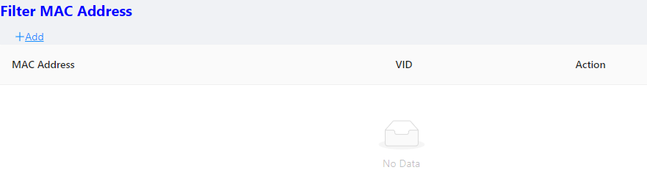
2. Click +Add to enter the page for creating filter MAC address, as shown in Figure 4-16. Table 4-9 shows the detailed configuration for creating a filter MAC address.
3. Type in MAC address, for example ‘00eb.fc00.8877’, select the VID in the VLAN drop down list.
4. Click Apply to end the operation.
Figure 4-16 Creating Filter MAC address
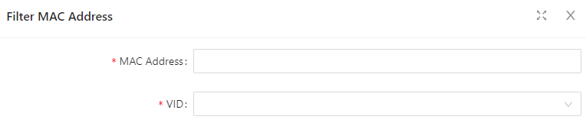
Table 4-9 Filter MAC Address items
Item |  | Description
Static  Mac  Address | MAC Address | Set the MAC address to be filtered.
Static  Mac  Address | VID | Sets the ID of the VLAN to which the MAC address belongs.

4.4 DHCP Snooping

4.4.1 Overview
DHCP snooping (Dynamic Host Configuration Protocol) is a security feature that acts like a firewall between untrusted hosts and trusted DHCP servers. When DHCP snooping is enabled on a VLAN, the system examines DHCP messages sent from untrusted hosts associated with the VLAN and extracts their IP addresses and lease information. This information is used to build and maintain the DHCP snooping database.
DHCP snooping is enabled on a per-VLAN basis. By default, the feature is inactive on all VLANs. You can enable the feature on a single VLAN or a range of VLANs.
Trusted Sources
The DHCP snooping feature determines whether traffic sources are trusted or untrusted. DHCP snooping acts as a guardian of network security by keeping track of valid IP addresses assigned to downstream network devices by a trusted DHCP server. The default trust state of all interfaces is untrusted.
DHCP Snooping Limit Rate
Configure the number of DHCP packets per second that an interface can receive, to reduce or eliminate the impact of DHCP packet attack from this interface.

MAC Address Verification
With DHCP snooping MAC address verification enabled, DHCP snooping verifies that the source MAC address and the client hardware address match in DHCP packets that are received on untrusted ports. The source MAC address is a Layer 2 field associated with the packet, and the client hardware address is a Layer 3 field in the DHCP packet.
Option-82 Insertion
DHCP Option82 option is also called DHCP relay agent information option, one of many dhcp options. The Option82 option is a DHCP option proposed to enhance the security of the DHCP server and improve the IP address allocation strategy. The addition and stripping of options are implemented by the relay component.
DHCP Database
The DHCP snooping feature dynamically builds and maintains the database using information extracted from intercepted DHCP messages. The database contains an entry for each untrusted host with a leased IP address if the host is associated with a VLAN that has DHCP snooping enabled. The database does not contain entries for hosts connected through trusted interfaces. When the Ip verify source function is enabled on the interface, database entries act as valid users on the interface.

4.4.2 Configuring DHCP Snooping
Configuring DHCP Snooping globally
1. Select Advance > Layer2 > DHCP Snooping from the navigation tree to enter the DHCP Snooping Configuration page, as shown in Figure 4-17. Table 4-10 describes the configuration items of configuring DHCP Globally.
Figure 4-17 DHCP Snooping global configuration

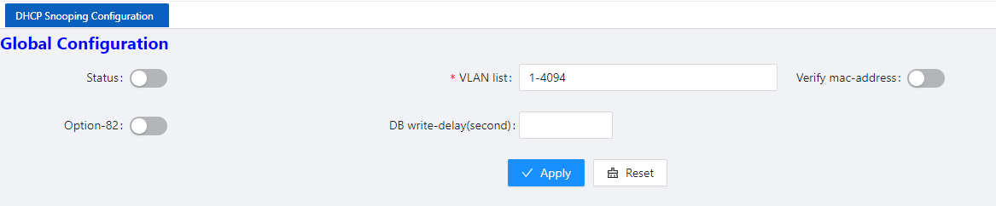
Table 4-10 The description of DHCP Snooping global configuration
Item | Description
Status | Enable/Disable the DHCP Snooping globally
Vlan | Enable/Disable the DHCP Snooping on the vlans
Verify mac-address | Verify the source MAC address and the client hardware address is matched in DHCP packets
option-82 | Enable/Disable option-82 insertion
DB write-delay(s) | Configure the interval time database writing to flash
Configuring DHCP Snooping ports
- Select Advance > Layer2 > DHCP Snooping from the navigation tree, as shown in Figure 4-18.

Figure 4-18 DHCP Snooping interface configuration status
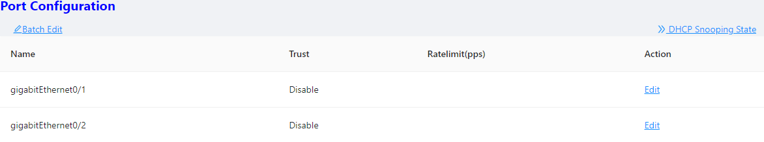
2. Click Batch Edit button below “port configuration” or Edit button correspond of the port to enter the page for configuring ports.
3、Check the ports to be configured, click EDIT to enter the interface configuration page as shown in Figure
4-19. Table 4-11 describes the configuration items of configuring DHCP snooping interface configuration.
Figure 4-19 DHCP Snooping global configuration
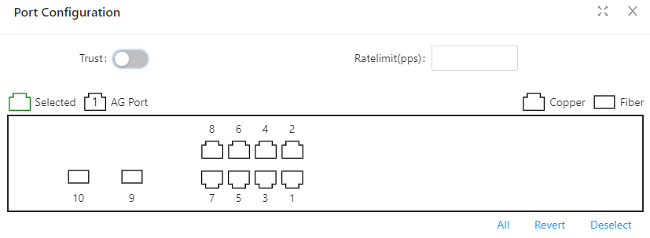
Table 4-11 The description of DHCP snooping interface configuration
Item | Description
Trust | determines whether traffic sources are trusted or untrusted
Ratelimit(pps) | Configure the number of DHCP packets per second that an interface can receive
NOTE
NOTE:
✦ Due to hardware limitations, for DHCP rate limit, when the limit value is not 0, the software rate limit is used, and when the limit value is 0, the hardware rate limit is used. Software rate limit will consume CPU resources.
View DHCP Snooping state
1. Click the DHCP Snooping state button in the current page to enter the DHCP Snooping state page, as shown in Figure 4-20. Table 4-12 describes the configuration items of configuring DHCP Snooping database.

Figure 4-20 DHCP Snooping database
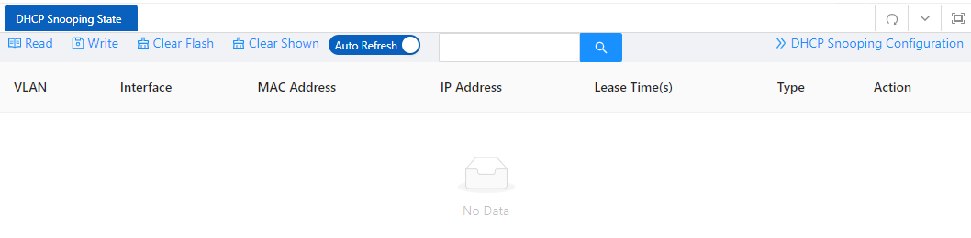
Table 4-12 The description of DHCP Snooping database
Item | Description
Search | Search database entries by fuzzy match the input strings
WRITE | Write database entries to flash
READ | Read database entries from flash
CLEAR | Clear database entries, you can narrow the scope by selecting keywords

4.5 QinQ

4.5.1 Overview
Introduction to QinQ
QinQ stands for 802.1Q in 802.1Q. QinQ is a flexible, easy-to-implement Layer 2 VPN technology based on IEEE 802.1Q. QinQ enables the edge device on a service provider network to insert an outer VLAN tag in the Ethernet frames from customer networks, so that the Ethernet frames travel across the service provider network (public network) with double VLAN tags. QinQ enables a service provider to use a single SVLAN to serve customers who have multiple CVLANs.
Background and benefits
The IEEE 802.1Q VLAN tag uses 12 bits for VLAN IDs. A device supports a maximum of 4094 VLANs. This is far from enough for isolating users in actual networks, especially in metropolitan area networks (MANs).
By tagging tagged frames, QinQ expands the available VLAN space from 4094 to 4094 × 4094. QinQ delivers the following benefits:
• Releases the stress on the SVLAN resource.
• Enables customers to plan their CVLANs without conflicting with SVLANs.
• Provides an easy-to-implement Layer 2 VPN solution for small-sized MANs or intranets.
• Allows the customers to keep their VLAN assignment schemes unchanged when the service provider upgrades the service provider network.

4.5.2 QinQ configuration
VPN Configuration
1. Select Advance > Layer2 > QinQ configuration in the navigation area. The system automatically enters the page as shown in Figure 4-21.

Figure 4-21 VPN Configuration summary
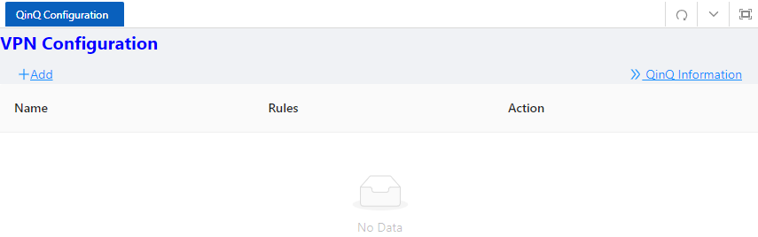
2. Click +Add button below “VPN Configuration” to enter the VPN rule creating page, as shown in Figure 4-22, Table 4-13 describes the items of configuring a QinQ rule.
Figure 4-22 VPN Configuration
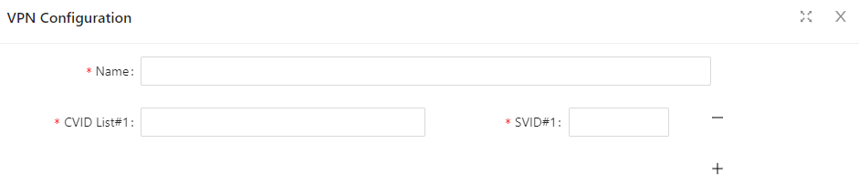
Table 4-13 VPN Configuration Description
Item | Description
Name | The name of the VLAN VPNRule
CVID | The ID of the customer VLAN
SVID | The ID of the service provider VLAN
Port Configuration
1. Select Advance > Layer2 > QinQ configuration in the navigation area. The system automatically enters the page as shown in Figure 4-24.
Figure 4-24 Port Configuration summary
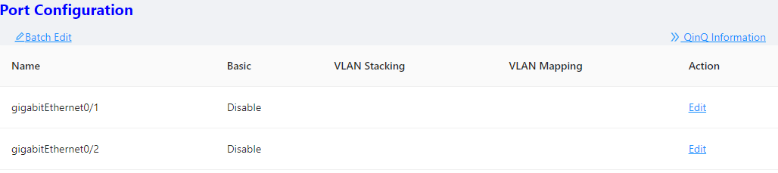
2. Click Batch Edit button below “Port Configuration” or Edit button correspond of the port to enter the QinQ port configuration page, as shown in Figure 4-25, Table 4-14 describes the items of configuring port.

Figure 4-25 Port Configuration
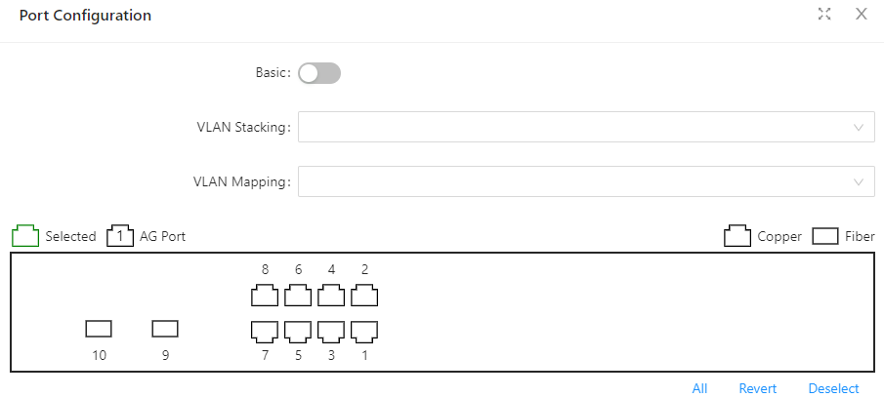
Table 4-14 The description of configuring a QinQ rule
Item | Description
Basic | Enable VLAN mapping mode
VLAN Stacking | Multi-layer tag mode
VLAN Mapping | tag replacement mode

4.6 ACL

4.6.1 Overview
An access control list (ACL) is a set of rules (or permit or deny statements) for identifying traffic based on criteria such as source IP address, destination IP address, and port number. ACLs are essentially used for packet filtering. A packet filter drops packets that match a deny rule and permits packets that match a permit rule. ACLs are also widely used by many modules, for example, QoS and IP routing, for traffic identification.

4.6.2 Configuring Acls
NOTE
NOTE:
✦A maximum of 128 rules can be configured under a single ACL-ID; due to hardware resource limitations, please refer to the specific product specification document for the maximum number of application rules supported by a single device.
✦When an ACL has been applied to a port, if you need to add and delete rules, you must first unapply them from the port.
.

Configuring a rule for an IP ACL
1. Select Advance > Security > ACL Configuration in the navigation area.
2. Click the +ADD ACL button to enter the rule configuration page and choose the ACL type ‘IP’ for a basic ACL as shown in Figure 4-26. Table 4-15 describes the configuration items of configuring an IP ACL.
Figure 4-26. Configuring a basic IP ACL
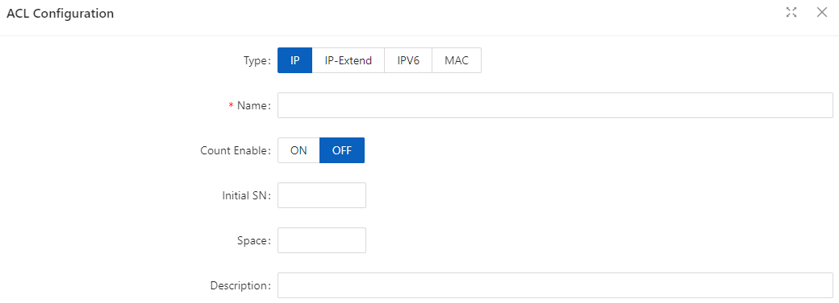
Table 4-15 The description of the basic IP ACL
Item |  | Description
ACL Type | IP | Standard IP ACL can match the source IP field in IPv4 packets
ACL Type | IP-Extend | the protocol number, source IP address, destination IP address, Layer 4 port number, etc. of IPv4 packets
ACL Type | IPV6 | IPv6 ACL can match IPv6 packet source IP address, destination IP address, protocol number, etc
ACL Type | MAC | MAC ACL, which can match destination MAC address, source MAC address, Etype and other fields
Name |  | Standard IP valid number range: <1-99> | <1300-1999>  Extended IP valid number range: <100-199> | <2000-2699>  MAC ACL valid number range: <200-699>  IPv6 ACL only supports string naming. All ACLs support string naming.  The string length range is <1-64>
Count Enable |  | Enable the counting function. When a packet hits the ACL, the count value is increased by 1
Initial SN |  | Starting value of rule entry sequence number, default value: 10, range <1-2147483647>
Space |  | Increment the serial number, default value: 10, range <1-2147483647>
Description |  | Define the ACL description information
3. Configure a rule for an IP ACL, and click Ok.
4. Select IP rule in the box below “ACE Configuration” and click +Add ACE button to enter ACE configuration page as shown in Figure 4-27. Table 4-16 describes the configuration items of configuring an IP ACE configuration.

Figure 4-27 IP Type ACE Configuation Interface
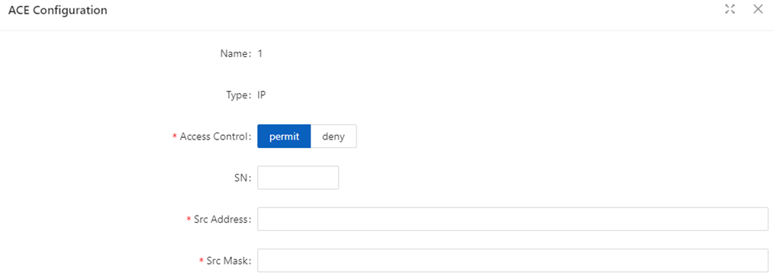
Table 4-16 The description of the IP type ACL
Item |  | Description
Access  Control | permit | Release the packets that match this rule
Access  Control | deny | Discard packets matching this rule
SN |  | Rule entry sequence number
Src Address |  | Source IP address, such as 192.168.64.1
Src Mask |  | The IP mask is inverted. If it matches the first 24 digits of the IP address, the mask is 255.255.255.0. Here it needs to be configured as 00.00.00.255
5. Configure ACE and click Ok.
4. Click Batch Edit below “Port Configuration” to enter the ACL port configuration page, select the ACL rules of the corresponding port, as shown in Figure 4-28, and click Ok.
Figure 4-28 Apply the ACL rule to the port
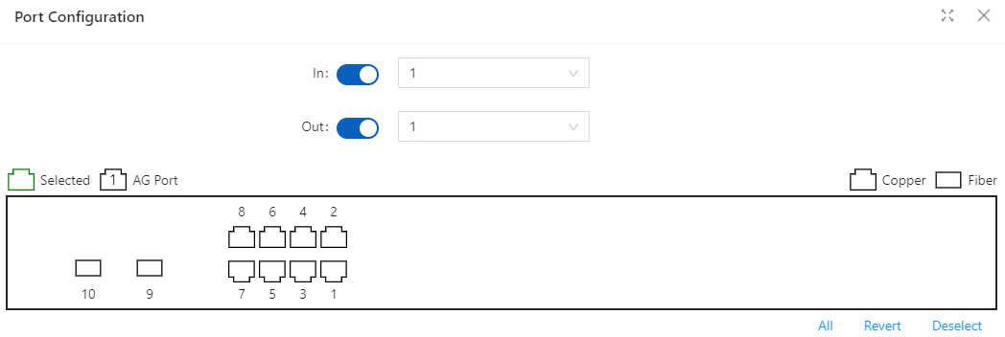
Configuring a rule for an IP-Extend ACL
1. Select Advance > Security > ACL Configuration in the navigation area.
2. Click the +ADD ACL button to enter the rule configuration page and choose the ACL type ‘IP-Extend’ for a basic ACL as shown in Figure 4-26.
3. Configure a rule for an IP ACL, and click Ok.
4. Select ACK rules in the box below “ACE Configuration” and click +Add ACE button to enter ACE configuration page as shown in Figure 4-29. Table 4-17 describes the configuration items of configuring an IP ACE configuration.
Figure 4-29 IP-Extend Type ACE Configuation Interface
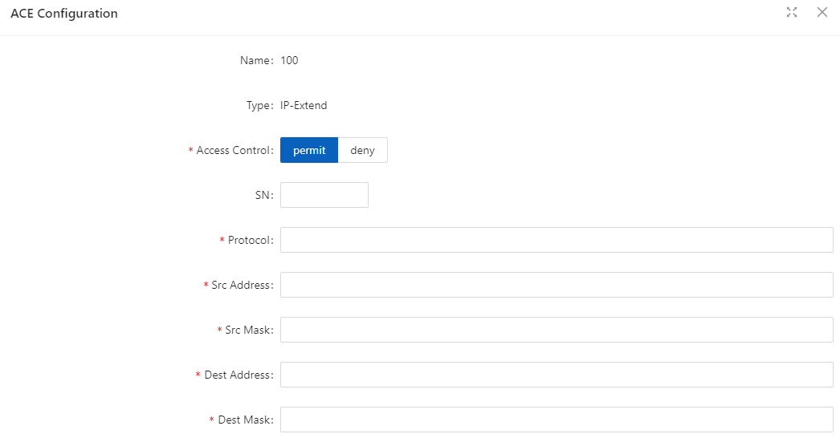
Table 4-17 The description of the IP-Extend ACL
Item |  | Description
Access  Control | permit | Release the packets that match this rule
Access  Control | deny | Discard packets matching this rule
SN |  | Rule entry sequence number
Protocol |  | Supports common protocol message options, including tcp, udp, vrrp, igmp, gre, ipcomp, ospf, pim, rsvp, etc.  Supports all IP v4 packets  IPv4 messages of customized protocol
Src Address |  | Source IP address, such as 192.168.64.1
Src Mask |  | The IP mask is inverted. If it matches the first 24 digits of the IP address, the mask is 255.255.255.0. Here it needs to be configured as 00.00.00.255
Dest Address |  | Destination IP address, such as 192.168.64.100
Dest Mask |  | homology mask
5. Configure ACE and click Ok.
6. Click Batch Edit below “Port Configuration” to enter the ACL port configuration page, select the ACL rules of the corresponding port, and click Ok.

Configuring a rule for an IPV6 ACL
1. Select Advance > Security > ACL Configuration in the navigation area.
2. Click the +ADD ACL button to enter the rule configuration page and choose the ACL type ‘IPV6’ for a basic ACL as shown in Figure 4-26.
3. Configure a rule for an IP ACL, and click Ok.
4. Select ACL rules in the box below “ACE Configuration” and click +Add ACE button to enter ACE configuration page as shown in Figure 4-30. Table 4-18 describes the configuration items of configuring an IP ACE configuration.
Figure 4-30 IPV6 Type ACE Configuation Interface
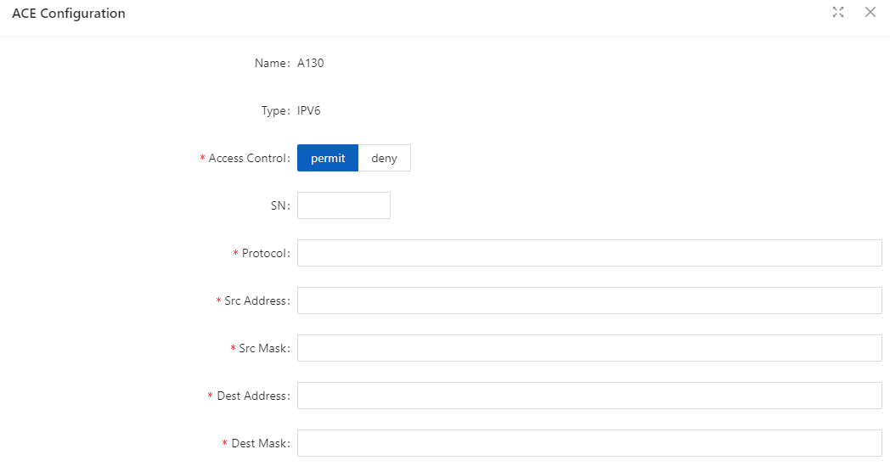
Table 4-18 The description of the IPV6 ACL
Item |  | Description
Access  Control | permit | Release the packets that match this rule
Access  Control | deny | Discard packets matching this rule
SN |  | Rule entry sequence number
Protocol |  | Supports common protocol message options , including tcp , udp , icmp , etc.  Supports all IP v 6 packets  Support IPv6 messages of customized protocol
Src Address |  | Source MAC address, such as 00.d 0.f 8.22.33.40
Src Mask |  | The MAC address mask is inverted. If it matches the first 24 digits of the MAC address , the mask is ffff.ff00.0000. Here it needs to be configured as 0000.00 ff.ffff
Dest Address |  | Destination MAC address, such as 00.d 0.f 8.22.33.41
Dest Mask |  | homology mask

5. Configure ACE and click Ok.
6. Click Batch Edit below “Port Configuration” to enter the ACL port configuration page, select the ACL rules of the corresponding port, and click Ok.
Configuring a rule for an MAC ACL
1. Select Advance > Security > ACL Configuration in the navigation area.
2. Click the +ADD ACL button to enter the rule configuration page and choose the ACL type ‘IPV6’ for a basic ACL as shown in Figure 4-26.
3. Configure a rule for an IP ACL, and click Ok.
4. Select ACK rules in the box below “ACE Configuration” and click +Add ACE button to enter ACE configuration page as shown in Figure 4-31. Table 4-19 describes the configuration items of configuring an IP ACE configuration.
Figure 4-31 Apply the ACL rule to the port
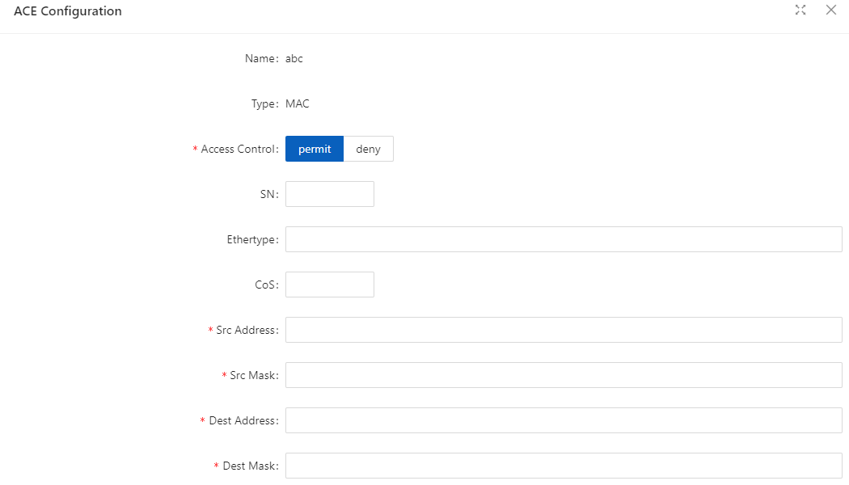
Table 4-19 The description of the MAC ACL
Item |  | Description
Access  Control | permit | Release the packets that match this rule
Access  Control | deny | Discard packets matching this rule
SN |  | Rule entry sequence number
Ethertype |  | Ethernet protocol type, range (0x05DD-0xFFFF)
CoS |  | Cos value of the message, range (0-7)
Src Address |  | Source MAC address, such as 00.d0.f 8.22.33.40
Src Mask |  | The MAC address mask is inverted. If it matches the first 24 digits of the MAC address, the mask is ffff.ff00.0000. Here it needs to be configured as 0000.00ff.ffff
Dest Address |  | Destination MAC address, such as 00.d0.f 8.22.33.41
Dest Mask |  | homology mask
5. Configure ACE and click Ok.
6. Click Batch Edit below “Port Configuration” to enter the ACL port configuration page, select the ACL rules of the corresponding port, and click Ok.

4.7 QoS

4.7.1 Overview
Quality of Service (QoS) reflects the ability of a network to meet customer needs. In an internet, QoS evaluates the ability of the network to forward packets of different services. The evaluation can be based on different criteria because the network may provide various services. Generally, QoS performance is measured with respect to bandwidth, delay, jitter, and packet loss ratio during packet forwarding process.

4.7.2 Configuring Qos
Enable Qos
1. Select Advance > Security > Qos Configuration in the navigation area to enter the QoS Global Configuration page, as shown in Figure 4-32. Table 4-20 describes the QoS summary items.
Figure 4-32 QoS Global Configuration
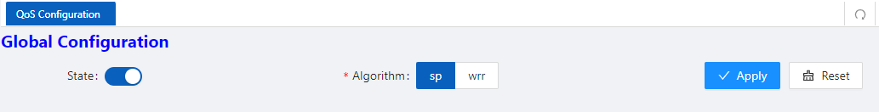
2. Click State button, choose Algorithm, click Apply to enable Qos.
Table 4-20 Descriptions of QoS summary
Items | Description
Qos  Configuration | State |  | Enable QOS, all QOS functions do not support configuration before enabling
Qos  Configuration | Algorithm | Sp | Absolute priority scheduling, the queue ID is large, the priority is high, and the low-priority queue is processed after the high -priority queue is processed.
Qos  Configuration | Algorithm | Wrr | robin scheduling algorithm schedules each queue in turn according to the queue weight, from the largest to the smallest queue ID.
QoS Mapping
1. In current page, click Queue button below “Qos Mapping” to enter Queue Configuration page, as shown in Figure 4-33. Table 4-21 describes the QoS summary items.
Figure 4-33 QoS Queue Configuration
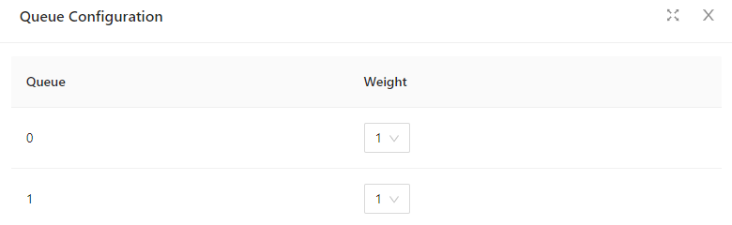

Table 4-21 Descriptions of Queue Configuration
Items | Description
Queue  weight | Queue | < 0, 7 >
Queue  weight | weight | < 0, 32>, the larger the value, the higher the weight, and the higher the probability of preferential processing of packets in this queue under the condition of channel congestion, 0 means infinity.
2. Click Cos button below “Qos Mapping” to enter Cos Configuration page, as shown in Figure 4-34. Table 4-22 describes the Cos configuration items.
Figure 4-34 QoS Cos Configuration
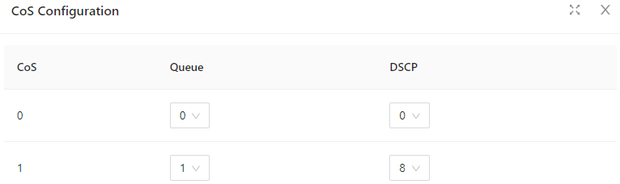
Table 4-22 Descriptions of Cos Configuration
Items |  | Description
CoS  Configuration | CoS | <0, 7>
CoS  Configuration | Queue | < 0, 7>, Cos - queue mapping relationship, based on the cos marked on the port, modifying the packet egress queue takes effect when the port is configured as no trust, trust cos or trust dscp and non-ip packets.
CoS  Configuration | DSCP | cos-dscp mapping relationship takes effect when the port is configured as no trust, trust cos or trust dscp and is not ip packets. Modify the packet dscp value.
3. Click DSCP button below “Qos Mapping” to enter DSCP Configuration page, as shown in Figure 4-35. Table 4-23 describes the DSCP configuration items.

Figure 4-35 QoS Cos Configuration
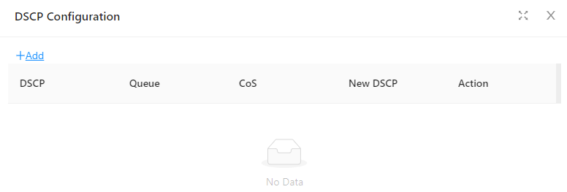

Table 4-23 Descriptions of Cos Configuration
Items |  | Description
DSCP  Map | DSCP | <0, 63>
DSCP  Map | Queue | < 0, 7>, dsp-queue mapping relationship, which takes effect when the port is configured as trust dscp and ip packets, modify the packet export queue
DSCP  Map | CoS | < 0, 7>, dscp-cos mapping relationship, which takes effect when the port is configured as trust dscp and ip packets, modify the cos field of the packet
DSCP  Map | Nes DSCP | < 0, 63 >, dscp-dscp mapping relationship, which takes effect when the port is configured as trust dscp and ip packets, first perform dscp-dscp mapping, and then perform dscp-cos mapping
Class Setting
1. In current page, click +Add button below “Class Setting” to enter Class Setting page, as shown in Figure 4-36. Table 4-24 describes the QoS summary items.
Figure 4-36 Class Setting page
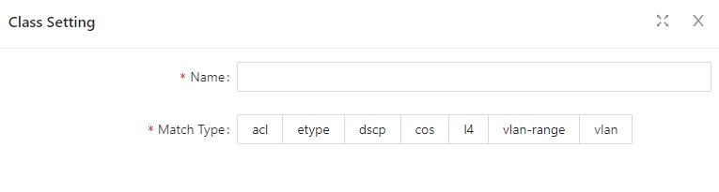
Table 4-24 Descriptions of Class Setting
Items |  | Description
Class Setting | Name | Create a category, define the category name
Class Setting | Match | Define match type, support associated ACL;  Support packet etype, dscp, cos, l4port, vlan field matching

Policy Setting
1. In current page, click +Add Policy button below “Policy Setting” to enter Policy Setting page, as shown in Figure 4-37. Text the box behind “Name”, click Ok button.
Figure 4-37 Class Setting page
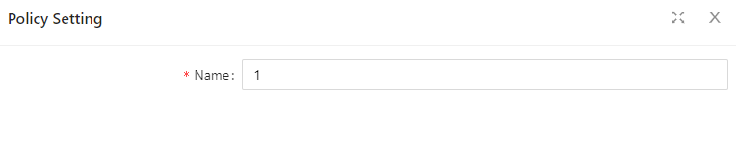
2. Click +Add Policy Rule button below “Policy Setting” to enter Policy Rule Setting page, as shown in Figure 4-38. Table 4-26 describes the QoS Rule Configuration items.

Figure 4-38 Rule Configuration page
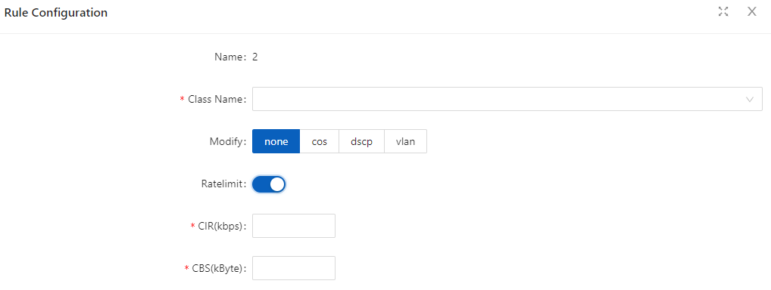
Table 4-26 Descriptions of Class Setting
Items |  | Description
Rule  Configuration | Name | Rule name
Rule  Configuration | Class Name | Create a policy, define a policy name
Rule  Configuration | Modify | policy, supports modifying cos, dscp, vlan and other actions
Rule  Configuration | Ratelimit | Action 2 corresponding to the strategy, speed limit
Rule  Configuration | CIR | Speed limit waterline, unit kbps
Rule  Configuration | CBS | burst capability, unit Kbyte
Port Configuration
1. In current page, click +Batch Edit button below “Port Configuration” to enter Port Configuration page, as shown in Figure 4-39. Table 4-27 describes the Port Configuration items.
Figure 4-39 Port Configuration page
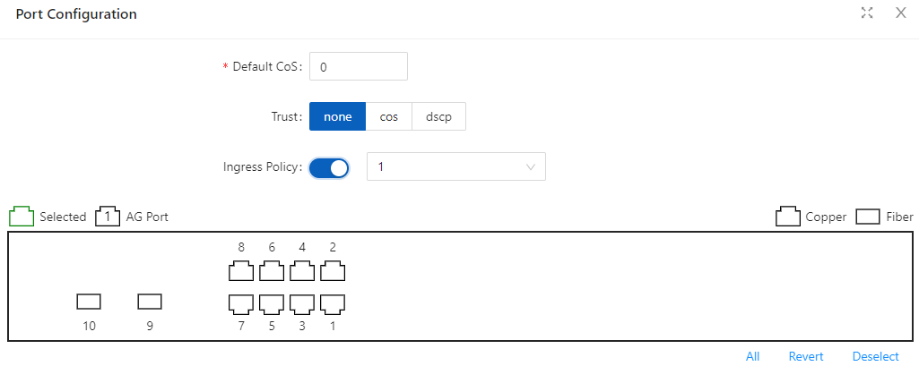

Table 4-27 Descriptions of Port Configuration
Items |  | Description
Port  Configuration | Default  CoS | < 0, 7>, when the configuration port is not trusted, or the configuration is trusted but the message does not meet the trust condition, the port default cos is used to mark the ingress message
Port  Configuration | Trust | Support untrust, trust cos, trust dscp configuration. When in no trust mode, the entry stage modifies the cos field and dscp field of the message according to the default cos of the port; when trust cos is configured, the same as the no trust mode for untagged messages, and for tagged messages, choose the message with its own cos; When configuring trust dscp, for ip packets, select the packet with dscp, and for non-ip packets, it is the same as trust cos mode.
Port  Configuration | Ingress  Policy | Select Ingress Policy

4.8 Route

4.8.1 ARP

4.8.1.1 Overview
ARP resolves an IP address into a physical address, such as an Ethernet MAC address.
On an Ethernet LAN, a device uses ARP to get the MAC address of the target device for a packet
ARP table
After obtaining the MAC address for the destination host, the device puts the IP-to-MAC mapping into its own ARP table. This mapping is used for forwarding packets with the same destination in the future.
An ARP table stores dynamic and static ARP entries.
Dynamic ARP entry
ARP automatically creates and updates dynamic entries. A dynamic ARP entry is removed when its aging timer expires or the output interface goes down, and it can be overwritten by a static ARP entry.

Static ARP entry
A static ARP entry is manually configured and maintained. It cannot get aged or be overwritten by a dynamic ARP entry.
Static ARP entries protect communication between devices, because attack packets cannot modify the IP-to-MAC mapping in a static ARP entry.

4.8.1.2 Configuring Static ARP
Displaying Static ARP
1. Select Monitor > ARP Information in the navigation area to enter Static ARP displaying page as shown in Figure 4-40. Table 4-28 describes the configuration items of static ARP.
Figure 4-40 Port Configuration page
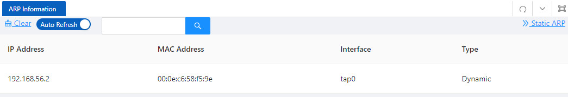

Table 4-28 Descriptions of Static ARP
Item | Description
IP Address | Terminal IP address
MAC Address | Terminal MAC address
Interface | The name of the Layer 3 interface where the terminal is located
Type | ARP address type
Configuring Static ARP
1. Select Advance > Layer3 > Static ARP in the navigation area to enter Static ARP configration page as shown in Figure 4-41.
2. Click +Add button to enter the crating page as shown in Figure 4-42.
3. Configure the IP address and MAC address.
4. Click OK button to complete the configuration.
Figure 4-41 Static ARP Configuration page
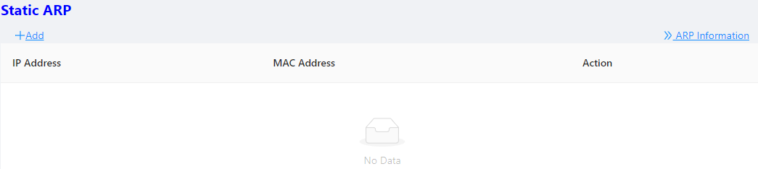

Figure 4-42 Creating a new Static ARP
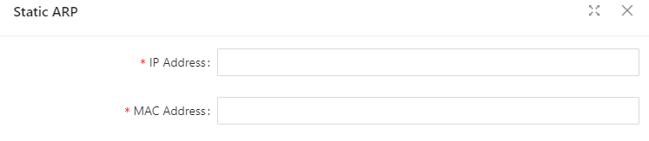

4.8.2 Route
Routers are responsible for routing packets on the Internet. A router selects an appropriate route according to the destination address of a received packet and forwards the packet to the next router. The last router on the path is responsible for sending the packet to the destination host.

4.8.2.1 Routing table
Routers forward packets through a routing table. Each entry in the table specifies which physical interface a packet should go out to reach the next hop (the next router) or the directly connected destination.
Routes in a routing table fall into three categories by origin:

• Direct routes: Routes discovered by data link protocols, also known as interface routes.
• Static routes: Routes that are manually configured.
• Dynamic routes: Routes that are discovered dynamically by routing protocols.
A route entry has the following items:
• Destination IP address: Destination IP address or destination network.
• Mask (IPv4)/prefix length (IPv6): Specifies, together with the destination address, the address of the destination network.
• Outbound interface: Specifies the interface through which a matching IP packet is to be forwarded.
• Next hop: Specifies the address of the next hop router on the path.
• Preference for the route: Routes to the same destination may be found by various routing protocols or manually configured, and routing protocols and static routes have different priorities configured. The route with the highest priority (the smallest value) will be selected as the optimal route.

4.8.2.2 Static Route
A static route is manually configured. If a network ‘s topology is simple, you only need to configure static routes for the network to work normally. The proper configuration and usage of static routes can improve network performance and ensure bandwidth for important network applications.
The disadvantage of using static routes is that they cannot adapt to network topology changes. If a fault or a topological change occurs in the network, some routes will be unreachable. In this case, the network administrator has to modify the static routes manually.
While configuring a static route, you can specify either the output interface or the next hop address as needed. The next hop address cannot be a local interface ‘s IP address; otherwise, the route configuration will not take effect.
Actually, it is necessary to identify next hop addresses for all route entries because the router needs to use the next hop address of a matching entry to resolve the corresponding link layer address.

4.8.2.3 Configuring Static Route
Displaying Static Route
1. Select Advance > Layer3 > Static Route in the navigation area to enter Static Route displaying page as shown in Figure 4-43. Table 4-29 describes the configuration items of static Route.
Figure 4-43 Creating a new Static ARP
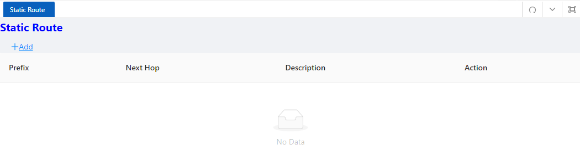
Table 4-29 Descriptions of Static Route
Items | Description
Prefix | Routing prefix address, or routing network segment; for example, common route 0.0.0.0/0 192.168.1.1, the prefix IP is 0.0.0.0
Next Hop | Next hop IP address of the route
Description | Route description information, optional configuration
Action | Delete or modify
Creating new Static Route
1. Select Configuration > VLAN in the navigation area to create VLAN ID.
2. Select Configuration > Port > Port Configuration > L3 port in the navigation area to create L3 SVI port as shown in Figure 4-44.
Figure 4-44 Creating a L3 SVI port
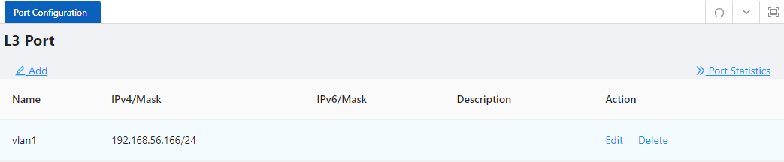
3. Select Advance > Layer3 > Static Route in the navigation area to enter Static Route page, click +Add button to enter the crating page as shown in Figure 4-45.
4. Configure the Prefix and Next Hop.
5. Click OK button to complete the configuration.
Figure 4-45 Creating a new Static ARP
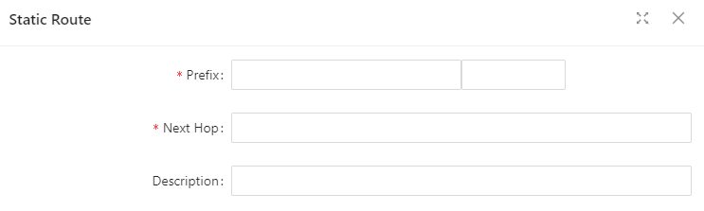
NOTE
NOTE:
✦ When adding a new SVI port, the default management IP address will be automatically deleted. Please ensure that the new SVI port can continue to be accessed.

5 Maintenance

5.1 System Configuration
The system configuration module provides host name settings, services of Telnet, SSH, HTTP, HTTPS, and management IP setting.

5.1.1 Host name settings
Select Maintenance > system configuration from the navigation area to enter the system configuration page, as shown in Figure 5-1. User can set the host name of the switch here.
Figure 5-1 Management Information page

5.1.2 Services Enable
The service management module provides the following types of services: FTP, Telnet, SSH, TFTP, HTTP and HTTPS. You can enable or disable the services as needed. In this way, the performance and security of the system can be enhanced, thus secure management of the device can be achieved.
Telnet Server
The Telnet protocol is an application layer protocol that provides remote login and virtual terminal functions on the network.
SSH Server
Secure Shell (SSH) offers an approach to securely logging in to a remote device. By encryption and strong authentication, it protects devices against attacks such as IP spoofing and plain text password interception
HTTP Server
The Hypertext Transfer Protocol (HTTP) is used for transferring web page information across the Internet. It is an application-layer protocol in the TCP/IP protocol suite. You can log in to the device using the HTTP protocol with HTTP service enabled, accessing and controlling the device with Web-based network management.
HTTPS Server
The Secure HTTP (HTTPS) refers to the HTTP protocol that supports the Security Socket Layer (SSL) protocol. The SSL protocol of HTTPS enhances the security of the device in the following ways:
• Uses the SSL protocol to ensure the legal clients to access the device securely and prohibit the illegal clients;
• Encrypts the data exchanged between the HTTPS client and the device to ensure the data security and integrity, thus realizing the security management of the device;
• Defines certificate attribute-based access control policy for the device to control the access right of the client, in order to further avoid attacks from illegal clients.
Configuring service
(1) Select Maintenance > system configuration from the navigation area to enter the system configuration page, as shown in Figure 5-2.
(2) Check the box in front of the services, Click Apply button to enable service.
(3) When HTTPS Server is enabled, the certificate and private key should be uploaded. If no certificate is specified, the device will use the default certificate.

Figure 5-2 Service page

5.1.3 Management IP
(1) Select Maintenance > system configuration from the navigation area to enter the system configuration page, as shown in Figure 5-3. Table 5-1 lists the configuration items of the Management IP Address.
Figure 5-3 Management Information page
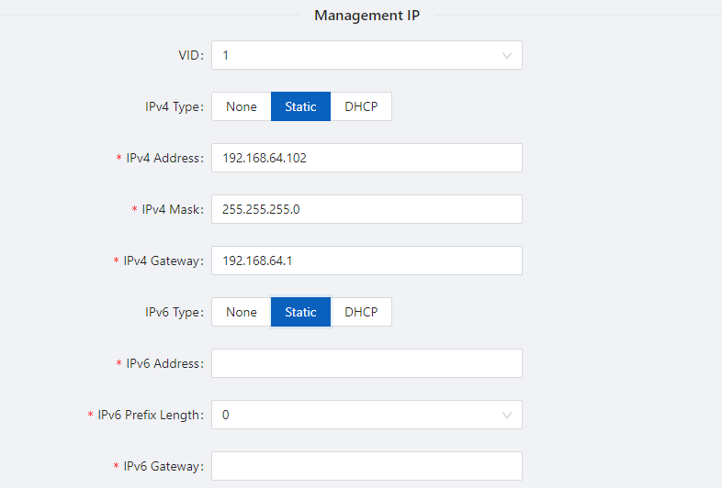
Table 5-1 Management Information configuration items
Item | Description
VID | Specify the management VLAN ID.  The default management VLAN is 1.
IPv4 Type | None：IPv4 management address is not used.  Static：Select this option to manually specify an IPv4 address and the mask length  DHCP：Select the option to get an IPv4 address through DHCP.
IPv4 Address | Specify the IPv4 management address.  The default IP is 192.168.56.166.
IPv4 Mask | Specify the IPv4 management mask.  The default mask is 255.255.255.0.
IPv4 Gateway | Specify the IPv4 management gateway.  The default gateway is 192.168.56.1.
IPv6 Type | None：IPv6 management address is not used.  Static：Select this option to manually specify an IPv6 address and the mask length.  DHCP：Select the option to get an IPv6 address through DHCP.
IPv6 Address | Specify the IPv6 management address.
IPv6 Prefix Length | Specify the IPv6 management address prefix length.
IPv6 Gateway | Specify the IPv6 management gateway.

5.2 File Management
The file management module includes basic information, image management, configuration management, certificate management, and page package management functions.

5.2.1 Basic Information
Select Maintenance > File Management > Basic Information from the navigation area to enter the page as shown in Figure 5-4. In the basic information page, you can view the usage of each partition of the device, and click the Clean button to clear the system log.
Figure 5-4 basic information page
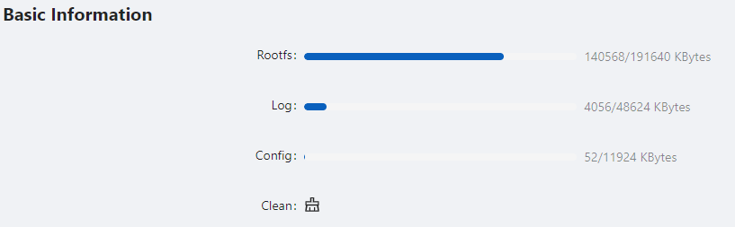

5.2.2 Image Management
Software upgrade allows you to obtain a target application file from the current host and set the file as the main boot file or backup boot file to be used at the next reboot.
NOTE
NOTE:
- A software upgrade takes some time. Do not perform any operation on the web interface during the upgrading procedure; otherwise, the upgrade operation may be interrupted.
1.Select Maintenance > File Management > Image Management from the navigation area to enter the page as shown in Figure 5-5.

Figure 5-5 Image Management page
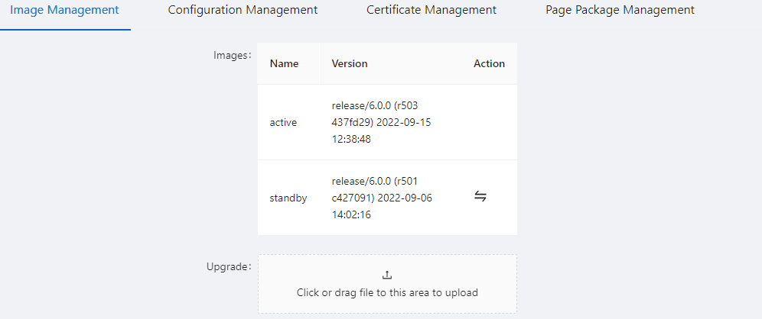
2. Click Upgrade button, In the pop-up dialog box, select the upgrade file corresponding to the device, the upgrade file is *.bin format, and the upgrade process is shown in Figure 5-6. After upgrade finished, the device will be rebooted.
Figure 5-6 Flash new firmware image page


5.2.3 Configuration Management
Select Maintenance > File Management > Image Management from the navigation area to enter the page as shown in Figure 5-7.
Figure 5-7 Configuration File Management page
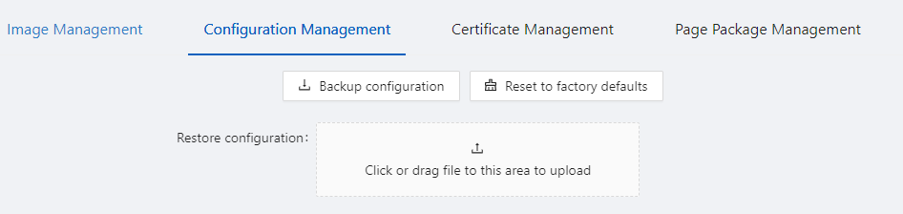

Backup configuration
Click the Backup configuration button, a file download dialog box appears. You can save the file locally.
Restore configuration
After you click the Choose File button in this figure, the file upload dialog box appears. You can select the *. conf file to be uploaded, then the device will be reboot.
Reset to Factory Defaults
This operation restores the system to factory defaults, delete the current configuration file, and reboot the device. Click the Reset to Factory Defaults button to apply this operation.

5.2.4 Configuration Management
When you enable HTTPS, you need to upload the certificate and private key, as shown in Figure 5-8. If you do not specify a certificate, the device uses the default certificate.
Figure 5-8 Configuration File Management page

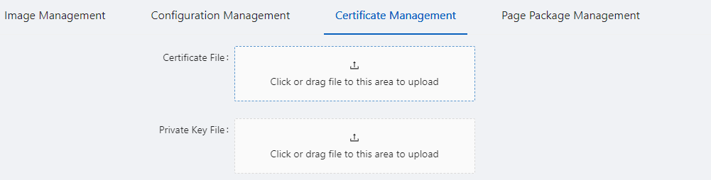

5.2.5 Page Package Management
The page package management module provides the ability to obtain the target page package file from the local host and apply the file as a device page package file, as shown in Figure 5-9.
Figure 5-9 Configuration File Management page
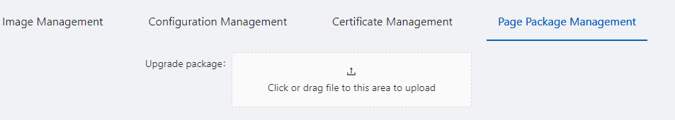

5.3 User Management
In the user management part, you can:
• Set the username, password.
• Create a new user.
Select Maintenance > User Management from the navigation area to enter the User Management page, as shown in Figure 5-10. Table 5-2 lists the configuration items of the User Management.

Figure 5-10 User Management page
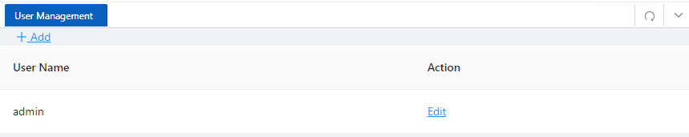
Table 5-2 Account configuration items
Item |  | Description
Account | Name | User name
Account | Edit | Click to change the password
Account | Delete | Click to delete the user account
Account | +Add… | Click to create a new user

5.4 Time Management
The system time module allows you to display and set the device system time on the Web interface. The device supports setting system time through manual configuration and automatic synchronization of NTP server time.
An administrator cannot keep time synchronized among all the devices within a network by changing the system clock on each device, because this is a timeconsuming task and cannot guarantee clock precision.
Defined in RFC 1305, the Network Time Protocol (NTP) synchronizes timekeeping among distributed time servers and clients. NTP allows quick clock synchronization within the entire network and ensures a high clock precision so that the devices can provide diverse applications based on consistent time.

5.4.1 View the system time
Select Maintenance > Time Management from the navigation area to enter the time management page, as shown in Figure 5-11. The current system time and clock status are displayed. Table 5-3 shows the network time configuration items.
Figure 5-11 System time configuration page
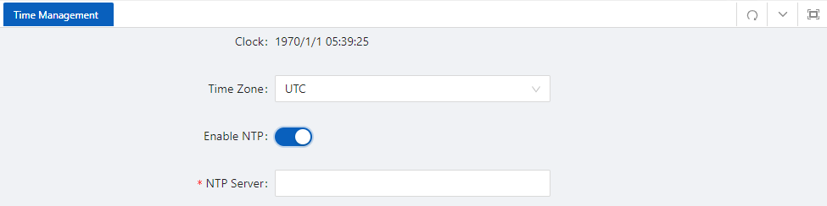
Table 5-3 System time configuration items
Item | Description
Clock | System date and time
Time Zone | Choose time zone
Enable NTP | Enable\Disable NTP
NTP Server | Set the NTP server IP address

5.4.2 Configuring System Time
1. Select Maintenance > Time Management from the navigation area to enter time management page.
2. Click synchronous buttonbehind clock, then click Apply button, as shown in Figure 5-12. The time of the pc will be synchronized to the switch.
3. Click Save of the auxiliary area.
Figure 5-12 System time configuration page
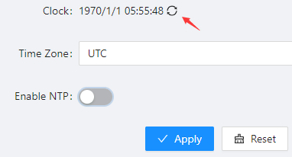

5.4.3 Configuring NTP Server
1. Select Maintenance > Time Management from the navigation area to enter time management page.
2. Enable NTP
3. Type 202.120.2.101 in the NTP Server IP box, as shown in Figure 5-13, click Apply.
4. Click Save of the auxiliary area.
Figure 5-13 NTP Server Time configuration page

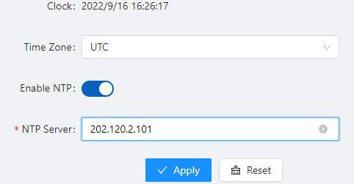

5.5 SNMP
Simple Network Management Protocol (SNMP) offers the communication rules between a management device and the managed devices on the network; it defines a series of messages, methods, and syntaxes to implement the access and management from the management device to the managed devices. SNMP has the following characteristics:
- Automatic network management. SNMP enables network administrators to search and modify information, find and diagnose network problems, plan for network growth, and generate reports on network nodes.
- SNMP shields the physical differences between various devices and thus realizes automatic management of products from different manufacturers. Offering only the basic set of functions, SNMP makes the management tasks independent of both the physical features of the managed devices and the underlying networking technology. Thus, SNMP achieves effective management of devices from different manufacturers, especially in small, high-speed, and low-cost network environments.
SNMP mechanism
An SNMP enabled network comprises Network Management Station (NMS) and agent.
- An NMS is a station that runs the SNMP client software. It offers a user-friendly interface, making it easier for network administrators to perform most network management tasks.
- An agent is a program on the device. It receives and handles requests sent from the NMS. Only under certain circumstances, such as interface state change, will the agent inform the NMS. NMS manages an SNMP enabled network, whereas agents are the managed network device. NMS and agents exchange management information through the SNMP protocol.
SNMP provides the following four basic operations:
- Get operation: NMS gets the value of a certain variable of the agent through this operation.
- Set operation: NMS can reconfigure the value of one or more objects in the agent MIB (Management Information Base) by means of this operation.
- Trap operation: The agent sends traps to the NMS through this operation.
- Inform operation: The NMS sends traps to other NMSs through this operation.
SNMP Configuration
(1) Select Maintenance > SNMP from the navigation area to enter the SNMP page, as shown in Figure 5-15.
(2) Select the SNMP version, configure the user, authentication encryption password, Trap host, and click the Apply button to complete the configuration.
Figure 5-15 SNMP configuration page
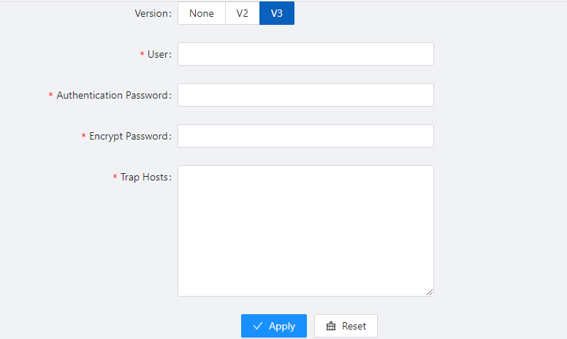

6 Diagnosis

6.1 Network Utilities

6.1.1 Overview
Ping
You can use the ping function to check whether a device with a specified address is reachable, and to examine network connectivity. A successful execution of the ping command involves the following steps:
1. The source device sends an ICMP echo request (ECHO-REQUEST) to the destination device.
2. The destination device responds by sending an ICMP echo reply (ECHO-REPLY) to the source device after receiving the ICMP echo request.
3. The source device displays related statistics after receiving the reply. Output of the ping command falls into the following:
• The ping command can be applied to the destination’s host name or IP address. If the destination’s host name is unknown, the prompt information is displayed.
• If the source device does not receive an ICMP echo reply within the timeout time, it displays the prompt information and the statistics during the ping operation. If the source device receives an ICMP echo reply within the timeout time, it displays the number of bytes of the echo reply, the message sequence number, Time to Live (TTL), the response time, and the statistics during the ping operation. Statistics during the ping operation include number of packets sent, number of echo reply messages received, percentage of messages not received, and the minimum, average, and maximum response time.
Traceroute
By using the traceroute command, you can display the Layer 3 devices involved in delivering a packet from source to destination. This function is useful for identification of failed node(s) in the event of network failure.
The traceroute command involves the following steps in its execution:
1. The source device sends a packet with a TTL value of 1 to the destination device.
2. The first hop (the Layer 3 device that first receives the packet) responds by sending a TTL-expired ICMP message to the source, with its IP address encapsulated. In this way, the source device can get the address of the first Layer 3 device.
3. The source device sends a packet with a TTL value of 2 to the destination device.
4. The second hop responds with a TTL-expired ICMP message, which gives the source device the address of the second Layer 3 device.
This process continues until the ultimate destination device is reached. In this way, the source device can trace the addresses of all the Layer 3 devices involved to get to the destination device.
The traceroute command can be applied to the destination’s host name or IP address. If the destination’s host name is unknown, the prompt information is displayed

6.1.2 Diagnostic tool operations
ping operation
1. Select Diagnosis > Network Utilities from the navigation tree to enter the IPv4&IPv6 Ping configuration page.
2. Type the IPv4/IPv6 address of the destination device in the text box, as shown in Figure 6-1.
3. Click PING to execute the ping command, and you can see the result in the box below, as shown in Figure
6-2.

Figure 6-1 Network Utilities page
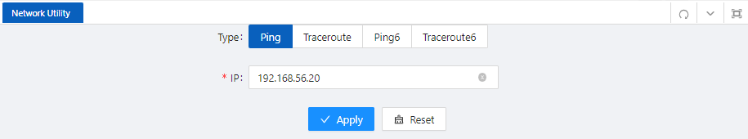
Figure 6-2 The ping result
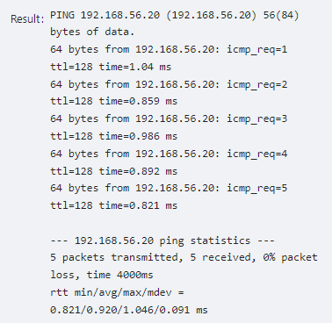
Traceroute operation
1. Select Diagnostic > Network Utilities from the navigation tree.
2. Type the destination IP address in the text box.
3. Click TRACEROUTE to execute the trace route command, and you see the result in the box below, as shown in Figure 6-3.
Figure 6-3 The trace route result
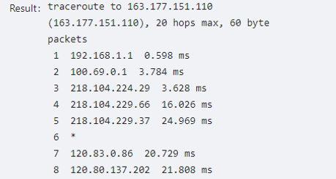

6.2 Optical Transceiver Information
Optical fiber is commonly used for long distance data transmission. However, when link issues occur, it is very costly to troubleshoot fiber cables and fiber transceivers at remote sites. To solve this problem, Moxa industrial Ethernet switches provide digital diagnostics and monitoring (DDM) functions on SFP optical fiber links and allow users to measure optical parameters and its performance from a central site. This function can greatly facilitate the troubleshooting process for optical fiber links and reduce costs for onsite debugging.

6.2.1 Displaying Optical Transceiver Information
Select Diagnosis > Optical Transceiver Information from the navigation area. The system automatically displays the optical transceiver information, as shown in Figure 6-4. Table 6-1 describes the optical transceiver information items.
Figure 6-4 optical transceiver information
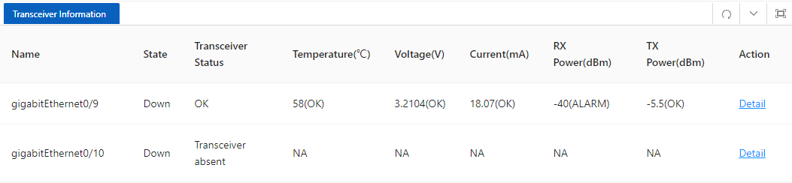
Table 6-1 optical transceiver information items
Item | Description
Name | Switch port number that the SFP is plugged into.
State | The state of the fiber interface, up/down.
Transceiver State | The absent of the transceiver.
Temperature(degree) | SFP casing temperature
Voltage(V) | Voltage supply to the transceiver.
Current(mA) | Current consumed by transceiver.
Rx Power(dBm) | The amount of light being received from the fiber optic cable
TX Power(dBm) | The amount of light being transmitted into the fiber optic cable
Detail | Click to show the detail information of the transceiver.

6.2.2 Displaying detail information
Click DETAIL of the interface to enter the page of transceiver detail information. as shown in Figure 6-5.
Figure 6-5 transceiver detail information
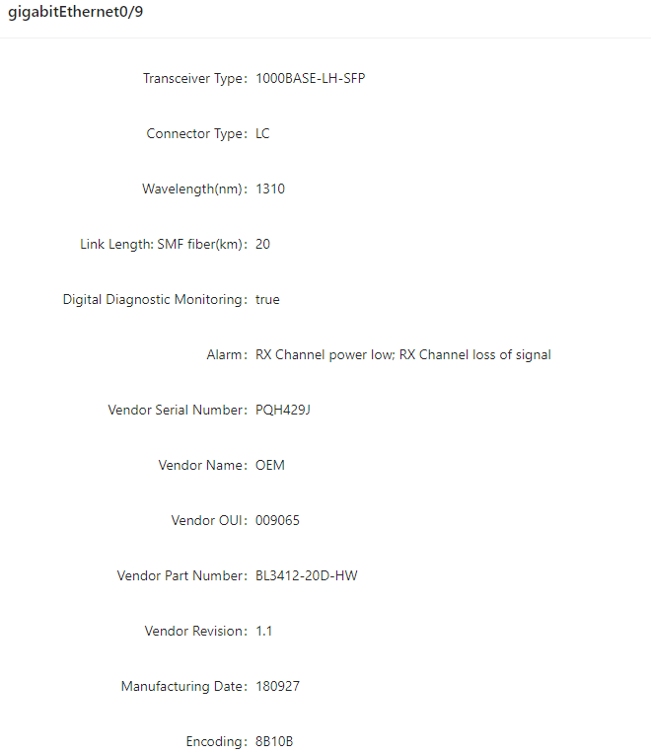

6.3 One-click Collection
Each functional module has its own running information, and generally, you need to view the output information for each module one by one. To receive as much information as possible in one operation during daily maintenance or when system failure occurs, the diagnostic information module allows you to save the running statistics of multiple functional modules to a file, and then you can locate problems faster by checking this file.
1. Select Diagnosis > One-click Collection from the navigation area to enter the page as shown in Figure 6-6.
2. When you click One-click Collection button, the system begins to generate the diagnostic information file, and after the file is generated, the File Download dialog box appears. You can save this file to the local host.

Figure 6-6 Backup log page
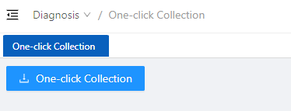

6.4 Dying Gasp

6.4.1 Overview
The networking devices rely on a temporary back-up power supply on a capacitor, that allows for a graceful shutdown and the generation of the dying-gasp message. This temporary power supply is designed to last from 10 to 20 milliseconds to perform these tasks.
According to the definition in 802.3ah, when a device power failure event occurs, the device sends an OAM event message to its connected device. Since OAM is a point-to-point protocol, the power failure event message will not be sent to the next device that supports OAM. Continue to forward again. The device that receives a power failure event will output a power failure LOG prompt message.
In addition to the OAM alarm information, the power-off device will also send a trap message to the smmp server.
Node information | Data
Mib files | DOT3-OAM-MIB.mib
oid | 1, 3, 6, 1, 2, 1, 158, 1, 6, 1, 4
value | dyingGaspEvent(257)

6.4.2 Configuring Dying Gasp
1. Select Diagnosis > Dying gasp from the navigation area to enter the page of dying gasp configuration page, as shown in Figure 6-7.
2. Select the box of dying gasp, click Apply button to enable dying gasp.
Figure 6-7 Dying gasp configuration page
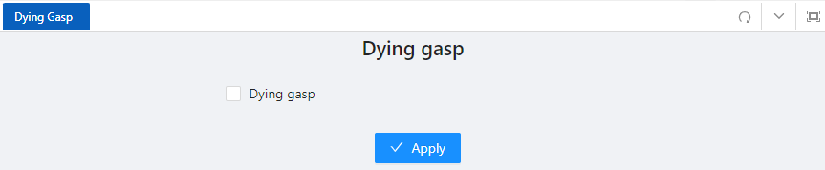

6.5 Cable Detect
Note
Only electrical ports support this command
Performing this operation will cause the already Up port to automatically go Down and Up again.
When the line length is less than 6 meters, there is a deviation between the test results and the actual value.

Cable detection means that users can detect the current status of the cable connected to the Ethernet interface on the device, and the system will return the detection results within 5 seconds. The detection content includes whether there is a short circuit or open circuit in the cable and the length of the faulty cable.
Step 1: Select Diagnosis > Cable Detect in the navigation bar to enter the cable detection page, as shown in Figure 6-8.
Step 2: Select the interface to be tested, click the Detect button to start the incoming line test, and the system will return the test results within 5 seconds.
Step 3: As shown in Figure 6-9, view the detection results on the pop-up page.
Figure 6-8 Cable Detection Page
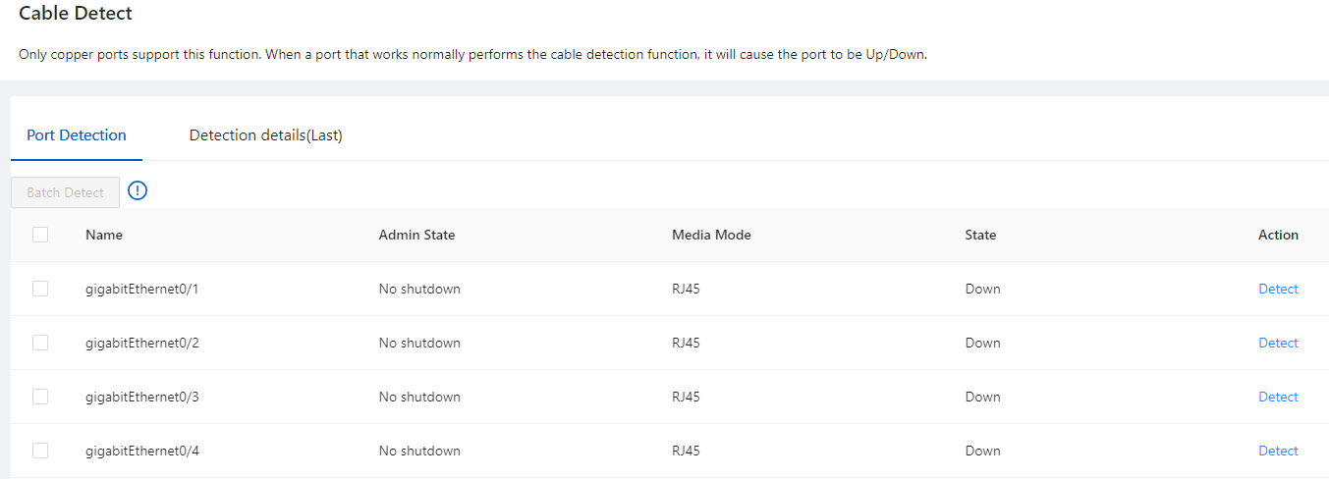
Figure 6-9 detection results
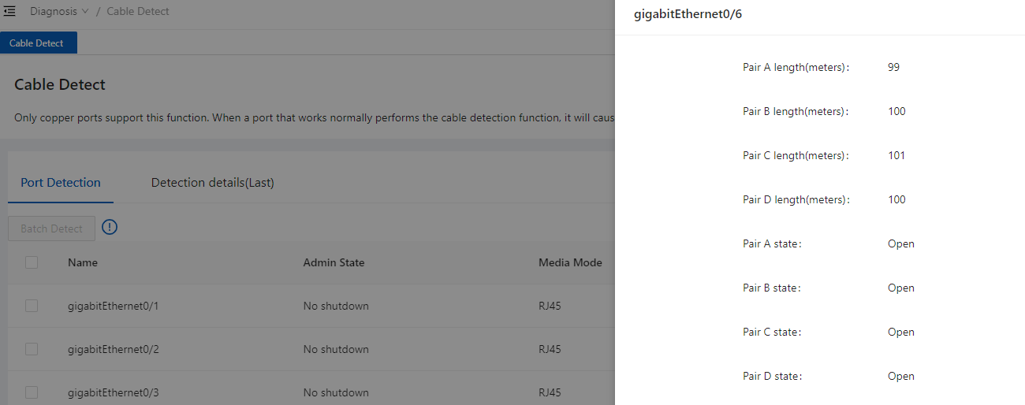
Note
Pair X length: unit meter, cable length, in case of fault, the length from the interface to the fault location
Pair X status:
OK (normal): Indicates that the line pair (PAIR) is terminated normally
Open: Indicates that the line pair is open
Short: Indicates a short circuit on the pair
Unknown: Other unknown causes of failure

